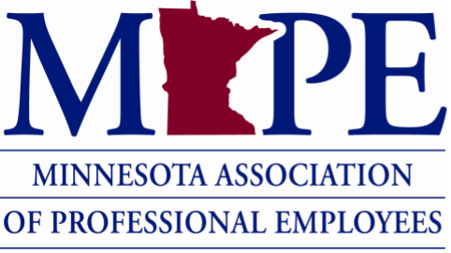
Steward Retreat
March 24-25, 2023
Delta Hotel
Tentative Agenda
Friday, March 24
6:30 p.m. Social hour, appetizers, games, karaoke, prizes
Bring your family for kids’ activities and swimming in the hotel pool. All stewards are eligible to stay at the hotel Friday night regardless of distance. The PAC may even be hosting a hospitality room.
Saturday, March 25
7:15-8:15 a.m. Registration, Coffee, Donuts, or hot breakfast
8:15-8:30 Welcome
8:30- 9:30 Keynote Meg Soper
9:30-9:45 Break
9:45-11:30 Morning Breakout Session (there will be a 15-minute break somewhere in this slot)
11:30-12:30 p.m. Lunch
12:30-2:15 Afternoon Breakout Session #1 (again a 15-minute break within the slot)
2:15-2:30 Break
2:30-3:2: Afternoon Breakout Session #2
3:30-4:30 Steward Panel, Q and A, Debrief
Session Descriptions
AM and PM Breakout Session 1:
Investigations 101
This session will cover the basics of investigatory participation as stewards to provide the best representation and advice to coworkers going through the difficult time of being the subject of an investigation. This training will cover appropriate behaviors at an investigation, required materials to be reviewed prior to questioning of the subject, and the role a steward plays through the investigative interview plus a chance to show off your investigative knowledge and skills!
Contract Language
Have you ever had to interpret unclear contract language? Has management ever applied terms of the contract incorrectly? If so, come to this training to learn rules and principles of contract interpretation. We’ll spend time talking about the challenges unions face when arguing contract language grievances, discuss how arbitrators interpret contract language, and dive into some examples of how our contract language has been applied, and how to establish a past practice.
ADA/FMLA/PPL
This is an overview of the Family Medical Leave Act, the Americans with Disabilities Act, and the Paid Parental Leave in our contract. Stewards will learn when each leave policy applies, how to support struggling members who may need to use one of these leaves, and the steward’s role in a reasonable accommodation meeting. Hint: Yes, you may attend them under our contract!
Respectful Workplace/Bullying
Everyone has an opinion about the Respectful Workplace Policy. Some have seen it benefit our members, while others claim it is used against us. Come and learn about the policy and how we ended up here, and what we can do moving forward.
PM Breakout Session 2:
Stewarding in the Virtual World
Join stewards from MAPE Region 5 to learn about how to represent members in the virtual world, with a focus on investigations. This workshop will go through the best practices for virtual stewarding, talk through what stewards need to know to roll with issues from tech to member behavior, and run scenarios for stewards to get hands on practice!
Organizing as a Steward
Besides a grievance, how else can we resolve this problem? This training will help us explore several different answers to this question. Current stewards will learn how to move non-grievance issues into action through engaging their membership and utilizing common methods of organizing.
Article 27/Telework policy/Remote Worker Policy/Negotiations Telework Rights
This training will cover best practices regarding telework agreements, appeal processes if denied and the application process. We will also cover the differences between telework and remote work agreements. Agency examples will be provided and discussed as well.

