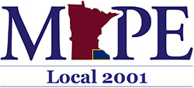
November Membership Secretary’s Report

Local 2001 Percentages- As of October 31, 2023.

Including Billable Members, our Local’s Membership is at 69.29%, with a total of 352 dues-paying members.
Local 2001 Percentages
.
. | Person Type Record Count Percentage  Billable Member 10 1.97%  Member 342 67.32%  Non-Member 156 30.71% | .
.

