January 19, 2021 Meet and Confer Meeting Notes
Quick Overview
- Gender neutral showers are important for a sense of belonging at the MPCA.
- Student loan assistance is critical for keeping new generations of workers at the MPCA.
- Phased retirement enables key knowledge transfer to happen in a documented way.
- Reallocation and career advancement process is currently unclear and creates confusion.
- Telework flexibility is important.
- Environmental justice in our work and equity in our office is important to MAPE members.
Detailed notes
Attended: Laura Bishop, Peter Tester, Helen Waquiu, Reena Solheid, Kellie McNamara, Anne Morris, Melissa Wenzel, Joel Peck, Claudia Hochstein, Kristin Kirchoff-Franklin, Brett Nagle, Shanna Schmitt, Mel Markert, Dave Kamper
Introductions: What is something you are looking forward to after COVID?
Legislative Session Updates from Laura:
- Evaluating the focus during COVID and expenses: where are staff deployed, permitting, and regulatory flexibility. There is a push for some federal reimbursement as part of the overall state budget.
- Clean Cars: Public information session went well and the topic has heated up with more information available. Some push back from the dealers association contending misinformation from MPCA. They are trying to present this message in front of the legislative supporters. This is a very important issue many at the agency worked hard on and will be at the forefront.
- Budget: A lot has been approved by the governor’s office for the environmental fund. There is a large focus to toll out a large plan for climate and climate resilience. Including the ability to direct funds to local governments and other partners who are working on their own plans. Optimistic about getting things through this session and the budget for the agency is looking good with no planned reductions or cuts.
- Env’t Justice: There is an effort to get Environmental Justice into statute so that it is preserved and a goal even if/when there are staff changes. It should be a focus and this would guarantee that.
From MAPE members:
- Gender Neutral Showers (Brett Nagle):
  - We hear from a lot of staff that this is a concern. Currently non-binary staff do not have a shower space and even cis members want an improved space so they are not in an uncomfortable situation around their coworkers and other staff. This is also an important component to supporting sustainable transit. Staff are encouraged to bike to work if possible, and are allowed to bike to and from meetings (provided they are close enough). These staff benefit from having a comfortable place to change and/or shower.
  - Laura noted we have looked into budgets and where else in the building we might be able to do this.
  - Reena discussed the following about work that has been done to the building and research done to address the shower space. They have done remodels on 1st floor and did look at remodeling the shower rooms then. When a facility is redone is has to be ADA compliant, so the showers would also have to be updated to be ADA compliant if work is done. This could mean space or stalls are lost to accommodate a larger stall. Currently there are ADA and neutral restrooms on other floors. To add showers they need to identify the best location and hire an architect/engineer. This is an older building and they determine if we can tie into existing infrastructure. Estimates and plans would cost $20,000-$30,000. Based on the most recent estimates, if they found a location it would be over $300,000 to construct. Replacement and expansion of the current shower facility could be over one million dollars. This is a very expensive project, but it’s understood why it has been suggested and the importance of it. They began investigating 2 years ago. Other ideas have been suggested such as a rotating schedule for lower level for gender neutral use. In the morning and afternoon there could be times set aside for reservation.
  - Peter and Reena also discussed that they have reached out to DNR and would consider working with them to find something to accommodate both agencies. This could possibly be expanded outside of our two agencies to explore spaces in the entire Lafayette Park. DNR is converting one of their main floor restrooms to an ADA complaint but there are no shower plans currently.
  - This is an important issue but cost is a major factor in completing it. Other, creative, options are being explored to provide a safe and private space for staff.
- Student Loan Assistance (Joel Peck):
  - This is consistently an issue we hear from members. A lot of members need assistance. These jobs require a higher degree and we need education to acquire them. This puts members at a financial disadvantage, even compared to those in the private sector. We keep addressing this because we need our members to know we hear them and we know this is a very important issue to them.
  - Laura did talk with the team, but right now there just isn’t money to put toward it. There is such a small percentage of budget that is from the general fund and this would need to come from that fund. PCA receives only ~3% from the general fund for their budget. They have not prioritized asking for this from the general fund. Laura does agree this is a big deal, but is not sure how to approach it.
  - Peter noted the governor has already asked for reductions in general fund spending. It does fund critical things at the agency and they can’t cut those. Additionally this would have to be offered across all contracts, not just MAPE and at up to $5,000 a person that is a large expense.
  - Joel reminded that this would be an economic stimulus for the state by redirecting money that would normally be used for federal loans. It could boost local economies and help members live more comfortably. In the future this could be a reason to request more general funds, to make this program a reality for members.

- Early and Phased Retirement (Anne Morris):
  - Members want a way to retire that passes on knowledge to the next generation of workers. It’s hard to transfer knowledge when someone who’s been here for 25 years retires and only leaves documents. Members want a pilot program of phased retirement that provides a clear timeline to retire and includes the transfer of knowledge.
  - We want to thank leadership for the communication about the decision opting out of the early retirement plan. However, considering how many people are close to retirement, how are we going to prepare for them leaving? This would be an opportunity for phased retirement.
  - Peter said they understand the expertise that exists in the agency and the integrity that comes with it. They understand the need to maintain the knowledge and the skill at the agency to continue functioning at the same capacity.
  - Kellie discussed salary savings leaves (a voluntary reduction of hours). It is already in the MAPE contract and works similarly to phased retirement. Members would still accrue benefits. The agency has done salary savings leave in the past but stopped because it required budget issues before using it. Since there are budget concerns again, salary savings is being reintroduced. However, it does not address the knowledge transfer. At the end of salary savings leave staff are not required to retire. A plan does need to be put together before someone wants to use salary savings. There is a link to information on the Lorax.
- Reallocation (Melissa Wenzel):
  - Stewards, the Meet and Confer Team, and Local leadership have all heard feedback that reallocation is not clear. We agree the process is not time-specific and should be based on performance, but the message that it’s based on time is still being given to some members. There are hold-ups before reallocations get to HR and members don’t know what to do. What we’d like to see is the status of reallocations in HR updated quarterly. Additionally a flowchart of the entire reallocation process in clear language. This would not include dates but should include steps before and through HR so members know how to address concerns along the way.
  - Kellie noted that quarterly might be too frequent but she will check on what resources are available. They are working on the flowchart but HR doesn’t have a way to track reallocations before getting them. Stay Interviews conducted at the agency showed this was a concern for staff. She would like to check in with the ADDs and get back to us about these topics and establish a timeline for working on these concerns. She also sees the need to keep addressing the misinformation that time, not performance, decides who is eligible for reallocation, and we agree to help with that. Please keep in mind that reallocations are non-competitive reappointments and to keep opportunities fair throughout the agency there needs to be a mix of reallocations and internal postings.
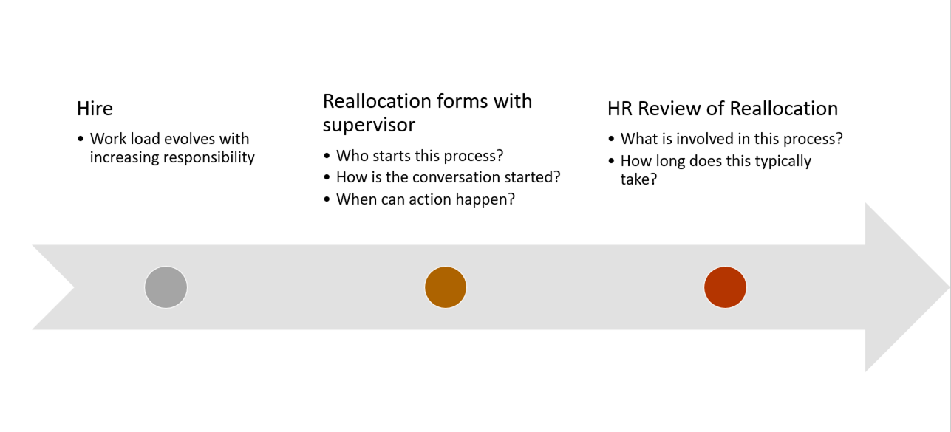
- Career Advancement (Melissa Wenzel):
  - Members want to know their opportunities and would like to see the agency provide more information concerning advancement. We shared the Career Path document from HR at past meetings and it was very well received. However some elements are outdated. We have 2 people on Meet and Confer who would like to help update them. Who can work we work with?
  - It was suggested we speak with Caroline Kammeyer (HR Retention Consultant) about working on the updates; Melissa Wenzel & Shanna Schmitt volunteered to work with her.
- Env’t Justice: Due to time restrictions we were not able to address the last topic: Equity and Environmental Justice.
- Telework: We were also unable to address telework, but agency leadership wants to hear what members' thoughts are concerning telework after COVID. No decisions have been made, but a flexible work environment is the message being heard so far. Leadership anticipates this will be a big topic moving forward.
- MAPE members are empowered: Dave wanted to note members at the PCA feel they are involved in decision making and the agency scored the highest in this metric in their survey. We have people who want to do good things and they feel like they can at PCA.
- Environmental Justice Policy: A final note from Helen about the Environmental Justice statute: There was a draft brought forward last year, but it was pulled back as it didn’t seem likely to move forward at the time. It was modeled after the New Jersey plan and the current atmosphere suggests this is a better time to bring this topic forward. This will likely be a several years long project, but one that is incredibly important.
Follow-Up Items:
- Estimates for the shower space and any related ballpark ranges for planning.
  - Provided by management 2/22/2021
- Links for the Lorax pages addressing salary savings.
  - Provided by management 2/8/2021
- Reallocation flowchart.
- Reallocation updates, Kellie is checking on resources & availability to determine frequency.
- A contact for Melissa and Shanna to help update the HR documents.
- A timeline for the Environmental Justice Policy and list of people who are drafting it from Helen.

Follow up context from overflow items from the end of the meeting:

Telework

- Telework was one of the top items mentioned by MPCA MAPE-represented employees both in a union-wide survey and in agency-wide listening sessions.
- Comments universally mentioned wanting the ability to continue teleworking post pandemic.
- Importantly, most staff valued the flexibility of the telework option, and would want to maintain office days. Staff do not want to be placed on permanent telework status.
- Staff appreciate the ability to telework while having their children at home.
- A stipend to purchase equipment during required telework.

Equity

- MAPE requests an appointment to the working group for the new EJ policy.
- MAPE requests to review the draft of the new policy.
- MAPE members want the MPCA to center equity in all work, internally and externally.

