MAPE, Local 1801 Meeting Agenda for March 9, 2021

Time: 12:00-1:00 p.m.

1. Roll Call—Taken from Adobe Connect Screen

|  |  |  |  |
| --- | --- | --- | --- |
| 17 | Salome Chonko | 9 | Paul Guerrero |
| 4 | Megan Benage | 6 | Rebecca |
| 10 | Molly Tranel Nelson | 8 | Josie Chavez |
| 14 | Bev Donley | 16 | Ann Lanners |
| 3 | Melissa Ball- Warriner | 7 | Theresa Ireland |
| 1 | Mary Larson | 18 | Pauline Arnst |
| 12 | Tim Beske | 19 |  |
| 5 | Kirsten Peterson |  |  |
| 15 | Lorie Skaro Johnson |  |  |
| 2 | Russ Derickson |  |  |
| 11 | Marcia |  |  |

2. Report from Officers

A. April meeting minutes- Russ approved minutes, Paul second…. Approved.

B. Treasurer’s report-

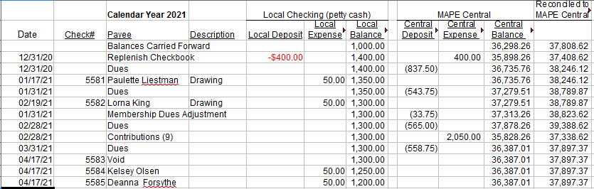

C. Membership Secretary Report- New Members: Brian Schindele (Granite Falls – Non-state Billable Member) Combined: 60.2% Members/ 39.8% Non-Members

Non-Member New Hires:

Sissi Torres Guanche – MNIT Willmar

Kimberly Simon – DHS Willmar

Tania Sletta – DHS Willmar

Melissa Peterson – DHS Willmar

Scott Briffett – MNSCU Marshall

|  |  |  |
| --- | --- | --- |
| **Person Type** | **Record Count** | **Percentage** |
| Billable Member | 9 | 2.42 % |
| Billable Non-Member | 2 | 0.54 % |
| Member | 215 | 57.80 % |
| Non-Member | 146 | 39.25 % |

#### 60.98% Member / 39.02% Non-Member

#### New members: Desiree Wright (DHS – Willmar)

#### New Hires (currently showing as non-members): John Salgado Maldonado (DHS – Willmar)

#### No dropped memberships.

* 1. Approval of [Minutes](https://gcc02.safelinks.protection.outlook.com/?url=https%3A%2F%2Fmape.org%2Fnews%2Flocal-1801-minutes-26&data=04%7C01%7Cmolly.tranel%40state.mn.us%7C30d576b0a2dd4ec091a608d9119da896%7Ceb14b04624c445198f26b89c2159828c%7C0%7C0%7C637560191230534664%7CUnknown%7CTWFpbGZsb3d8eyJWIjoiMC4wLjAwMDAiLCJQIjoiV2luMzIiLCJBTiI6Ik1haWwiLCJXVCI6Mn0%3D%7C1000&sdata=fqNOl6tqUO%2BHycCHVK8UP3Ix4ClX6ti%2FTPlcIApUb8o%3D&reserved=0)
  2. Regional Director Update- Tim Beske

Vacant BA position. MMB wants to bring back workers between July 1st and labor day, earlier for some. In the legislative session with one week left. Special session likely. Pharmacy benefits manager is bidding out right now. Coalition building board group focused on building community partners and build member involvement. Delegate assembly will be virtual. Steward Classes for those interested. <https://mape.org/resources/training/classes>

* 1. BA Update- Alex Erikson
  2. Negotiations update

This is going to be a very rough contract year. Despite sign the petition, health insurance proposed 3.6% increase per year over the next 2 years, MMB wont commit to being anti-racist,

MMB is saying hard no to everything, more so than other years. Trying to raise everything with healthcare. Just received a letter from MMB regarding steward time. Their new interpretation is that stewards wouldn’t be paid for their time, would have to take vacation. Looks like a class action grievance will be filed. MMB is putting forth the worst anti-labor proposals in many years. AFSME opened their meetings in mediation. MAPE determined that they wouldn’t gain anything through mediation so staying with open negotiations. You can listen in to the negotiations. No interest in equity, student loan reimbursement…ect.

1. Drawing - Theresa Ireland

*Local 1801 Officers:* [*Megan Benage*](mailto:megan.benage@state.mn.us) *(President),* [*McKenzie Kack*](mailto:mckenzie.kack@state.mn.us) *(Vice President),*[*Teren Novotny*](mailto:teren.novotny@ridgewater.edu) *(Treasurer),* [*Molly Tranel*](mailto:Tranel,%20Molly%20(DNR)%20%3cmolly.tranel@state.mn.us%3e) *(Secretary),* [*Nathan Mullendore*](mailto:Nathan.Mullendore@state.mn.us) *(Membership Secretary)*