MAPE Local 1801 Meeting
3/14/2023
12:00-1:00 p.m.

Roll Call—
15 | Krista Howk | 6 | Emily Douglass
5 | Molly Tranel nelson | 1 | Tim Beske
12 | Russ Dickerson | 10 | Christy Johnson
9 | Beth bents | 22 | Lorna King
13 | Joseph Zimmerman | 11 | David Kratz
7 | Karen RB | 3 | Pauline Arnst
8 | Lynn Baker | 4 | Laura
16 | Wael Abdelkader | 14 | Taralee
2 | Theresa Ireland | 18 | Nathan Mullendore
20 | Gretchen | 21 | Talia Larson
19 | Kathy iPHone | 17 | Ellen Preisinger
24 | Dave Van Watermeulen | 25 | Paula Paplow
15 | Beth Rakow | 23 | Joseph Zimmerman

- Report from Officers
  - Treasurer’s report-
Local balance $ 861.47
Mape Central- $ 34795.02
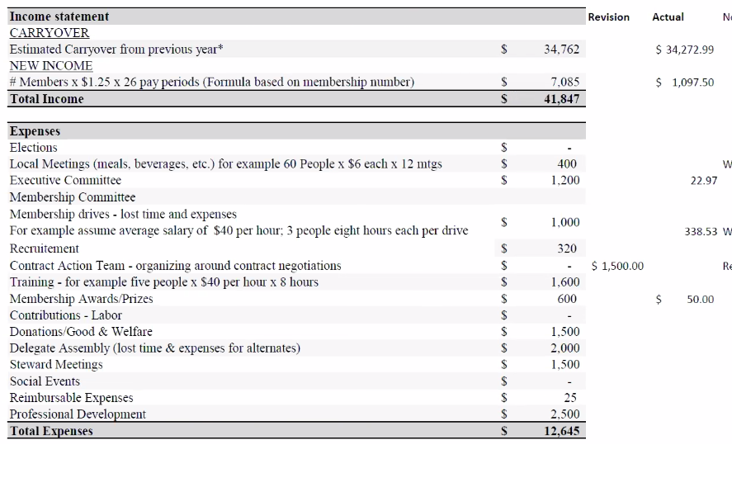

- Membership Secretary-

Local 1801 Percentages
Person Type | Record Count | Percentage
Billable Member | 7 | 1.85%
Billable Non-Member | 2 | 0.53%
Member | 211 | 55.67%
Non-Member | 159 | 41.95%

Combined: 57.52% Members/ 42.48% Non-Members

New Members:
Daniel Lewis - Granite Falls

New Hire Non-Members:
Lucas Schreiber - MNDOT (Willmar)

Dropped Memberships:
None

- Board or Directors- Tim Shared the mission statement.
Crisis funds for when we need it, Future Operations- for years when expenses are greater than what we pull in. We are now in that scenario. So, we need new member recruitment. When we had fair share, 85% of full dues was paid. After Janus, 2017 that went away. So now the full dues paying members are the only contributions. Reach out to new members and do some recruiting. Discussion about grievance cleanup that have been on the books for a few years. Accessibility workgroup forming to make documents available for those who need it. Charter was put together. More info coming.
Capitol Lobby Day coming March 23rd. Only 1 person from 1801 going as of now. Registration is closed but people can still go.
https://mape.org/capitol-lobby-day
https://mape.org/news/response-february-2023-budget-forecast
https://mape.org/news/legislative-update-feb-28-2023
Special Election voting information is out. https://mape.org/resources/mape-documents/mape-internal-election-information

Open House at SMSU- 15 people, David presented.

- BA report- David
Day on the hill- connects members with legislators.

Marshall event in Feb was great to meet new faces. Marsha, Gretchen, others organized, big thanks. If you have new employees, reach out to them, and talk about MAPE and why you are a member. Members are more interested during bargaining years.

Marshall office for MN lottery is closing, they will be going to different locations. Housed out of different areas. Working on an MOU with lottery on that.

Want to build more of a contract education piece into these meetings, reach out to David if you have topics to discuss.

- Negotiations Update- Gretchen – The platform and getting everyone’s home phone numbers in the update so they can all get a text with updates. Signing up new members while reaching out to them. Bargaining platform- https://mape.org/platform 1600 signatures, get people to sign. April 11th is opening exchange.
Wages, Healthcare, Healthy Workplace, Telework

- Meet and confer updates.

Scholarship announcement- Committee volunteers: Wael, Tara, Ellen, Kathy
They went through the eligibility, application, and scoring forms. Ready to send out the RFP for the applicants running from April 1st through may 15th. Added graduate degrees as well as members who are pursuing graduate degrees. Include a $500 for members so this would increase the line item budget. That would be for employees training/license, first come, first serve. Must be a member for 1 year to be eligible for college one. Wael- awareness will be important. Nate mentioned going this way first year and if multiple people applied, then next year we could pro-rate it or split for multiple people.

Motion By Ellen to add the $500 and make eligibility for 1 year. Wael seconded. Motion approved.

- New Member Recruitment through April 4th. Event in New Ulm on April 4th. David will be attending. Super knock Saturday is April 1st.

- Drawing- Pauline Arnst is the winner.

