MAPE Local 602 meeting
Date: May 5, 2023
Location: Teams
Minutes Table of Contents
MAPE Local 602 meeting 1
Roll call 1
• Vice President and Secretary 1
Introduce new Region 6 Director 1
Business Agent negotiations update, Frank Cave-LaCoste 1
ACTION: Negotiations 2
Response we get at the table is impacted by our actions. 2
ACTION: Become a member 2
Membership numbers speak to our power 2
ACTION: Request for negotiation stories, Meal reimbursement 2
Arts Board update 2
Nomination for VP: 2
Volunteers for Secretary 2
Q&A/Walk on items 2
• Get Involved/Amber Zumski 2
• Mileage Reimbursement Policy/ 2
Party, Katey/– who wants to volunteer to coordinate something fun? 3

Roll call. Katey Kinley, President, and Steward; Sanderia Davis, Membership Secretary; Amber Zumski, Treasurer; Annie Reierson, Co-Lead Steward; Jennifer Willette, Steward.
- Vice President and Secretary are currently open positions available for nominations.
Introduce new Region 6 Director, Nate Hierlmaier (from Local 601)

Business Agent negotiations update, Frank Cave-LaCoste
- Contract Negotiations Updates MAPE 2023-2025 Contract Negotiations | Minnesota Association of Professional Employees
- Healthcare bargaining session began 5/3
- General Contract Negotiations began last week. Jason Bonnet (Local 601) is our rep for Region 6
- Strategy was to put forth a narrowly focused proposals for what is most important and impactful to members overall. Negotiations Proposals 2023-2025 | Minnesota Association of Professional Employees (mape.org)
- In the past, proposals were numerous and this year they a smaller focused set
- Gov Walz sat in on the initial session, the proposal was effective and well received.

ACTION: Negotiations

Response we get at the table is impacted by our actions.
- MAPE is focused on Recruitment, retention, and actions pushing for our proposals.

ACTION: Become a member
Membership numbers speak to our power
- Katey will send the list of membership status with this update. No judgements, many have reported not being aware that they do need to opt in by filling out this application

ACTION: Request for negotiation stories, Meal reimbursement
- This request is from Jason Bonnett. Several Minnesota Housing employees were involved in putting this on the table. Please share your stories of how the meal reimbursement as is affects you.
- Email stories to: jbonnett@mape.org
Arts Board update
- From Davia (MAPE): Regarding move to 540 Fairview Ave in Saint Paul, which is Local 1101
- Local 602 is now Minnesota Housing only
Nomination for VP: Nick Boettcher (welcome back!)
- Nomination seconded by Amber, approved by hand raise vote.
Volunteers for Secretary: Nominations are being accepted for this open spot.

Q&A/Walk on items
- Get Involved/Amber Zumski: Within your team of people directly ask people to become members. Think of how you can get involved. Many hands make light work. There are many ways to become more involved in MAPE.
- Mileage Reimbursement Policy/ Connie Montgomery, Lenee, Mike
  - Mileage reimbursements – agency chose to use of the .07 reduction from the IRS amount (when a fleet vehicle isn’t available)
  - Considerations are leaving personal car in the ramp for multi-day trips, backtracking to the office from home to obtain a fleet vehicle
  - We will organize a Meet and Confer to negotiate with agency leaders on this change
  - Please email Katey if you want to participate, in the Subject Line please add Mileage Reimbursements, so I can easily track interest.
  - 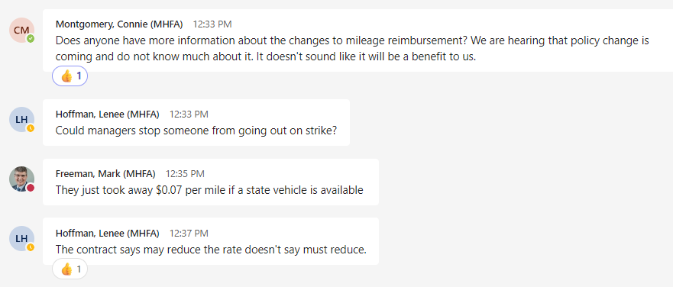

Party, Katey/– who wants to volunteer to coordinate something fun?

