Meeting Agenda:
- Roll Call – taken from Zoom screen.
- Report from Officers
  - Regional Director update
    - Dues Proposal Change
  - Treasurer’s report
  - Membership Secretary’s report
  - Approval of minutes
  - Meet and Confer updates as available.
  - Other reports?
- BA David Contract Education and new language updates within the newly approved contract.
- Delegate Assembly Lorna and Anne attending
  - Resolutions to be presented at October Meeting
- Announce Current Executive Committee Local 1801
  - President Anne Hall (Gretchen retired), VP Taralee Latozke (Anne moved president), Secretary Wael Abdelkader (Molly moved different union), Treasurer Ellen Preisinger (Tara moved to VP), Membership Secretary Nate Mullendore (Please include in minutes for bank updates to account access)
- Drawing
- Adjourn

Meeting started with treasure report discussed the expenses for this month. about the charity events
Expense for this month + year to- date
Roll Call – taken from Zoom screen.

Report from Officers:

Treasurer Report:
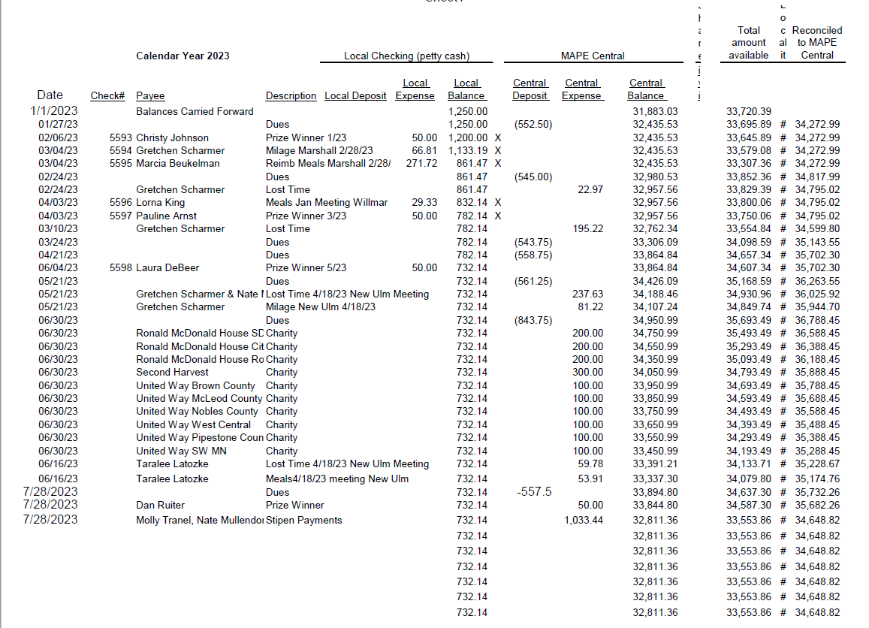
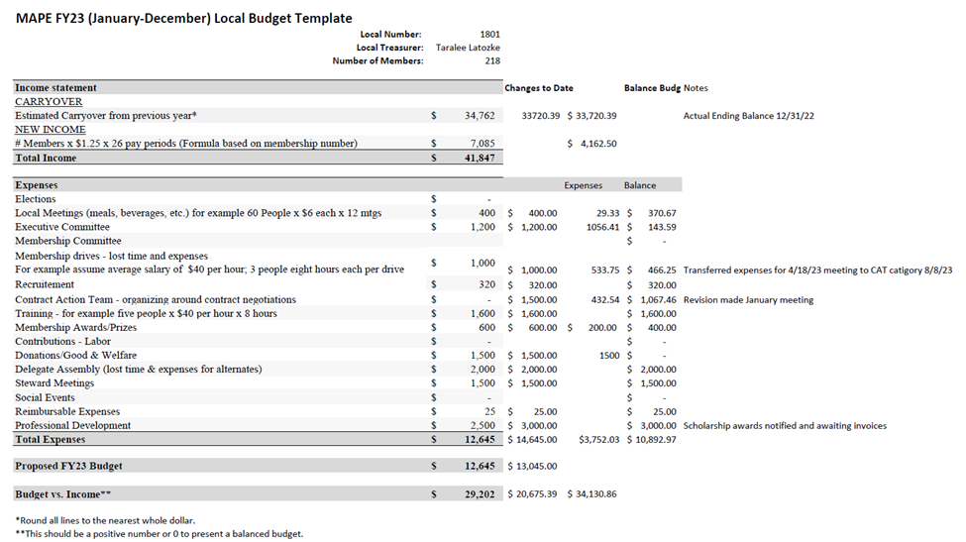

This discussion leads to the following question:
What options of dues structure can be implemented?

Tim Beske:
Discussed recent board meeting and discussion around restructuring dues. He made comparison of number of paying members (monthly dues of $22 fee) and numbers of non-paying, non- voting members. He also, spoke about the impact the union / locales’ gross income. Purposed changes in dues structure will impact MAPE’s ability to grow and increase number of lost opportunities. The board of director and the Finance Workgroup have been working together to find a solution to this issue. Some of their strategic plan is coming up with a fair dues structure to fulfill member’s demand. One can ask: What does fair mean? Tim shared some examples from his time working at the county. Tim: At any rate MAPE approved a 5-year membership growth which contain:
- Modernizing MAPE’S Systems in additional to other things.
- Building Power – community, union, and a better future for all members.
- Organize resources is an example of what exactly members want from us.
Tim also discussed Delegate Assembly in Oct 27 – 28th 2023. He highlighted that Finance Workgroup did most of the work to come up with a plan that will implement the fair dues. The dues update: for more than a decade MAPE has not increase its dues. Because of it, MAPE has been in a very lean operation mood however it does implicate resources and benefits. Tim commended local 1801 on our ability to manage our meeting and expenses. Financial solvency depends upon dues increase and increased membership.
Current MAPE membership is at 67% with a goal of 70% membership. Our last dues increase was in 2013 and no other increase happened since then. Tim: Dues generates 99% of income and resources – in additional to other statistics and MAPE track records. He also discusses the momentum, union achievements, and union stability which relies on equitable dues to have financial base.
How dues will be used: investing in negotiations, data analytics, information management, etc. Also, building power through member’s engagement and celebrating member’s leaders and building the future of a highly skilled members.
The proposed use of 2024’s dues: The board recommends a dues structure tied to an individual’s hourly wage that’s capped at $32.50. This cap is to ensures fairness and equitability (look at the presentation and information on the MAPE site https:\\mape.org/dues.). We moved from $15 to $21 per pay period for members. Some of the additional funds will go into future funds. Next steps – there are three forms, check the website for more details and please contact your reginal director for more information. Tim discussed the delegates opportunity; roles and that local president can appoint individuals if there’s the local doesn’t current have any. Tim also, discussed Public Sector, unions – Advocacy, service ex education, etc. in conclusion – Tim asks members to support the dues increase.
There was a Q & A that Tim and David helped answering.
Some of the question from the chatroom:
- Janet Meier 12:29 PM: Is that amount of $32.50 cap per pay period or week?
- Krista Howk: - I feel this is really reasonable. I came from AFSCME just over a year ago and my dues were over 150% / pay period and many AFSCME employees are part time.
Note: Tony Cairns joined as a guest.
David Hearth: The budget included a projection of a loss of 5% of members. It also included a projection that just under 500 of the employees that we represent would see a dues reduction.

David elaborated on the above written comment. There was no other question which ended Tim’s presentation for today’s meeting. Tim made one last attempt to encourage attendees to vote for the due increase.

Taralee presented the treasure report.
– She went through attached report details and highlighting current balance. She also pointed out our local budget with balances for scholarships payout.

Nate Mullendore: Reports – membership report –
Note – meeting that we need to focus on increasing recruiting efforts to increase membership.
Person Type | Record Count | Percentage
Billable Member | 8 | 1.99%
Billable Non-Member | 2 | 0.50%
Member | 218 | 54.09%
Non-Member | 175 | 43.42%
September 2023 Local 1801 Membership Secretary Report

Local 1801 Percentages
Combined: 56.1% Members/ 43.9% Non-Members

New Members:
Erin Barker - DEED (Marshall)
Tony Nelson - MNSCU (Willmar)

New Hire Non-Members:
Cynthia Wilkens - VA (Montevideo)
Barbara Sorenson - VA (Montevideo)
Brenda Kalthoff - VA (Montevideo)
Brian Gelster - MNSCU (Marshall)
Jacq Williams - DEED (Marshall)
Nicole Hahn - MNSCU (Hutch)

Dropped Memberships:
None

SECRETARY REPORT:
David Hearth – discussed the care facility in Willmar’s closure and how that will impact members. He is working with some of the facility leadership to plan the impact of that closure on our members. He will come back to the group later as he gets updates. MNDOT members has meet and confer – David asked members to contact him with any questions.
Anne also asked David to discuss information and educate the group on the contract changes.
David Hearth - Now that we are in September – right after vote completion in August – he went through some the structural changes, collective bargaining changes and more highlights of important wage changes. 5.5% increase in this year pay period, then 4.5% increase in the year after which totals 10% increase in the next 2 years. He also, discussed the step increase in addition to the negotiated increase which could total much higher than that 10%. There are some changes to healthcare; however, there was some nonchanged as well. Premium will increase slightly based on their current premium rather than on their wages. David directed members to MAPE website for more details. He also, went through some of the changes of Mental Health copay as well as Dental Plan increase. He talked about 5 areas –
- Traveling (reimbursing rate – meals and millage – in state and out of state.).
- Manager must justify their decision – “Why they will require employees to come into the office”.
- Also, change in the definition of “Family” What does family means? There is now an expansion that allow members to determine who are their family members.
- David mentioned the vacation accruals – removed the requirement to be in a vacation qualified position. Also, there’s no window required or seasoning to qualify or length of service credit.
- David discussed healthcare benefit after retirement – searb vs cobra (MS
There were no more questions as a follow up on David’s presentation. He also pointed out that our local have Stewarts who can answer questions. He stressed that the contract is active, and members should spend time to understand the changes.
Chatroom Q:
- Shawna Ehlenbach 1:00 PM - Where do we find the language on requesting vacation leave increase?
- Diane Stieper 1:02 PM - Does it go back more than one job.
- Lorna King: offered to assist members to fill up some needed forms.
Lorna King 1:03 PM My contact- Phone Number: (320) 222-5742 | Email: Lorna.King@ridgewater.edu
Anne Hall: brought up the Delegate Assembly – she discussed the number of members required per assigned delegate. She also discussed the possibility of having enough members for one more delegate position. She went through different scenarios Please contact Lorna for more information about the delegates.

Anne Hall: Announced the current executive board members for local 1801
President Anne Hall (Gretchen Retired)
Vice President Taralee Latozke (Anne moved to President)
Secretary Wael Abdelkader (Molly moved different union)
Treasurer Ellen Preisinger (Tara moved to VP)
Membership Secretary Nate Mullendore

Anne asked for today’s attendee’s prize winner: number 17 – Jason Gibbs (Taralee will send him the form to be complete.)
Anne asked members to contact local leadership for any questions and needs.

Provided a list of names of the attendees.
Mape Union local 1801 monthly meeting - September meeting attendees
Number | Name
1 | Taralee Latozke
2 | Tim Beske
3 | Ann Lanners
4 | Paulette Liestmen
5 | Al Gleisner
6 | Anne Hall
7 | Barb Sorenson
8 | Ben Nwachukwu
9 | Beth Bents
10 | Beth R
11 | Brenda Kalthoff
12 | Bryan Roiger
13 | David Hearth
14 | Diane Stieper
15 | Heather Wright
16 | Janet Meier
17 | Jason Gibbs
18 | Joseph Zimmerman
19 | Karla Ihns
20 | Krista Howk
21 | Laura Debeer
22 | Loran King
23 | Marcia Beukelman
24 | Mark Senkyr
25 | Mary From Willmar
26 | McKenzie Kack
27 | Megan Stadem
28 | Nate Johnson
29 | Pauline Arnst
30 | Shawna Ehlenbach
31 | Tony Cairns

Number # 17 = Jason Gibbs is the prize winner.

