MAPE Local 1302 Meeting Agenda | 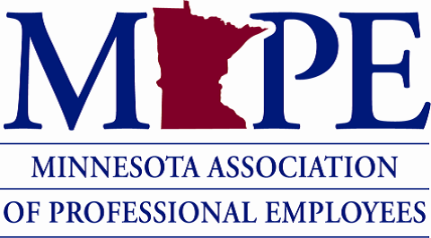 | Date: Wed. April 13th, 2023  Time: 12:00-12:50 pm

Topics | Notes | Additional notes and Action Items
Introductions | - President – Paige Wheeler, paige.wheeler@normandale.edu  - Rae Simonson – Treasurer, rae.simonson@normandale.edu  - Ted Scamp – Secretary, ted.scamp@normandale.edu
Contract Bargaining | - Platform: https://mape.org/proposals  - General Contract Bargaining Platform: https://mape.org/platform Please sign if you haven’t yet. Asking people to sign the Contract platform to show widespread support for the broad priorities. Optional to include your cell # for rapid response/updates during bargaining.  - Supplemental bargaining is gearing up  - Telework: some telework people being called back into office | -Negotiations started yesterday. Amanda Prince (MAPE Business Agent for our Local): MMB went first in negotiations for the first time. This is a positive change.  -Proposals: now available. Cost of Living Increase MAPE proposing 11% first year and 10% second year (up from 2.5% currently)  -Still looking for signatures on the platform if you haven’t signed already.  -A good way to show support in negotiations.
Local President Updates | - Organizing Council Updates: ideas for organizing around contract negotiations this year. Doing more small actions than big ones. Will release a toolkit soon. Goal is to tell commissioners/other agency leaders to commit to supporting the contract.  - Local Actions to Support the Contract: Change background to MAPE logo for online meetings, wear buttons/MAPE gear, pictures of animals and/or babies with union signs on social media | Ideas for supporting negotiations, reach out to Amanda: aprince@mape.org
Open Local Positions | - Open Local 1302 Positions: Vice President & Membership Secretary  - VP supports Paige if she’s not available for events. Membership Secretary supports efforts to convert non-members to become members.  - Every other month meeting  - Let Paige.Wheeler@normandale.edu know if you are interested  - Would serve until May 2024
Donations/Good & Welfare Budget | - 2023 Budget  - How do we want to use our 2023 “Donations/Good & Welfare” $2,000 budget?  - Member Assistance Fund: Some Locals allocate a portion of their budget to support members in need (i.e., $1,500-$2,000 and give $50-$200 per request). Sample policy from Local 1702.  - Nonprofit donations | -Let Paige know if you have suggestions on which non-profits to donate to (paige.wheeler@normandale.edu)  - In 2021 did Twin Cities Food Justice and Second Harvest Heartland ($1,000 to each).  -Member suggested Open Arms MN for 2023 donation.  -Donation money can be rolled into next year’s budget if not spent in 2023.  -Paige will send a follow up email to members with a survey about this.
Meet Your Local Colleagues (time allowing) | - Introduce yourselves: Name, work site, job, and something that is giving you joy
Other topics?
Next Local Meeting | - June meeting: Wed. June 14th 12-1 pm at Normandale Community College. Paige will email out RSVP for lunch and location info. | -Location at Normandale with room TBD. Possibly pitch membership to new hires at this event?
Questions?

