MAPE Local 1302 Meeting Agenda | 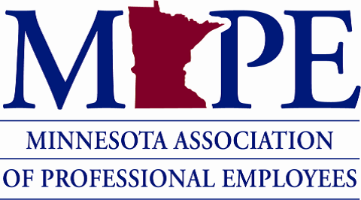 | Date: Wed. Feb. 8th, 2023  Time: 12pm

Topics | Notes | Additional notes and Action Items
Introductions | - President – Paige Wheeler, paige.wheeler@normandale.edu  - Rae Simonson – Treasurer, rae.simonson@normandale.edu  - Ted Scamp – Secretary, ted.scamp@normandale.edu
Contract Action Teams (CAT) (5 minutes) | - Guest speaker: Theresa St. Aoro  - https://mape.org/getinvolved | At-Large Negotiator; helping with Region 13.  Tsaoro@MAPE.org  Looking for recruiting to have more members. More members boosts negotiation support when meeting with MMB.
Contract Bargaining Platform | - https://mape.org/platform  - List of our biggest priorities going into contract negotiations with MN Management & Budget (MMB)  - MAPE is trying to get 8,600 signatures from across the union in Feb. to show our support for the bargaining platform. Takes 1 minute to sign: https://mape.org/platform | Sign the online bargaining platform (takes 1 minute): https://mape.org/platform  Sign up for rapid text response in order to help with negotiations, like in a rally.
Special Elections | - Open Local 1302 Positions: Vice President & Membership Secretary  - Nominations close TODAY, 2/8/23  - To nominate someone, or yourself, email SWElect@mape.org. You must be a MAPE Member to hold office.  - More information | VP supports Paige if she’s not available for events. Membership Secretary supports efforts to convert non-members to become members.
Budget Ideas | - 2023 Budget  - How do we want to use our 2023 “Donations/Good & Welfare” $2,000 budget?  - Member Assistance Fund: Some Locals allocate a portion of their budget to support members in need (i.e. $1,500-$2,000 and give $50-$200 per request). Sample policy from Local 1702.  - Nonprofit donations | Discussion about how to apply and how to get funds to the member that needs it quicker.  Paige reaching out to other Local Presidents about their process for vetting/approving Member Assistance Fund requests.
Meet Your Local Colleagues (time allowing) | - Introduce yourselves: Name, work site, job, and something that is giving you joy
Other topics?
Next Local Meeting | - Wed. April 12th 2023, 12-12:50 pm via Zoom: https://minnstate.zoom.us/j/95220479029  - June meeting hybrid or in-person | Attending people are in favor of in-person meeting for June.
Questions?

