MAPE Local 1302 Meeting Agenda | 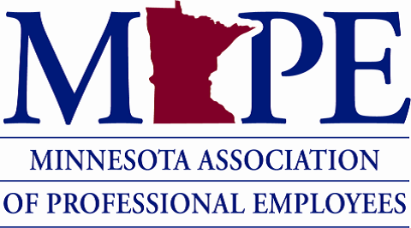 | Date: Wed. Dec. 14, 2022  Time: 12pm

Agenda Items | Discussion Points | Action Items
Members vote on Local Budget for 2023 | Only members can vote  Vote by show of hands  Not set in stone: we can change how we spend the money if needs or priorities change if Members approve at a local meeting | Questions during discussions: About social events, about charitable donations. The budget passed.  Passed 2023 Local 1302 Budget
VP and Membership Secretary positions open | Email paige.wheeler@normandale.edu if interested
Anything else?
Next meeting: Wed. Feb. 8th 12-12:50 pm via Zoom: https://minnstate.zoom.us/j/95220479029

