Local 301 Membership Meeting
Tuesday March 9th, 2021, 12 pm – 1 pm, Microsoft Teams
Meeting called to order at 12:05 pm by Vice President Snyder
Attendees: 35
Welcome/Announcements, Mark Snyder, Local Vice President
- Summit with the Governor
Wednesday, March 10th is the Summit with the Governor from 12-1pm on Zoom
  - Follow MAPE on Twitter (@mapemn) if you aren’t signed up to attend and share your thoughts
  - Contact your state legislators following the Summit to encourage them to support MAPE in our contract negotiations.
- Staff Telework Survey
There will be a staff survey on telework coming soon as the agency continues planning for staff return to offices after vaccinations. Encourage your coworkers to fill it out as well.
- Mark handed off announcements to Brett Nagle, Local President – welcome back, Brett!
  - Brett provided a few updates and reminders:
    - Brett reiterated the importance of filling out the staff telework survey. Before the pandemic, telework was largely based on supervisor discretion. This is an opportunity to encourage management to maintain work space flexibility.
    - Brett also brought up a discussion from Meet and Confer (https://mape.org/committees/meet-and-confer-committees/pollution-control-mpca) regarding staff’s request for gender neutral showers.
      - Management estimates an addition would require $20-30k for planning and over $300k to install. They cited a cost of renovating the existing space at over $1M.
      - Because of this high cost, we would like member feedback on the importance of pursuing this and/or alternatives ideas you may have to approach this.
    - COVID reminder – staff have been told to expect to telework until June, but there has been some discussion about changes coming sooner with the return to office and how to conduct fieldwork. This is a reminder that if there is something you hear that troubles you with these transitions, please reach out to let us know at mape_pca@mape.org.
Treasurers Report, Anne Morris, Local Treasurer
- Anne introduced herself as Local 301's treasurer.
- Lunch Donation
During the last month, Anne got access to a debit card and the checkbook to continue lunch donations.
  - Recipients for our 2021 monthly lunch donation:
    - Jan 2021 – Every Meal
    - Feb 2021 – Second Harvest Heartland
    - March 2021 – Volunteers Enlisted to Assist People
- Local Audit
Audit is coming up this week – thank you to the volunteers that will be supporting that audit!
Board of Directors Update, Shanna Schmitt, Regional Director
- Shanna introduced herself as the Regional Director.
- February Board of Directors Update
Shanna provided updates from the February 19th, Board of Directors meeting:
  - MAPE has a circle project that you can join and sign up to through the MAPE portal.
    - Mar 10 & 24
  - If you are redeployed, you will be assigned to a new local. If you’d like to stay with Local 301, please email Davia Curran at MAPE Central (dcurran@mape.org).
  - Political Council and MAPE Central are looking for members willing to
    - Attend Day on the Hill (DOTH)
      - No specifics yet on timing, but there is a discussion for a targeted DOTH for BWSR, MPCA, and DNR. Meet & Confer Team will communicate more details once they are confirmed.
    - Attend specific meetings or log into a virtual event
    - Share your stories and work successes
    - Become a Steward – you can sign up through MAPE portal and join upcoming trainings.
  - Working Class History course is available at New Brookwood Labor College
  - MAPE newsletter is now weekly
  - Donation was approved for $5,000 to Teamsters Local 120
    - To act in solidarity of people striking, please consider not purchasing from Marathon and Speedway
  - The Region 3 Director position (Shanna’s position) is up for election this spring. If you are interested or would like to discuss it further, contact Shanna (shanna.schmitt@state.mn.us or 651-757-2697). Nominations opened on January 28th.
    - Statewide positions up for election are: SW VP, SW Secretary, SW Trustees (2), Political Council members (2), Organizing Council members (2)
    - Delegate Assembly is set for Saturday, Sept 18th – save the date and consider being a Delegate for Local 301 (we have 5, with the Local President as an automatic delegate, and then can have up to 5 alternates).
Steward Update, Barb Peichel, Steward
- Barb introduced herself as a 301 MAPE steward, cover for Kristin Kirchoff-Franklin, Chief Steward/Contract Negotiator
- MAPE Website
Barb provided tips on finding information on the MAPE website:
  - Check out the Hot Topics
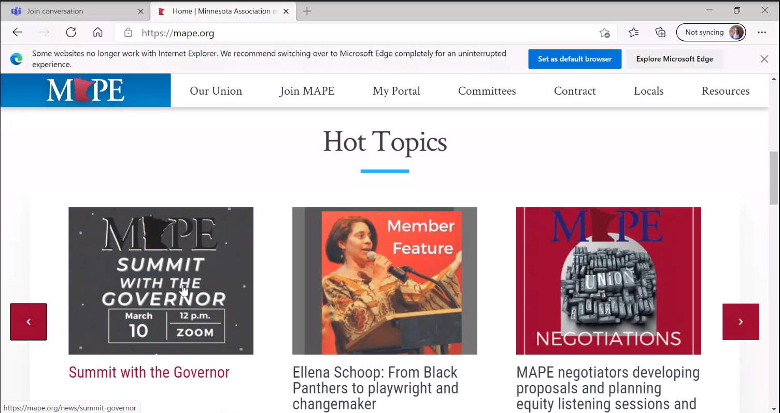
  - You can also find local executive team and steward names
    - One way to find your local is by entering your name in the search
    - Don’t need to go to a steward from your agency – can be any steward from Local 301.
      - Every steward has their own approach, but some will set up a confidential meeting on your calendar for a video/phone call to discuss your concern and help empower you.
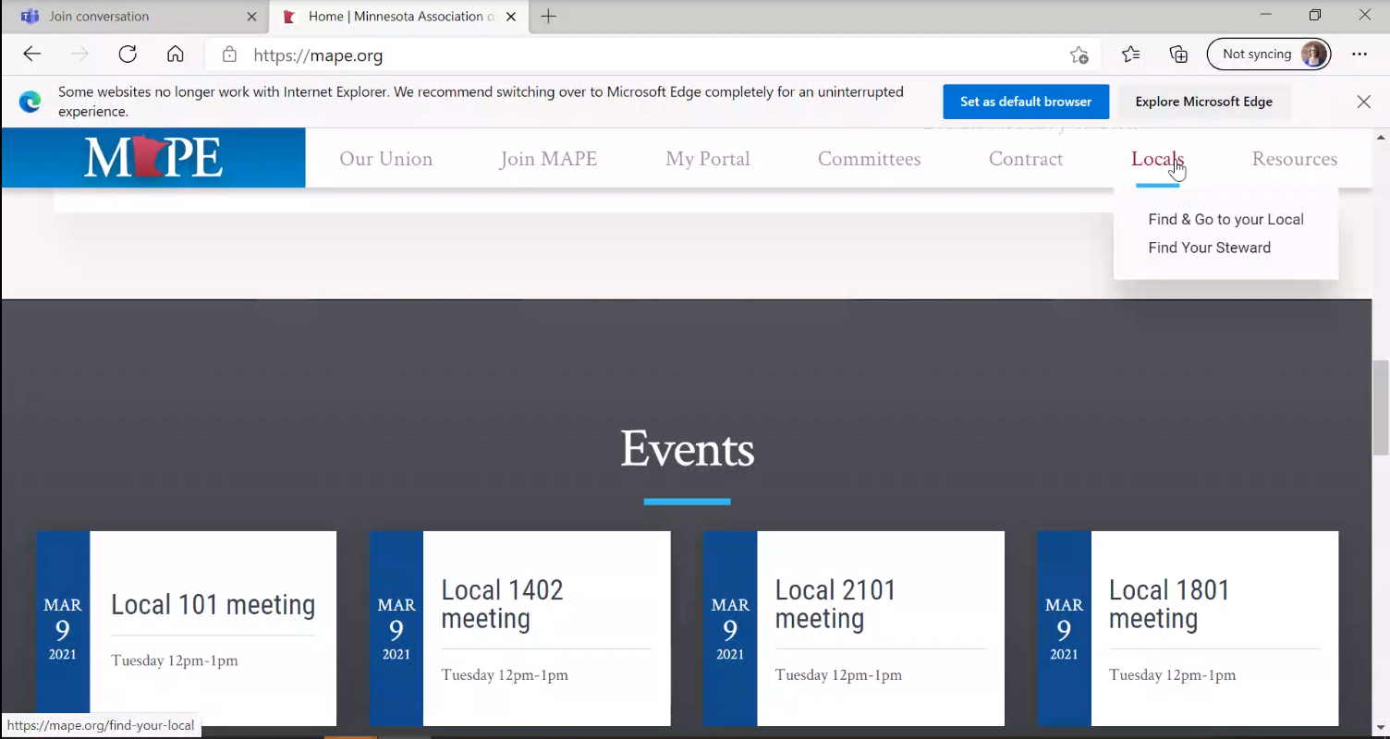
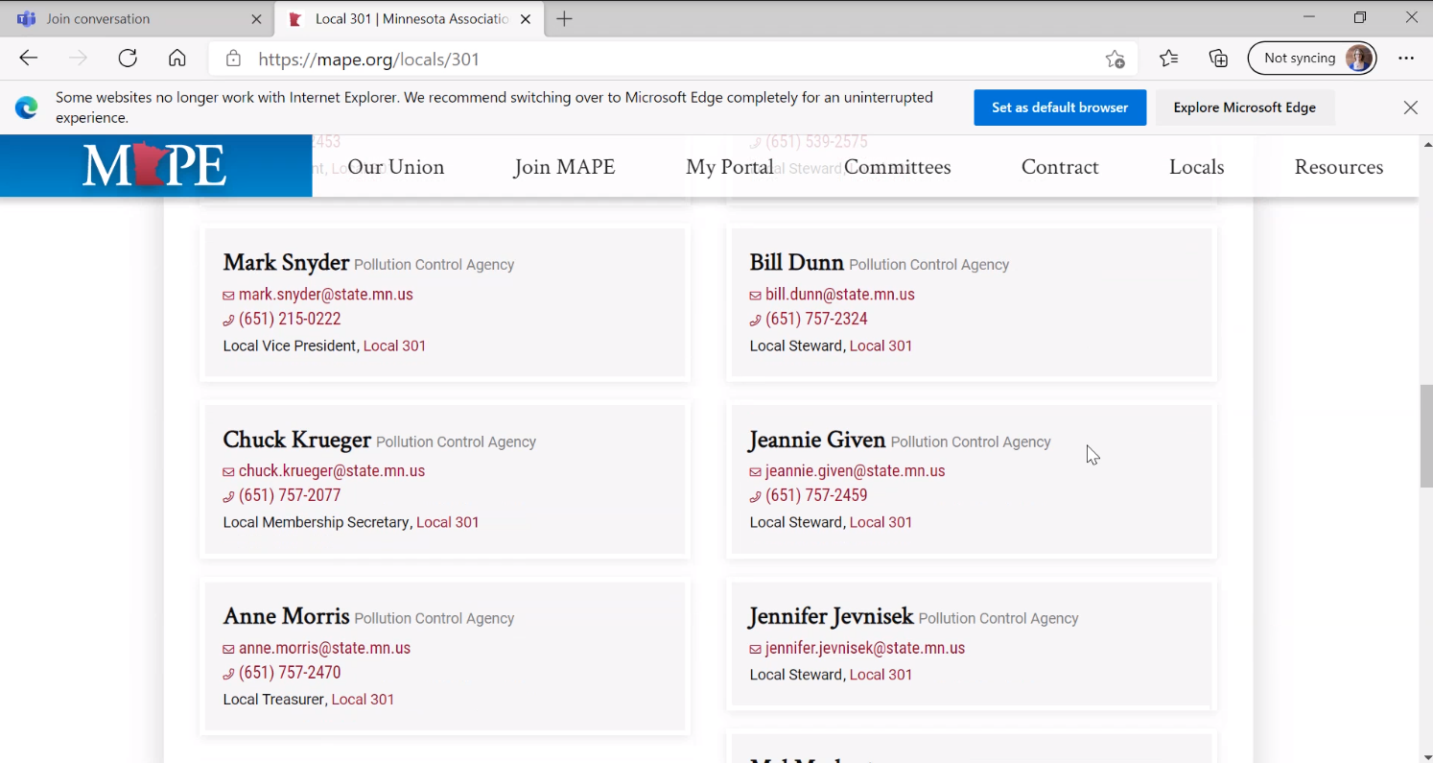
  - Go to the portal to sign up for Steward training
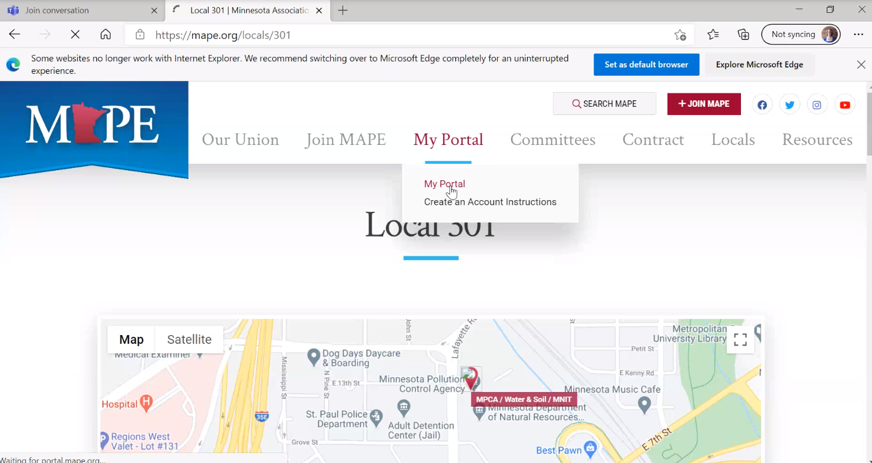
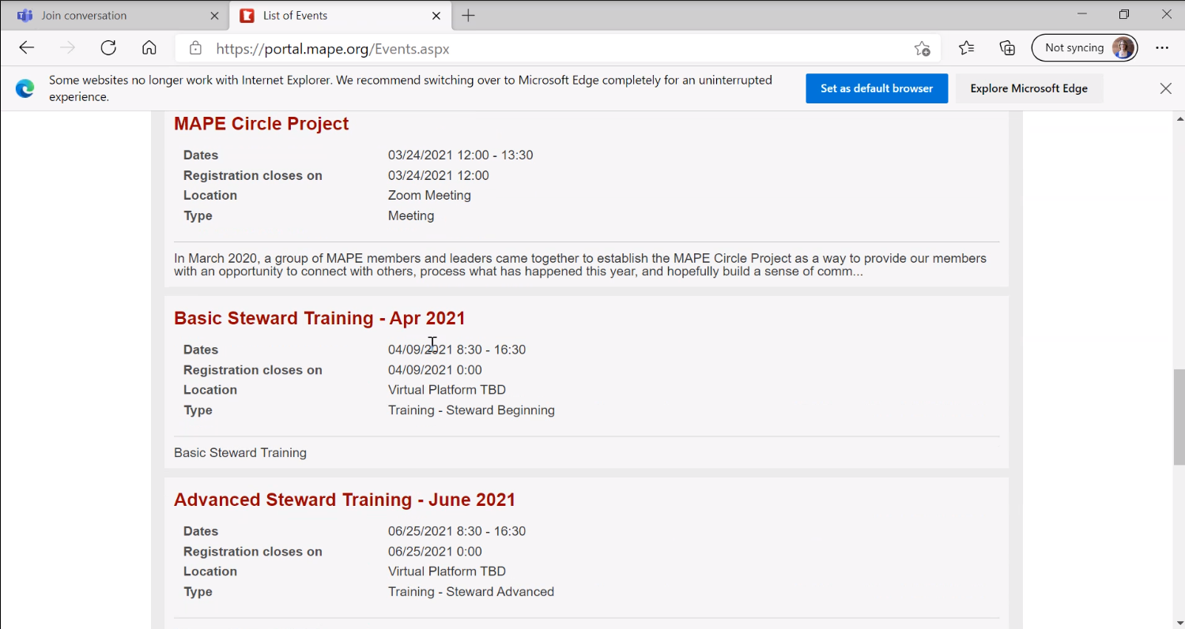
- Reach out if you’re interested and sign up for the training!
  - Time commitment can vary – may be one lunchtime steward meeting or it could be a question from a member that results in a 30mn meeting with them once a week.
    - Most often it is answering questions about the contract – you don’t need to be an expert though, because you work with other stewards.
  - Being a steward is counted as staff time.
- Local 301 Stewards: Jen Crea (MNIT), Bill Dunn (MPCA), Jeannie Given (MPCA), Jen Jevnisek (MPCA), Mel Markert (MPCA), Barb Peichel (BWSR), Melissa Wenzel (MPCA), Dave Wischnack (MPCA)
Membership Committee Update, Chuck Krueger, Membership Secretary
- Chuck introduced himself as the Membership Secretary.
- Chuck provided a quick membership update –
  - The Membership Committee reaches out to new hires at MPCA, MNIT, and BWSR that are in local 301, encouraging people to get involved in MAPE and becoming a member.
    - Offer to answer questions and discuss the contract (ex: how to get credit for vacation from previous employment)
    - Commitment for being on the committee is typically one 1:1 per month, and then a team meeting every other month
  - We don’t have someone in Municipal and Industrial Divisions – if you are in these divisions and willing to do outreach, let Chuck know.
- Membership Drawing
  - Last month, we voted on which businesses to include for the membership drawing:
    - Afro Deli
    - El Burrito Mercado
    - National Co-op Grocers
    - I Like You
    - Black Garnet Books
  - Winners!
    - Christopher Goscinak, Kathryn Grant, Kristin Mroz Risse and Jennifer Nguyen Moore
Negotiations, Mark Snyder, Local Vice President
- Kristin Kirchoff-Franklin was unable to join, so Mark provided an update.
- Mark shared that Negotiations is still writing and working through contract proposals.
- The opener with MMB is scheduled for April 6^{th.}
- Kristin and Claudia Hochstein will be reaching out when MAPErs are needed to join in negotiations meetings for support on specific proposals or overall.
Business Agent Update, Mark Snyder, Local Vice President
- Dave Kamper left MAPE and has a new job at Economic Policy Institute – congratulations to Dave!
  - Mark has a virtual thank you card for Dave Kamper – please sign it! https://www.groupgreeting.com/sign/58ddfd1c4d72a56
- Pete Marincel introduced himself as the temporary business agent until the position can be filled
  - Pete is happy to bring any updates that are wanted from the Local; will be working with the Meet & Confer team.
  - Contact information for MAPE Central staff: https://mape.org/contact-us
- Questions:
  - Is the hiring freeze going away with the surplus? Pete said that hasn’t been communicated at this point, there are still questions on the budget and operating adjustments.
  - Has MAPE heard if there is going to be a new COVID policy with vaccines/going back to work? Pete said he hasn’t received updates on changes to the existing or addition of new policies. If he hears anything, he will share back.
Closing, Mark Snyder, Acting Local President (Local Vice President)
- Jennifer Jevnisek said there is going to be an upcoming webinar on FMLA, so keep an eye out for it in the next newsletter.
- Help spread the word that we are still meeting and we are going to continue trouble-shooting the issues with the invites, so ideally we can have a recurring invite again.
Meeting adjourned at 12:54 pm by Vice President Snyder
Next meeting April 13th at 12:00pm.

