Local 301 Membership Meeting
Tuesday February 9th, 2021, 12 pm – 1 pm, Microsoft Teams
Meeting called to order at 12:07 pm by Vice President Snyder
Attendees: 23
Welcome/Announcements, Mark Snyder, Acting Local President (Local Vice President)
- Mark introduced himself as the acting Local 301 President. Brett Nagle is still out on paid parental leave, but he will be returning March 3rd.
- There appear to be issues with the meeting invite getting blocked for some member’s emails. The team will check with MNIT to find a way to resolve this.
Treasurers Report, Anne Morris, Local Treasurer
- Anne introduced herself as Local 301's treasurer.
- We haven’t made donations with our lunch budget yet, but will be focusing more on food banks per the request of the Local. We can donate up to $1,000 to each location.
- For 2021, Anne proposed our monthly lunch donation goes to:
  - Jan 2021 – Every Meal (formerly known as The Sheridan Story)
  - Feb 2021 – Second Harvest Heartland
  - March 2021 – Volunteers Enlisted to Assist People (VEAP)
  - April 2021 – The Open Door
  - May – North Point Health
  - June - East Side Neighborhood Services (ESNS)
- Jeanne Giernet made the motion to approve Anne’s proposal of organizations to receive our monthly lunch donation. Claudia Hochstein and Kristin Kirchoff-Franklin both seconded.
- Mark asked if anyone had questions or concerns, there were none. Motion was approved.
- In March we need to do an audit for 2020 – Anne will need 3 volunteers that aren’t officers to support in this process. Contact Anne if you’re willing to participate. It should only take a couple hours at the most.
Board of Directors Update, Shanna Schmitt, Regional Director
- Shanna introduced herself as the Regional Director.
- Shanna provided updates from the January 15th Board of Directors meeting:
  - MAPE has a circle project that you can join and sign up to through the MAPE portal.
    - Feb 10 & Feb 24 ; Mar 10 & 24
  - If you are redeployed, you will be assigned to a new local. If you’d like to stay with Local 301, please email Davia Curran at MAPE Central (dcurran@mape.org).
  - If you would like to participate in legislative actions, there are a few upcoming opportunities:
    - Attend Day on the Hill (DOTH)
      - No specifics yet on timing, but there is a discussion for a targeted DOGH for BWSR, MPCA, and DNR. Meet & Confer Team will communicate more details once they are confirmed.
    - Attend specific meetings or log into a virtual event
    - Share your stories and work successes
    - Become a Steward – you can sign up through MAPE portal and join upcoming trainings.
  - There are two new directors for Region 5 and Region 6, and there are two new trustees.
  - An apology statement from President Dayton was approved for the website – this was not discussed further, but Shanna offered to discuss with anyone that would like more information.
  - There is a lawsuit from Republican lawmakers suing MMB over the state contracts (including MAPE); however, it isn’t supported unilaterally by Republicans.
  - There is work underway for the new Tactical Goals Dashboard and on the new strategic plan.
  - Approved a $1000 donation to the Minneapolis Rent Control Coalition to help with technology and set up as they begin to develop their campaign.
  - The Organizing Council kicked off a statewide membership campaign, which aligns well with our Local’s membership engagement plan with the gift cards.
- The Region 3 Director position (Shanna’s position) is up for election this spring. If you are interested or would like to discuss it further, contact Shanna (shanna.schmitt@state.mn.us or 651-757-2697). Nominations opened on January 28th.
  - Statewide positions up for election are: SW VP, SW Secretary, SW Trustees (2), Political Council members (2), Organizing Council members (2)
  - Delegate Assembly is set for Saturday, Sept 18th – save the date and consider being a Delegate for Local 301 (we have 5, with the Local President as an automatic delegate, and then can have up to 5 alternates).
- If you want to participate in the process, you need to be a member by February 26th.
Steward Update, Kristin Kirchoff-Franklin, Chief Steward/Contract Negotiator
- Kristin introduced herself as the Chief Steward.
- MNIT also opted out of the early retirement incentive (ERI), like the MPCA.
- Kristin encouraged members to sign up to be a steward!
- Local 301 Stewards: Jen Crea (MNIT), Bill Dunn (MPCA), Jeannie Given (MPCA), Jen Jevnisek (MPCA), Mel Markert (MPCA), Barb Peichel (BWSR), Melissa Wenzel (MPCA), Dave Wischnack (MPCA)
Membership Committee Update, Chuck Krueger, Membership Secretary
- Chuck introduced himself as the Membership Secretary.
- Chuck reiterated the proposal introduced at the last member meeting that is intended to increase participation at monthly meetings and replace the birthday drawings.
  - What
    - Purchase $500 worth of gift cards, using the entire 2021 membership line item of the budget
    - For 5 months of 2021, give away $100 worth of gift cards each month ($25 increments)
      - Gift card drawings would replace the birthday drawings
      - Give away 4 gift cards each meeting, adding up to 20 winners total
    - If the proposal passes, consider proposing another 5 months and amend the budget
  - Rules
    - Must be present at the beginning of the meeting to win
    - Winners will be picked at random, and can only be picked 1 time/year
    - Random gift card will be sent to winners; team is willing to work with you if there are issues with random picks
  - Nominations (were unable to do bars because of limitations with alcohol)
    - Restaurants & Bakeries
      - El Burrito Mercado (Saint Paul)
      - Afro Deli (Minneapolis & Saint Paul)
      - Karibu Grocery and Deli (Saint Paul)
      - Green Garden Bakery (Minneapolis)
    - Book Shops & Crafts
      - Black Garnet Books (Minneapolis/Online)
      - Birchbark Books (Minneapolis/Online)
      - Moon Palace Books (Minneapolis/Online)
      - I Like You, I Like You Too (Minneapolis & Saint Paul/Online)
    - Coffee
      - Dunn Brothers on Grand (Saint Paul)
      - Roots Roasting (Saint Paul/Online)
      - Bootstrap Coffee Roasters (Saint Paul/Online)
    - Co-ops
      - National Co-op Grocers
  - Chuck launched the Mentimeter voting with attendees to vote for where the gift cards will be purchased. Attendees ranked all the selections based on preference (1 to 12).
    - 17 people voted, and the winners were:
      - Afro Deli
      - El Burrito Mercado
      - National Co-op Grocers
      - I Like You
      - Black Garnet Books
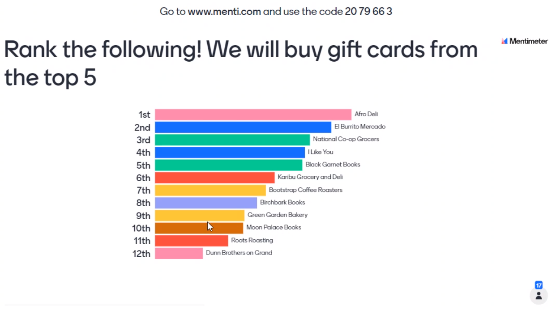
Meet and Confer Update, Anne Morris, Temporary MPCA Meet and Confer Lead
- Anne introduced herself as the temporary MPCA Meet and Confer lead
- There was a Meet and Confer meeting on Jan 19th with MPCA leadership for 1 hour
- Topics discussed included:
  - Gender neutral showers
    - Management said they are too expensive, so the team asked for quotes
  - Student loan reimbursement
    - Management said it is too expensive, so the team asked for budget details
  - Early retirement incentive
    - Management said that staff should use the Salary Savings Leave (more information on the Lorax on the page for Supervisors)
    - It is unclear on the requirements for this
  - Reallocation and career advancement
  - Telework
  - EJ and equity in our work and office
- Topic to be discussed next time is transit options and how to incentivize them
- Anne encouraged members to continue sharing information because MAPE member voices and perspectives are so important for these discussions with Management.
Negotiations, Kristin Kirchoff-Franklin, Chief Steward/Contract Negotiator
- A survey done in December – Dave Kamper and Kristin presented on the key findings from that survey. The presentation slides and a summary report are going to be sent to the Local for further review.
- Dave provided a full overview, including the following highlights:
  - Demographics – our Local is younger and more educated than other Locals
  - Our local is more satisfied than other locals with: Job security, Job safety, Professional development for advancement, Participation in decision making, Mentoring, Opportunities to perform quality work, Whether an employee’s opinion is valued
  - High priorities for our local are: Flex time, Severance at retirement, Paid leave, Opportunities for advancement and/or development
  - Large problems identified by our local are: No position for me to advance to, Jobs aren’t opening up because people stay in them a long time
- Kristin asked members to view the results and consider these questions:
- What is one thing you learned from the survey results?
- What could be added or changed to the contract issues?
- “Pie in the sky” – What would you want if you could have anything?
  - If you’re willing to share your thoughts about the survey, contact Dave, Claudia, and/or Kristin.
- March Action will be a virtual meeting with the Governor to kick off our public contract campaign.
  - We are aiming for 500 total MAPErs and at least 30 from Region 3. Please plan to join if you can (it will be during the day)!
  - The team will share the date as soon as it is sent, and then there will be a link to a Google doc to sign up to attend.
  - During this call we will have specific requests for the Governor to support us.
- Kristin provided a negotiations update that the proposals are currently being written and reviewed as a team based on the survey results and listening sessions.
  - The opener with the State is scheduled for the beginning of April.
  - We will need people to join us (virtually), so keep an eye out for sharing your stories and support.
  - Let Kristin know if you’re willing to be a part of a Contract Action team.
Closing, Mark Snyder, Acting Local President (Local Vice President)
- Help spread the word that we are still meeting and we are going to figure out the email blocking that is happening and preventing invites from getting to members.
- Mark will send out an email explaining the issues since the blocking only seems limited to invites.
Meeting adjourned at 12:55 pm by Vice President Snyder
Next meeting March 9th at 12:00pm.

