24 August 2020

TO: Mr. Landers, MAPE Elections Committee Former-Chair

FROM: Megan Dayton, MAPE President

SUBJECT: Apology letter, as directed by MAPE Board of Directors

Dear Mr. Landers:

On 24 August, the MAPE Board of Directors issued corrective action based on an investigation conducted by Ann E. Walther of Rice, Walther & Mosley, LLP. In accordance with this decision, this letter serves as an apology for publicly accusing you of blackmail that “doubtlessly resulted in a sabotage of his character and reputation,” as Ms. Walther concludes in her 12 June 2020 Summary of Investigation.

Yours,
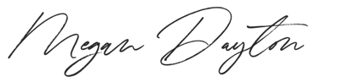
Megan Dayton | President
Minnesota Association of Professional Employees

