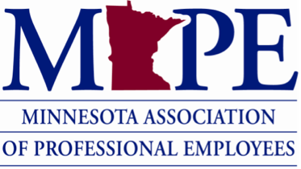

Discussion Questions for Contract Info Meetings

- Send members into breakout rooms and ask them to answer the following questions.

What is the value of the union for you?

How did you show your support for that value during negotiations this cycle?

What’s something in the contract that’s important to you?

Give them a few minutes to talk about it in small groups, then bring everyone back to main meeting room.

- Follow up talking points:
We saw unprecedented participation by members in the negotiations process this cycle, which led us to key themes including historic wages, health care without out-of-pocket increases and a workplace grounded in benefits, flexibility and equity. We just completed a contract tentative agreement that includes 5.5% and 4.5% raises. Other wins include CERP, telework appeals process, pilot extensions, temporary unclassified wins, fertility services made permanent, expanded definition of family for sick and bereavement leave and more.

Though we didn’t get everything we asked for, and our wage increases fell short of where we hoped, we ended up with wage increases bigger than we’ve seen in more than 30 years.

How are you feeling about this tentative agreement?

Have members raise their hands and answer individually or ask them to put it in the chat.

- Recruitment talking points (making the ask):
You must be a member to vote on the contract. Now’s a great time to join MAPE so you can cast your ballot and let your voice be heard. Every vote matters - it sends a message to MMB that our jobs matter and we deserve a fair contract.

Our power to negotiate strong and fair contracts ties directly to the strength of our membership numbers.

Will you be part of this team and join MAPE today? https://mape.org/join-mape

