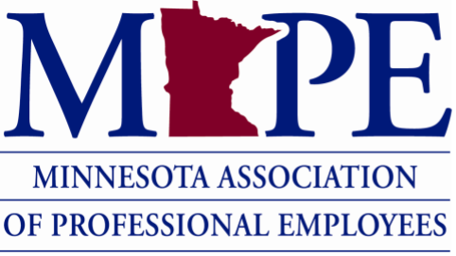
Dear Union siblings,
The labor movement was built by workers coming together to strengthen their voice and improve the livelihoods of their communities. You may have received communication from anti-union groups in your email or at your home address. These groups target unions across the country, including MAPE. They often present themselves as pro-worker. However, they are front organizations backed by enormously wealthy companies and individuals.
These are the same anti-union groups that funded the Janus v. AFSCME lawsuit in 2018 which eliminated the ability of MAPE and other unions to collect fees from non-members they are forced to represent. These billionaires are the ones supporting the president’s executive order stripping federal workers of the ability to collectively bargain with their government agencies through their unions.

Simply put, they are committed to silencing workers’ voices.

These anti-union groups see our success and our commitment to unions as threats.

Using your voice to create power as you stand in unity with your fellow MAPE siblings earned us our contract. Putting your dues behind your power is what garners important benefits including:

- Job elimination protections
- Higher wages than non-unionized workers (19.4% more on average)
- Significantly better and more affordable health care
- Protection from retaliation
- FMLA
- Fair workload expectation
- Safe reporting channels
- Collective bargaining strength
- And more!

Your membership in our union brings power to you and your co-workers. Our union makes Minnesota one of the best places to work in the country.
Don’t fall for the $900 distraction

Why do you think these anti-union groups fight so hard? Do you think they really care if you have more money in your pocket? No, they don’t. What’s in it for them? These billionaires want to create a work environment that only benefits those at the top. At the end of the day, without a union, which is what they want, YOU LOSE – they win.

Here’s what does change when workers leave the union:

- You lose collective power
- You weaken enforcement of our contract
- You make it easier for management to quietly roll back protections

Right now, our legal rights as workers are constantly under attack. These rights are not free. They exist because workers stand together.

Those anti-union groups want you isolated. They want you silent. They want you alone.

Stay united. Stay protected. Stay MAPE.

Solidarity matters — especially now.

