Agenda for Tuesday, October 14, 2025 Noon to 1:00 PM
MAPE Local 1801 Monthly Zoom Meeting
- Roll Call- Taken from Zoom screen

  - Ben Nwachukwu
  - Taralee Latozke
  - Chris Henderson
  - David Plagge
  - Ellen Preisinger
  - Erin Barker
  - Heather Wright
  - Jennifer Loeschen
  - Jim Levitt
  - Josh Kircher
  - Lorena
  - McKenzie Kack
  - Nichole Bredeson
  - Shawna Ehlenbach
  - Brmontro
  - Paula Paplow
  - Nathan Mullendore

2. Report from Officers
a. Regional Director update
b. Treasurer’s report (See documents Attached)
Income from dues: $626.25
Ending Balance: $28,863.35
c. Membership Secretary’s report
Overall: 55.41% Membership (down from last time)
New members:
Jace Jackman-DNR (Ortonville)
New Hires-Non-members:
Eh Paung -PCA (Marshall)
Ciera Conrad – MNSCU (Hutchinson)
Brent Lamfers- MNSCU (Marshall)
Laura Herman -VA (Luverne)
d. Local Presidents Committee updates: No update
d. BA Updates: No update
3. Delegate Assembly
a. Resolutions Results
• Individual and Group Meal Allowed for Hybrid Meetings
• Locals Providing Out of State Travel Allowed
• Stipends Increased and Expanded
• Fixing the Date of Delegate Assembly Submissions
- Resolution Added at DA: Defense of Immigrant Rights—This resolution called upon MAPE to protect the well-being of immigrants in our workplace and communities and remain in compliance with statutes and regulations.
2025 Delegate Assembly features six new breakouts, five passed resolutions | Minnesota Association of Professional Employees

- Most resolutions passed, though there was some uncertainty about one related to expanded stipends.
- The assembly emphasized responsible spending and flexibility for local decisions on compensation.
- The final language of the resolutions is pending publication on the DA website.

b. Budget Results (See budget breakdown on final page of agenda)
- The budget breakdown showed a surplus for 2025, with funds reserved for a crisis/strike fund.
- For 2026, a deficit is projected due to switching membership tracking software.
- Dues are now on a sliding scale based on income, with a cap increase for maximum contributors.

4. Updates on: Upcoming Elections 1801 Local Officers President, Vice President, Membership Secretary
- Internal elections are upcoming, with some positions (e.g., membership secretary) still vacant.
- Nominations and acceptances for president and other roles were discussed.
- The election process and timeline will be clarified in future meetings and communications.
MAPE Internal Election Information | Minnesota Association of Professional Employees
Other Topics
- Plans for traditional in-person holiday meetings at various locations (Hutchinson, Willmar, New Ulm, Marshall) were proposed, with volunteers sought for coordination.
- Updates on prize winners and other committee matters were pending further follow-up.
5. Change in date for next local 1801 Meeting due to conflict with holiday. Rescheduled for 11/18/25 via zoom at noon-1:00.
a. Will begin planning 2026 local budget.

6. Adjourn

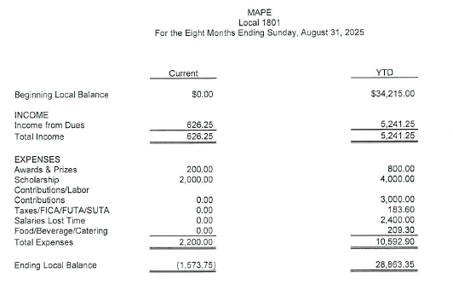
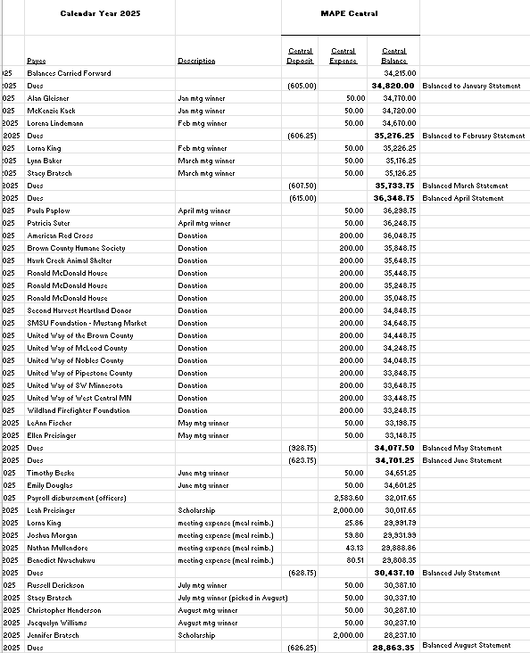

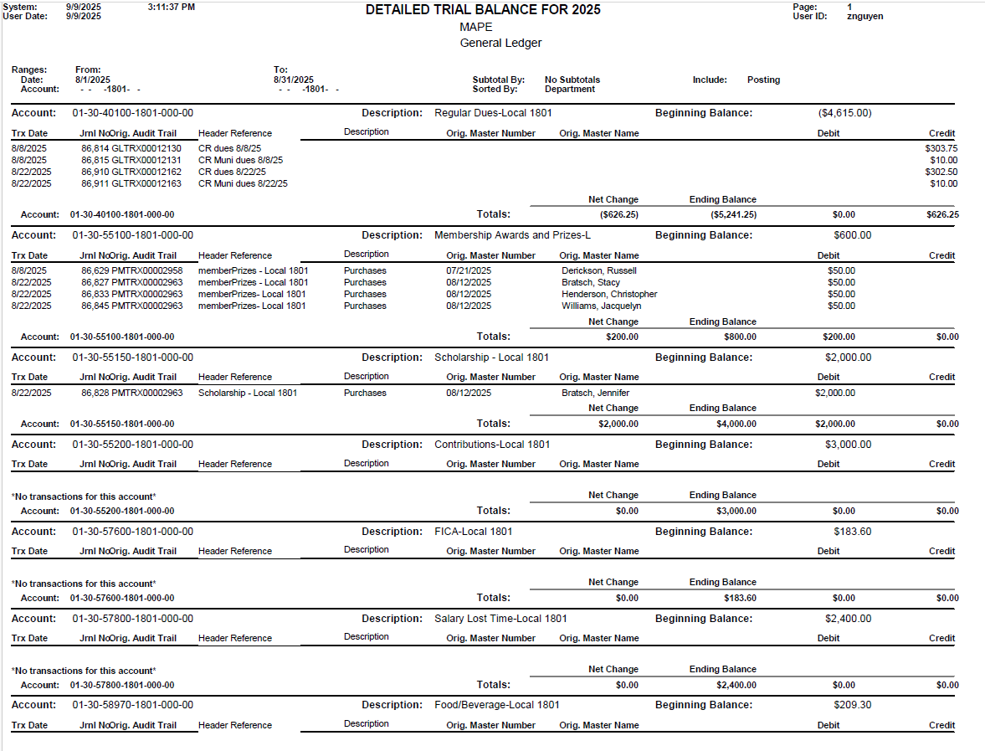
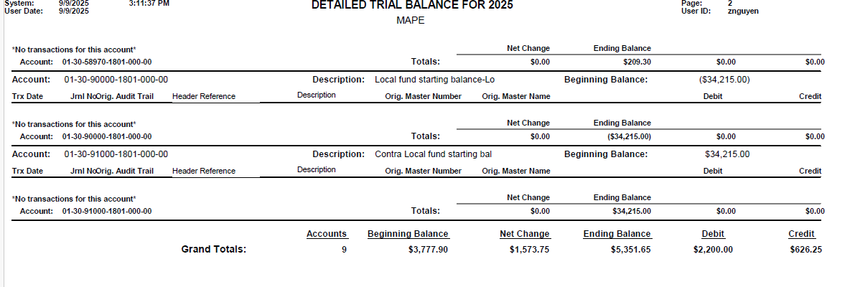
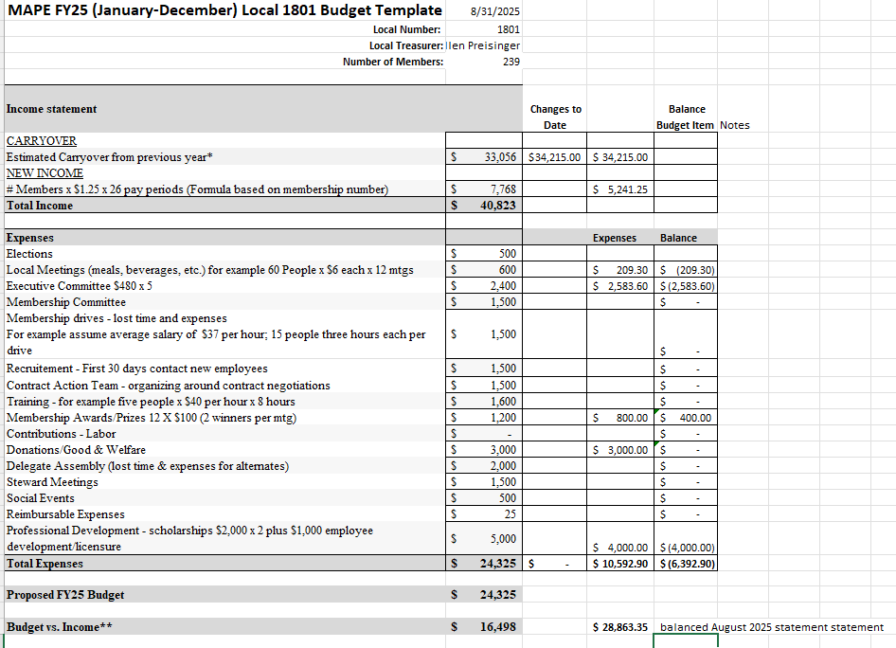
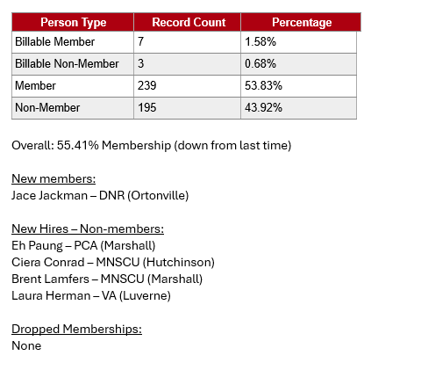

5 resolutions.
1. Individual and group meals allowed for hybrid meetings. Allows locals to decide whether to allow for meal reimbursement when there is a hybrid meeting. The logic is that with RTO some are in the office and some are at home and prevent virtual attendees from receiving meal reimbursement. The meal allowance policy is amended to allow fir such reimbursement if approved by the local, regional or statewide governing entity.

2. Locals providing out of state travel funds. Locals, if they so choose may now authorize out of state travel funds if authorized by the local. These would be for things like Labor Notes which provides training on union organizing.

3. Stipends increased and expanded. If a local chooses to do so, it may expand stipends to more than just officers and may offer up to 52 times the average hourly wage (about $2,186.60). This changes financial policy and finance work group should come up with a process if locals decide this is what they want to do.

4. Fixing the date of delegate Assembly submissions. Submissions, whether resolutions or proposals, may be received no later than 11 weeks before and no earlier than 15 week before Delegate Assembly.

5. Resolution submitted at Delegate Assembly set a policy for a level of cooperation for MAPE members regarding immigrants of unknown status. MAPE policy is to do what we are legally required to do, but to not assist federal authorities. I do not have this resolution in front of me so I am not entirely sure regarding the wording.

Budget Approved

Dues cap was moved to $34.50 in accordance with the percentage increase in our contract.

Dues income for first half of 2025 is $4.7 million. Expense at $4.1 million. There is money in the bank for our rainy day fund.

For 2026, Income $9.916 million. Expenses at $10.299 million. Will move $500,000 from a reserve fund to help pay for a one time expense, software to manage member related databases, and will result in a surplus of $117,000.

STATEWIDE MAPE BUDGET APPROVED AT DELIGATE ASSEMBLY
