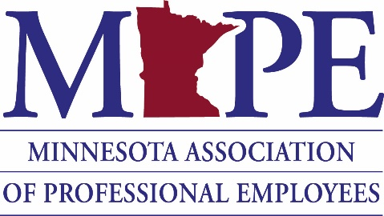
MAPE Accomplishments
For more than 35 years, MAPE members like you have made Minnesota a great place to live, work and play. Together, we are building a stronger union that serves as a cornerstone for quality public services and good jobs for all state professional employees.

Wages and benefits - MAPE has successfully fought for wage increases for its members during
difficult economic times:
- In the last two contracts, MAPE has negotiated a 9 % cost of living adjustment in addition to available step increases (3.55%).
- Market value increases to out-of-pocket maximums, co-pays and deductibles.
- Increased orthodontia benefits from $2,4000 to $3,000. Vision coverage will be available in 2021.
- MAPE-represented employees continue to pay just 5% of single premiums and 15% of family premiums, much less than the average non-unionized public sector worker and private sector employee are paying.
Member advocacy
- Student Loan Payment Reimbursement A new letter has been included in the contract allowing agencies the option of offering student loan payment reimbursement not to exceed $5,000 per calendar year or $25,000 over five years. Participating employees will be required to have been employed for 18 months and remain employed for one (1) year after receiving a reimbursement payment.
- Paid Parental Leave (PPL) MAPE led the battle for six weeks of PPL for all state employees. New moms and dads now have access to paid time off after the birth or adoption of a child.
- Union representation of wronged employees has resulted in many success stories including several reinstatements of jobs with full back pay, $60,000 awarded to a member for wrongful termination and reinstatement of a member who had not been given the proper disability accommodations.
- See backside for more stories

Political accomplishments
- Pension Reform MAPE helped unanimously pass the largest piece of pension reform in state history, providing pension sustainability for the next 30 years.
- Avoided IT outsourcing We successfully fought against the decentralization of MnIT services and outsourcing of MAPE employee’s work.
- Prevented Agency Cuts MAPE helped prevent massive cuts to state agencies including Human Rights and the Department of Revenue.
- Protected Contract Approval Process Maintained current legislative contract interim approval process rather than go to a majority rule process.
- Fought for Contract Funding Fought for inclusion of operating budgets in agency budgets to prevent cuts, job loss and ensure funding for MAPE’s 2020-2021 contract.
- Prevented the passage of legislation severely limiting the ability of workers to telecommute.
- Helped preserve investments in health care that would have resulted in $750 million in state cuts.
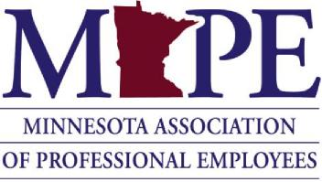
Successful agency accomplishments

MNIT
- We are fighting the agency’s misuse of the temporary unclassified designation. MAPE leaders have brought this issue to multiple MNIT commissioners, the Governor’s Chief of Staff and the commissioner of MMB. Member leaders and staff continue to work toward a solution, so the agency uses the designation properly and these employees are treated fairly.
- Through supplemental bargaining we secured a student loan repayment program, which will be included in the 2019-21 contract.
Revenue
- We expanded the professional development bonus to all MAPE-represented employees at Revenue and added additional professional certifications to be eligible for up to $2,000.
- We continue working with management to overhaul Revenue’s sexual harassment complaint process, so it is more transparent, gives employees more rights and improves training and communication.
- Through meet and confer, pushed management to install wheelchair accessible doors to bathrooms on each floor of the central office (Stassen) building.
- That team also secured a water filtration system in the St. Cloud office after learning about the poor quality of drinking water.
- MAPE leaders continue fight for a student loan repayment program at the agency.
DHS (DCT and Central Offices)
- Through supplemental bargaining we expanded the student loan repayment program beyond a small group of Direct Care and Treatment employees. This expansion will be included in the 2019-21 contract.
- MAPE continues to work with other unions to improve workplace safety at patient facilities.
MDH
- Improved the on-call and call back process, which will be included in the 2019-21 contract.
- Secured a process for giving part time employees the ability to use vacation to make up for loss holiday pay.
MDE
- Through meet and confer we created a fair process for the balancing of hours for exempt employees and an equitable/transparent process for flex schedules and teleworking.
- We continue framework for developing a professional development program.
- Through supplemental bargaining, we have developed a One MDE Council on Diversity, Equity and Inclusion.
MN State Colleges
- Expanded a vacation accrual credit to include private sector experience and held each college and university accountable to ensure the benefit is properly applied.
- We used the meet and confer process at M State Community & Technical College to end the practice of requiring employees who work 32 hours per week to use vacation time to make up for lost pay during holiday weeks.
- Through supplemental negotiations, we secured and expanded a tuition waiver program for MN State employees that allows member to use the waiver for two or four-year colleges regardless of where they work.
Lottery
- MAPE utilized the supplemental bargaining process to create a sales bonus program for employees.
DOC-MCFs
- Our #1 priority in this agency is safety. We have addressed several issues of workplace safety with agency commissioners and wardens. This continues to be an ongoing effort.
DOC Field Offices
- Members organized around workload issues, securing an additional 3.5 FTEs at the Moorhead office.
Human Rights
- Garnered the commissioner’s support for pay equity bargaining and revising positions descriptions to accurately reflect the work the members are doing.

