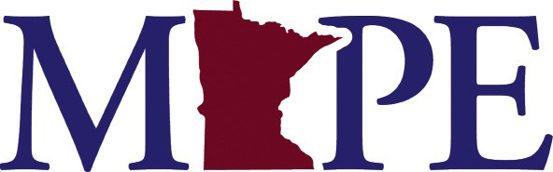

Local 101

Your points of contact

Looking for something?
We can help!
Know your network.

Local Officers: Members elected to lead the local
They plan regular membership meetings and ensure all members stay informed about important issues.

Stewards: Trained member volunteers. Find your stewards: www.mape.org/my-mape/stewards/find
They know the contract and make sure it’s being followed appropriately in your workplace.

Business Agents: MAPE staff
They are trained labor relations and organizing specialists.

Contact information

Local Officers

President:
Liz Samuel
(651) 259-5427 Liz.Samuel@state.mn.us

Vice President:
Harland Hiemstra
(651) 259-5765
Harland.Hiemstra@state.mn.us

Secretary:
Monica Weber
(651) 259-7560
Monica.Weber@state.mn.us

Treasurer:
Al Stevens
(651) 259-5239
Al.Stevens@state.mn.us

Membership Secretary:
Frances Li
(651) 284-5296
frances.li@state.mn.us

Regional

Director:
Darci Wing
(651) 284-5114
Darci.Wing@state.mn.us

Chief Steward:
Jed Becher
(651) 259-5450
Jed.Becher@state.mn.us

Negotiations Rep:
Harland Hiemstra
(651) 259-5765
Harland.Hiemstra@state.mn.us

MAPE Staff

Business Agent (Contract Enforcement):
Kathy Fodness
(651) 287-8755
kfodness@mape.org

Business Agent (Organizing)
Dan Engelhart
(651) 287-8752
dengelhart@mape.org

