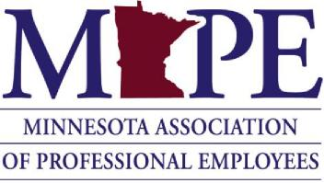
Local Budgets Policy
Original Policy Approval Date: 6/20/2003
Board of Directors Revision Date: 5/6/2010, 6/21/2013, 5/16/2014, 6/19/2014, 2/15/2019
Summary: Guidelines for local budgets and allocations.
Policy:
- Local budget
Locals will prepare an annual budget and submit their budget to the Board of Directors' Finance Workgroup by January 1st of each year.Establishing a local budget and approval by membership allows local officers to spend funds throughout the year within their budget.
Locals that do not submit a budget in a timely manner may be subject to losing access to their local funds until an approved budget is in place.
- Budget supplement
Locals with 200 or less MAPE represented employees shall have funds replenished monthly with $1,000 if their balance falls below $1,000. Money will be used for operations of the Local in providing services to their members. A budget supplement may be obtained by any local through a request to and approval by the Board of Directors' Finance Workgroup and the Board of Directors.
- Training and local/regional election costs
Costs associated with local elections (including special elections) will be covered by MAPE Central.

Training costs for lost time, mileage, meals, lodging and any other expenses will be covered by the MAPE Central training budget for statewide training initiatives. This also applies to locally initiated basic steward training of five or more members at one location. This does not prevent a local from funding additional training for their officers or members.

- Financial ramifications of members changing locals
When buildings are closed or when 15 or more members are moved between locals, the director(s) of the affected region(s) shall meet with the leadership of the locals that are involved and mediate a solution. If all attempts at resolution are exhausted, the issue shall be presented to the Board of Directors' Finance Workgroup for resolution, with final approval by the Board of Directors.

