**20240319 Agenda**

20240319 MAPE Local 1002 Monthly

Time: Mar 19, 2024 11:30 AM Central Time (US and Canada)

Join Zoom Meeting

https://us06web.zoom.us/j/88232570591

Meeting ID: 882 3257 0591

One tap mobile

+13052241968, 8232570591# US

+13092053325,88232570591# US

Dial by your location

• +1 305 224 1968 US

Meeting ID: 882 3257 0591

Find your local number: https://us06web.zoom.us/u/kbdhe1qVIs

**President: Saadia Mohamed**

Welcome

* 2024 Legislative session, actively advocating for bill to restrict agency classified and unclassified positions, championing for striking workers and embracing PELRA guidance.
* Please feel free to reach out to leadership to be a part of our local.

**Treasurer’s Report: Kristine Anderson (2)**

Audit Update

* Finished audit, sent to MAPE.
* MD: We’re in strike authorization season: Several local unions are seeking strike authorization in the next few weeks. Interest in building Union to Union Financial support and mutual aid.
* Initial proposed language: An additional $1500 shall be allocated from the Local's reserve funds to be given to other unions that go on strike, including but not limited to the Minneapolis Federation of Teachers. In the event a Local meeting is not scheduled at a time that allows for a vote on the use of funds, the officers of Local 1002 are authorized to donate up to $500 per strike to other unions, with preference given based on the order in which requests for funds from striking unions are received.
* Motion to amend: Jackie B. Mike Dolbow seconds

Discussion

* Question: Can the funds be earmarked for specific purposes? Not all unions have strike funds. So we can likely request specific uses for our donation, but can't DEMAND it. We'd be putting some trust in the union leadership to carry out our request.
* Stipulation for supporting highest need personnel first.
* Proposed Friendly Amendment: When possible, the donation from Local 1002 will be prioritized for the lowest paid workers on strike.
* No objections to proposed amendment
* Vote on original proposal with friendly amendment:
* An additional $1500 shall be allocated from the Local's reserve funds to be given to other unions that go on strike, including but not limited to the Minneapolis Federation of Teachers. In the event a Local meeting is not scheduled at a time that allows for a vote on the use of funds, the officers of Local 1002 are authorized to donate up to $500 per strike to other unions, with preference given based on the order in which requests for funds from striking unions are received. When possible, the donation from Local 1002 will be prioritized for the lowest-paid workers on strike. Motion Passed, no objections.

**Meet and Confer: Michael Diedrich (5)**

Professional Development Update

* April 4, July and October dates unannounced, make up days unannounced.
* First All staff development day since 1997.
* Generated significant response, summary data reviewed, details in newsletter
* Shared information with administration. ADA: reach out to Lynn Link.
* Travel will be reimbursed based on if the travel to Hopkins is greater than travel to Stinson from original location. current understanding is that this would be mileage from your telework location, but I am not fully sure that is correct or HR's understanding. We will have the details nailed down shortly!
* Make up days will be in person

Future discussion session on MAPE statewide restructure

* There are conversations statewide on what MAPE restructure statewide will look like

**Membership: Holly Andersen and the Membership Committee (5)**

* Survey/poll on Newsletter Name
* 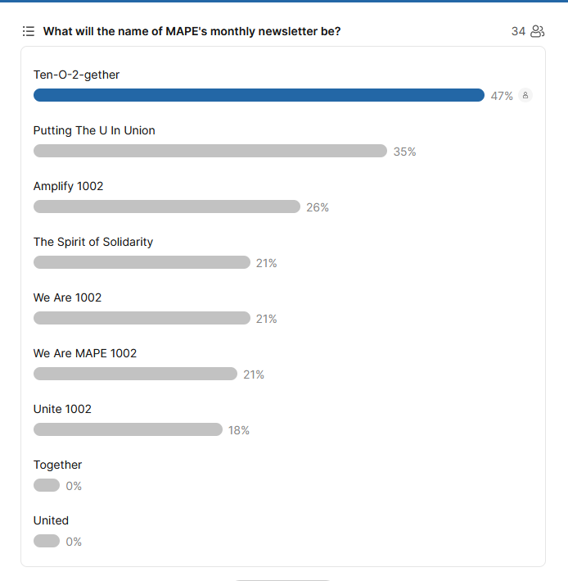
* 2 Membership Events in May:
  + May Day Trivia (workers of the world unite!)
  + Save the dates, May 9

**Discussion/Break out (30 minutes)**

**https://jamboard.google.com/d/17Trhcrikdswr-faUnSJzGgLHq_Aj-vj1Djh8tvo3djQ/viewer?f=1**

Same groups, ongoing brainstorms:

* Student Loans, Facilitator: Liz Vaught, Alina Campana
* Workload, Facilitator: Jackie Blagsvedt,
* Accessibility, Facilitator: Holly Andersen,
* Telework, Facilitator: Saadia Mohamed, Michael Diedrich

**Business Agent: Dan Engelhart (Jackie Blagsvedt, Region 10 Director)**

* Regional steward summit: Refining steward practices
* Elections for Meet and Confer (April Nom, May Election, June Seating)
* Negotiations Team (April Nominations, May Elections, June Seating)
* [Learn about the MAPE statewide restructure and complete the restructure feedback form](https://mape.org/restructure)

**Org Council: Sarah Weiss**

* No updates

**Raffle: Holly A to choose winners:**

* Nawid Raai
* Ann Iweriebor

**Closing**