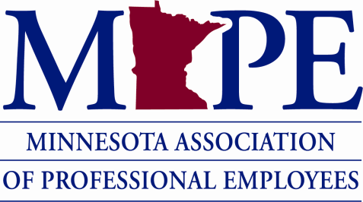

Date: March 29, 2023

To: Board of Directors

From: Statewide Elections Committee

Re: Special Election Results

For the 2023 MAPE Special Election, nominations opened on January 25, 2023 and closed on February 8, 2023. Overall, 47 people were nominated for 85 open positions.

Open positions included:
- four members of the Organizing Council
- one member of the Political Council
- two Trustees
- Meet and Confer Chair of the Minnesota Department of Human Rights and the Meet and Confer Chair for the Minnesota Department of Veterans Affairs
- three regional director positions (Region 6, Region 12 and Region 19)
- many local positions (including positions that have temporary appointments and those that are currently vacant)

Changes to the election rules were approved at the Delegate Assembly last fall so this is the first MAPE election where local nomination and election committees were not required.

Instead:
- Nominations for local positions were submitted by members of that local to the statewide elections committee at swelect@mape.org
- Nominations for regional positions were submitted by any member of that region to the statewide elections committee at swelect@mape.org
- Nominations for statewide positions were submitted by union members to the statewide elections committee at swelect@mape.org

While it is logical that Meet and Confer Chairs would be nominated by a member of the agency of that particular team that is not a requirement of the election rules so our interpretation is that any union member is eligible to make Meet and Confer Chair nominations.

Uncontested Positions
Article IX of the MAPE Election rules state that if only one person is nominated for a position in a special election, the person is seated immediately after nominations are closed and candidate eligibility is determined. Upon checking eligibility, one person --- a dues paying non-member -- did not meet the 30 day membership requirement from Article VIII of the MAPE Bylaws so was not seated. All other candidates in uncontested races that accepted their nomination were seated when the candidate eligibility report was published on the website.

Contested Positions
For the Political Council, four people accepted their nomination and were eligible for the one vacant position. A statewide candidate forum was held on March 8 and the recording posted on the MAPE internal election page of the website.

- Ballots were handled by our elections vendor, www.bigpulsevoting.com
- Voting was open from March 13 through the end of the day on March 23
- 2,641 out of an eligible 10,653 voters (24.8%) cast a ballot in this election

Liz McLoone got the most votes and will be seated on March 29th as specified in the election timeline. Here are the vote counts for each of the candidates:

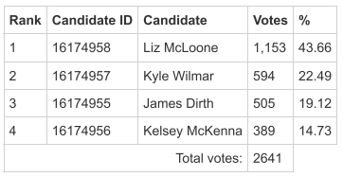

Congratulations to Liz and thank you to all four of the candidates for running for this position on the Political Council. If you have any questions for the statewide elections committee, please direct them to swelect@mape.org.

Thank you,

Statewide Elections Committee Members:

Christopher Cimafranca Christopher.Cimafranca@state.mn.us

Dan Dodge Dan.Dodge@mnlottery.com
Stephanie Boucher Stephanie.Boucher@state.mn.us

