2023-2025 Contract Tentative Agreement Overview

Overview

The 2023-2025 tentative agreement reflects:
- the work of MAPE’s bargaining team,
- substantial engagement from our membership and
- extraordinary services MAPE members provide every day.

Victories/Gains

We secured major wins, including:
- Historic wage increases.
- 21st Century contract including a flexible workplace and affordable, quality health care with significant benefits at nominal cost increases.
- Members in the Correctional Employees Retirement Plan (CERP) will now have
healthcare retirement parity with CERP members in other unions.
- Gains in the areas of temporary unclassified, meal reimbursements, length of service credit and more!

Victories: Fight Backs

We fought back proposals from MMB that aimed to:
  - Lower wage increases below those in current contract - 2.5%/2.5%
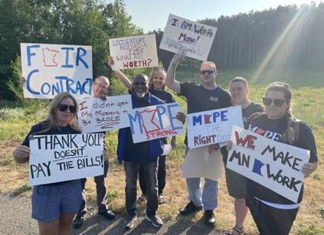
  - Sunset CERP
  - Allow removal of step increase(s) as part of discipline
  - Eliminate bumping and layoff options
  - Restrict union NEO participation to 10 minutes
  - Eliminate benefits for intermittent employees

Negotiations Process

Survey and Listening Sessions
Pre-Push Week Planning
Health Care Negotiations

Proposals came from all of you!
The team met often throughout the winter and spring to plan and write proposals.

More than 1,000 letters were written to commissioners, MMB Labor Relations Director and Gov. Walz urging support for our contract.
Negotiations Team worked with other unions on health care proposals.

Negotiations Process, cont.

MAPE Develops Nine Contract Proposals

Bargaining Opens April 11

MMB Demands Mediation

Your input led to the development of MAPE's nine proposals:
  - Telework
  - Temporary Unclassified
  - Definition of Family
  - Length of Service/Vacation Accrual
  - Deferred Compensation
  - Meal Reimbursement
  - Student Loan
Reimbursement
  - Across-the-Boards and Health Care.
Gov. Tim Walz and MMB heard negotiators tell your powerful,
personal stories around our
nine proposals.
This did not stop our ability
to communicate with members.

Developed texting campaign, provided social media posts, video updates, website stories and hosted townhalls.

Negotiations Process, final

Push Week
Tentative Agreement Reached

Rally
    - Hundreds gathered at the bargaining site to show support for our negotiators and contract.

Member Actions
    - Members at individual agencies held actions on issues that mattered to them.
Negotiations Team votes to refer tentative agreement to the board. The Board votes to refer tentative agreement for member vote.

Both bodies recommend approval of the TA.

Approval Process

Non-members must join by Aug. 4 to vote on TA. Join us!

Dues-paying members vote on TA Aug. 11-17.

Results of TA Vote announced Aug. 18.

If members vote to approve the TA, the contract will be ratified and automatically implemented.

If members vote down the TA, it authorizes a strike and empowers the Board to set a strike date.

Member Action

7,100 members signed a petition

More than one dozen agencies hold actions
Push Week Rally with 200+ members onsite

More than 1,000 letters
Hundreds of members joined their Local Contract Action Team

to commissioners, MMB &
Governor

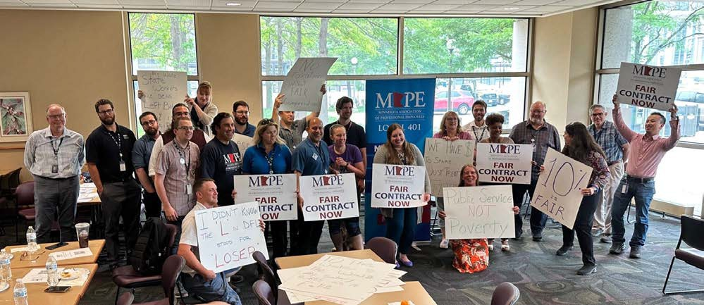
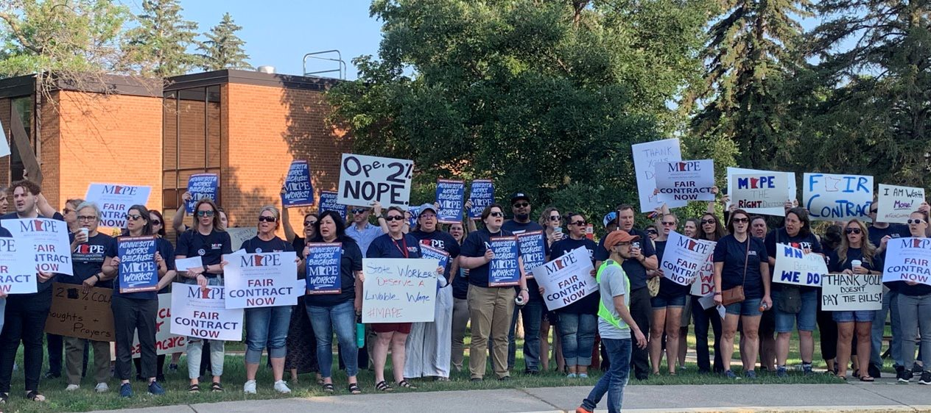
Member Action

Member actions throughout negotiations are incredibly important!
Thank you for your help!

Wages

Across-the-Board Increases
5.5% in FY24
4.5% in FY25

- Retroactive to July 1, 2023.
- Note, FY25 builds on FY24- you get 4.5% on top of 5.5% of FY23.
- Retro-pay is expected 4-6 weeks after contract is implemented.

Health Care Premiums

No increase to our share of health care premiums.

The overall cost of premiums, currently determined by SEGIP, will go up an 3% for both the state and members.

The estimated 3% increase on health care costs is not based on your wages, it is based on a much smaller health care premium amount.

For those with individual coverage, the increase will equate to an additional
$1.16 per month.

For those with family coverage, the increase will equate to an additional
$7.88 per month.

Health Care Impacts

Monthly Premium Costs | Monthly Cost 2023 (current) | Monthly Cost 2024 | Monthly Cost 2025 (estimate)
Single | $38.50 | $39.66 | $40.85
Family Cost | $262.66 | $270.54 | $278.66

Individual Example

Wage Increase
Premium Increase

2025 + Step: $35.46
2023 Hourly Wage: $30 | Single | Family
2024 Hourly Wage: $31.65 | 2023: $38.50 | 2023: $262.66
2024 + Step: $32.77 | 2024: $39.66 | 2024: $270.54
2025 Hourly Wage: $34.24 | 2025: $40.85 | 2025: $278.66
Monthly salary increases: | Monthly | Monthly
$391.20 | premiums increases:  $2.35 | premiums increases:  $16

Health Care Toplines

No increases in our out-of-pocket costs.

Mental health and wellbeing
- Beginning Jan. 1, 2024, mental health care visits will have no copay with the deductible waived for those in Tier 1 and 2 clinics.
- For those in Tiers 3 and 4, the copay will be $50 and
$70, respectively, for mental health services, which is
$20 lower than current medical office visit copays.

Health Care Toplines, cont.

Out-of-Service-Area Care Expansion
- A more robust plan will replace the limited "point
of service" program. All covered services outside the Advantage service area for employees, former employees and dependents will be covered at Tier 3 with a separate deductible.

Fertility Services
- Expanded Fertility Services (including in-vitro fertilization) pilot will become permanent in the contract and available through all
plan administrators (instead of only HealthPartners).

The Wellbeing Incentive Deductible
- Credit of $70 will be discontinued on Jan. 1, 2025.

Dental Toplines

Dental Annual Maximum Increased $200 Raised from $2,000 to $2,200

Dental premiums will increase 5%

Dependent care premium going from $41.90 to $44.00 a month

Telework

- Employees will now be granted a meeting with the employer to discuss changes in telework, with a union representative if they wish, prior to changes taking place.
- There will also be an appeal process for when an employee disagrees with a telework change determination.

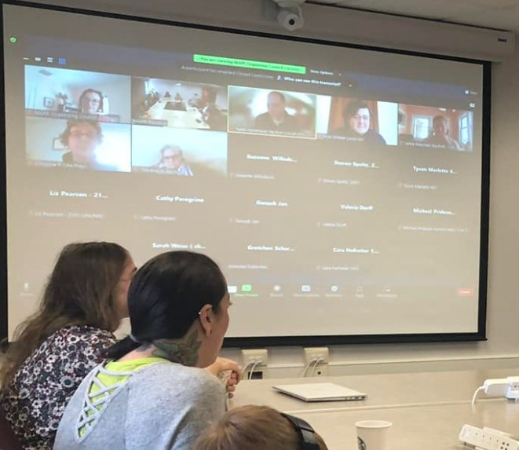
- Teleworking employees whose permanent office closes will have mileage covered when required to do field work or commute to a newly assigned office more than 35 miles away.

Corrections Early Retirement Program (CERP)

- Retirees who are covered under the Corrections Early Retirement Program (CERP) will now have their health care premiums covered at the same rate as current employees in other bargaining units covered by CERP.

This inclusion could save eligible members $4,000 annually.

Expanded Definition of Family

- The definition of who is family for the purpose of sick leave usage has been expanded to include "any other individual related by blood or whose close association with the employee is the equivalent of a family relationship; and up to one individual annually designated by the employee."

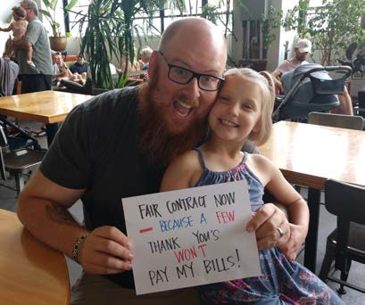
- The definition of family for bereavement leave has been expanded.

Expanded Length of Service Vacation Credit Program

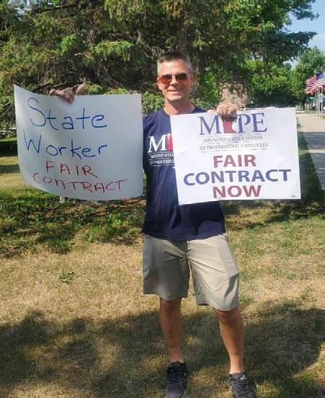
- For both new hires and current employees, the length of service vacation accrual credit program has been expanded to include self-employment and contracting work.

- Credit is still granted at the discretion of the employer, but can be granted to an amount up to the total years of previous work related to the employee’s current position.

- The conditions of vacation eligibility and documentation have been removed.

Meal Reimbursement Increase

Meal | 2021-2023 Contract | 2023-2025 TA
Breakfast | $9 | $11
Lunch | $11 | $13
Dinner | $16 | $19

For high-cost localities as identified by the IRS (excluding MN)

Meal | 2021-2023 Contract | 2023-2025 TA
Breakfast | $11 | $12
Lunch | $13 | $15
Dinner | $20 | $23

Temporary Unclassified Employees

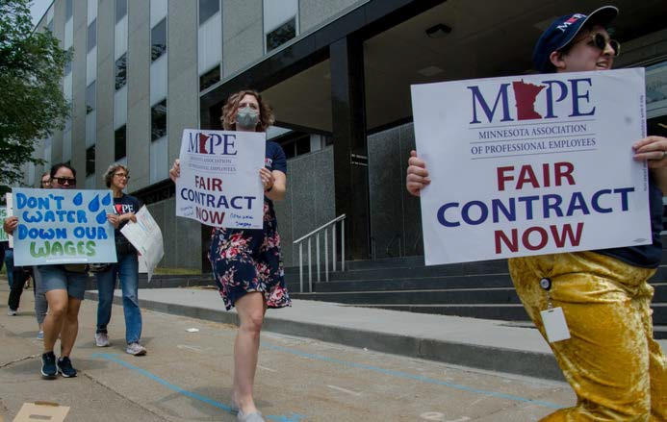
- The 21-day notification language for the ending of TU appointments now includes notification when
an appointment is to end early "when practicable."

- At the discretion of the employer, when a TU employee's appointment ends early, the
employee may remain in payroll status for 40 hours of paid leave.

- Also at the employer's discretion, a TU employee who has exhausted accrued sick leave may receive up to six months of unpaid leave for sickness or injury.

Student Loan Reimbursement

  - The Student Loan Reimbursement pilot has been made a permanent part of the contract and applies to all agencies.

  - The amounts are the same and granting reimbursement is still at the discretion of the employer.

  - The documentation provision was fixed to clarify it is a reimbursement program,
not a matching program.

More Wins

Pilot Projects Extended: The dates for pilot projects on multilingual pay differential, phased retirement and equity adjustments have all been changed to be active through the new contract period.

Incentives Programs Authorized: Upon approval from MMB and notice to MAPE, agencies are now authorized to create incentives programs for recruitment and retention.

PPL Usage: Paid Parental Leave (PPL) will now be available for bereavement leave in the case of a stillbirth or the death of a child.

… and more ...

Temporary Change in Employment Condition: Employees may now request to go from full-time to part-time or part-time to full- time on a temporary basis of up to 12 months. The request must be approved by mutual agreement with the employer.

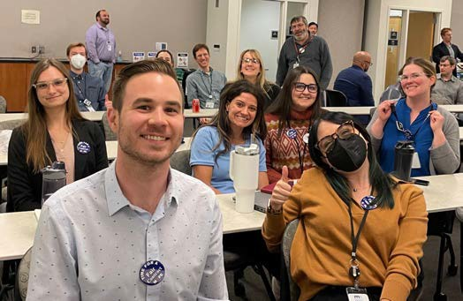
Employee-Initiated Location Reassignment: Employees may now request in writing if they wish to be reassigned to a new location further than 35 miles from their current location, and this will no longer create a vacancy.

Removal of Discipline Materials: Upon mutual agreement with MAPE, the removal of discipline from a personnel file resolves related grievances.

… and more!

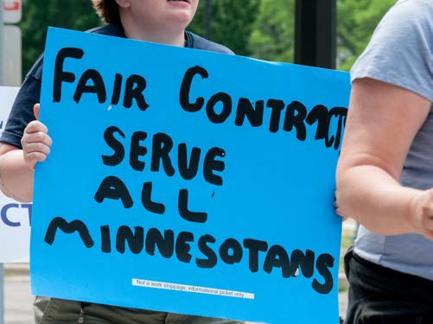
Voluntary Separation and Discipline: Upon mutual agreement with MAPE, an employee’s voluntary separation from the State resolves related grievances unless the grievance directly affects their status upon termination or a claim of vested money interests (for example, back wages or accrued vacation).

Supplemental Agreements: Meet and Confer teams at nine agencies bargained specific changes for their agencies.

Technical and Clarification Changes: We also agreed to numerous technical and clarification changes that do not substantively change the agreement.

Next Steps: Preparing for a vote

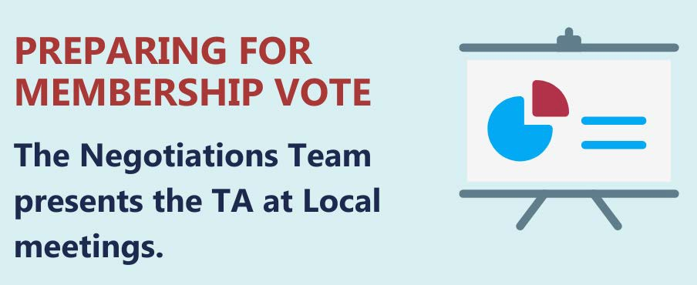

Next Steps: Join!

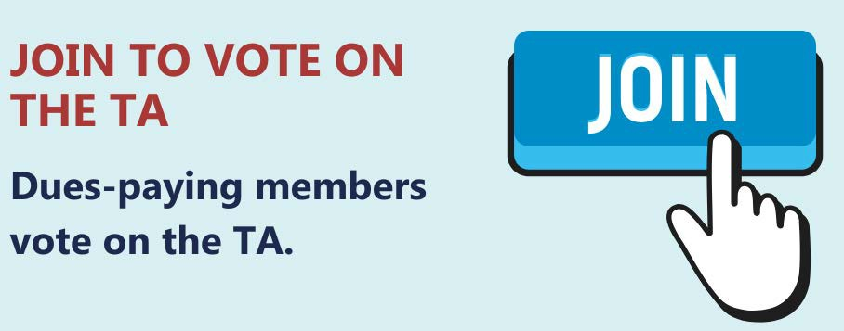

Ensure you are a dues-paying member by Aug. 4 to be able to vote on the TA.

Join at: mape.org/join-mape

Next Steps: Implementation

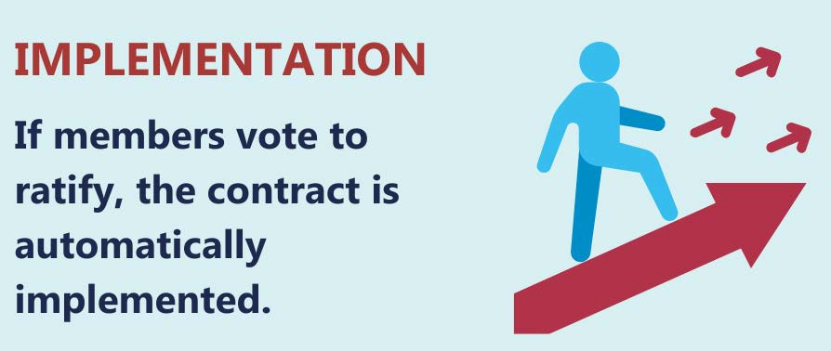

Members are expected to receive retro-pay 4-6 weeks after the contract is implemented.

Take Action: Be a Member

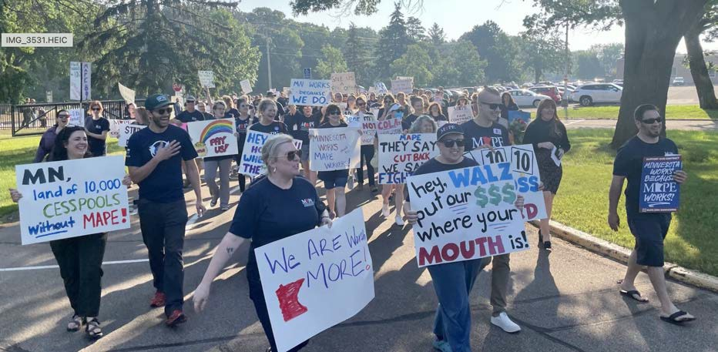
Build our power!

Solidarity in
our numbers means power as a union.

Become a member by Aug. 4 to be able to vote on the contract and build for future contracts!

Join online on MAPE.org/join-mape.

Questions about becoming a member, reach out to your Business Agent.

Take Action: Locals

Get involved in your Local!

Look up your Local: https://mape.org/find-your-local Attend Local meetings.
Run for open positions.

Nominations for Delegates open July 5!

Take Action: Vote

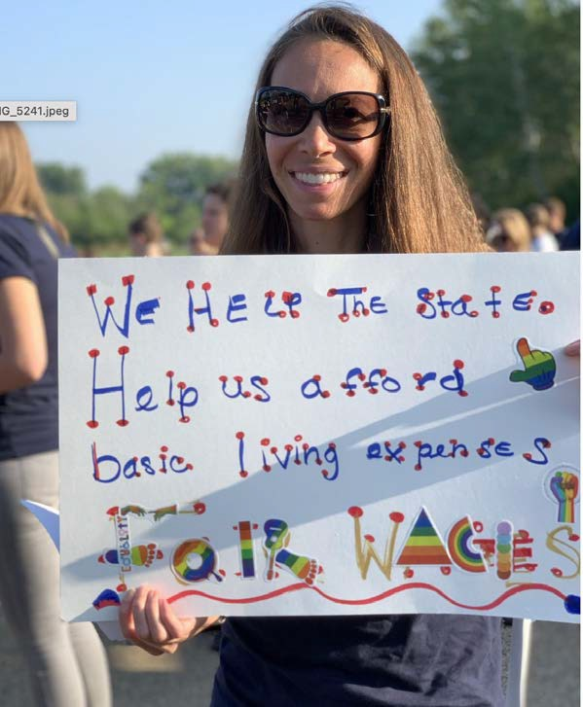
Voting for contract begins Aug.
11. Look for an email.

Get involved volunteering for the 2024 election.
Funding for our contract gets voted on in the Legislature.

Vote!

Questions?

