Local 2001 March Meeting Minutes
March 7, 2023
Noon

Steven Speltz, President, called the meeting to order at 12:05pm

1 Officer Reports
- Secretary Report: https://mape.org/locals/2001
- Chief Steward Report: (Currently Vacant) Sign up for Steward Retreat!
- Treasurer Report: (Currently Vacant) Steven reported that currently there is $31,168.57 in Local 2001’s budget at the end of January. There were no expenses posted to our budget in January.
- Membership Secretary Report: (Attached) Nicole reported that membership is currently at 67.21% in our Local. Ask new state employees to sign up for MAPE as they start with the state.
- Regional Director Report: (Attached) Sign the platform/petition. We need to show strength in numbers to the state. Sign up for Lobby Day by March 13th.
- Regional Negotiations Representative: Rick reported that the team is working on a figure for the wage increase but has not come to a number yet. The details/wording of proposals will be shared after the team gives the state their first proposal on April 11th. Sign the petition/platform. Can you volunteer for the Contract Action Team? Let Rick know at rickypo@yahoo.com
- Business Agent Report: Adam reported that being a member of the CAT involves talking to 5-10 people at your worksite about what was going on with the contract. It is a very do-able job. Consider helping out the team.
2 Contract Action Team (CAT) members are needed in Region 20. If you are interested contact Rick Pospichal, our Negotiations rep at rickypo@yahoo.com
3 Sign the petition/Bargaining platform https://mape.org/platform. Our goal is to show strength by having almost all members sign onto this platform.
4 Steward Retreat on March 24-25. Register at https://portal.mape.org
5 Steward Training for 2023 open. Register at https://portal.mape.org
6 Voting in Local 2001 offices will be from March 12-23 on-line
7. Lobby Day is March 23-register at https://portal.mape.org Training provided. Get a great winter scarf as a treat for attending.
8. Solidarity Saturday had been scheduled the Saturday after our recent snow dump—It is rescheduled to Saturday, April 1, no foolin’. Region 20 hopes to have a few teams working throughout the Winona and Rochester areas.
9. Reach out to new employees as they join the state. Membership is important to negotiating a good contract.

2023 Important Dates in MAPE Local 2001
March 23-MAPE Lobby Day in St. Paul
March 24-25-MAPE Steward Retreat, Delta Hotel, Minneapolis
April 1: Solidarity Saturday (rescheduled)
April 4- Noon: Monthly Meeting Broadcast via ZOOM and in person at Riverland in Austin
April 28-4:30-Basic Steward Training
May 2- Noon: Monthly Meeting Broadcast via ZOOM and in person at PCA, Rochester
June 6-Noon: Monthly Meeting Broadcast via ZOOM and in person at RCTC
June 9- Advanced Steward Training
July 11- Noon: Monthly Meeting Broadcast via ZOOM (note this meeting delayed 1 week) in Owatonna (TBD)
July 25-4:30-Basic Steward Training
August 1- Noon: Monthly Meeting Broadcast via ZOOM and in person at Winona State
September 5-Noon: Monthly Meeting Broadcast via ZOOM and in person at Red Wing at 5pm
October 3- Noon: Monthly Meeting Broadcast via ZOOM and in person at Southeast Minnesota State, Winona
October 27-4:30-Basic Steward Training
November 7- Noon: Monthly Meeting Broadcast via ZOOM at Rochester DEED/Heintz Center at RCTC
December 5- Noon: Monthly Meeting Broadcast via ZOOM at TBD
December 8- Advanced Steward Training

March 2023 Regional Directors Report

I attended the Board of Director’s meeting on Friday, February 17th in-person at MAPE HQ in Shoreview, MN.

Have you signed the petition for Negotiations? Show the team your support and sign onto the Bargaining Platform here -> https://mape.org/platform.

The BOD continues to explore replacing the Executive Director by possibly moving to a Chief of Staff or an Elected Executive Team (Statewide President, Statewide VP, and Statewide Sec/Treasurer). The BOD does not have the authority to change to an executive team without changes to governing documents. You will likely see this brought forward to Delegate Assembly this fall.

The Board did form an Accessibility Taskforce in January to address items of digital accessibility brought forward at the October 2022 Delegate Assembly. If you have interest in assisting MAPE with this important updating, please contact Megan Dayton at mdayton@mape.org.

The Board does set aside time at every Board meeting to hear from members. We meet the third Friday of every month (except when Delegate Assembly is held). We set aside time every board meeting at 11:30am for members to join us via ZOOM and give us feedback on how things are going. Please consider joining us. E-mail me at kpedretti@mape.org for the ZOOM link.

As you know, our contract is approved by the legislature, so it is important to stay in touch with our representative and senator and insure they are supporting us. MAPE’s Lobby Day this year is Thursday, March 23rd. Plan to attend in St. Paul and talk in person with your legislators. Get a MAPE scarf for attending. https://portal.mape.org/Login.aspx?ReturnURL=/EventDetails.aspx?EventID=2950
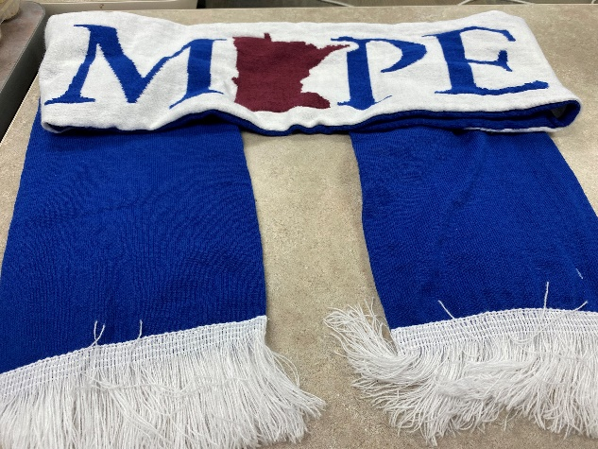

Are you interested in becoming a steward? In 2023, MAPE will be offering hybrid Steward training – so you can come in person to Shoreview or attend via ZOOM. The dates are below. If you have any issues with signing-up, please contact me. Basic Steward Training: Jan 27, April 28, August 25, and October 27

Kay Pedretti, Region 20 MAPE Director

January’s Membership Secretary’s Report

Local 2001 Percentages- As of January 10, 2023.

Including Billable Members, our Local’s Membership is at 67.21%
Local 2001 Percentages  Person Type Record Count Percentage  Billable Member 11 2.23 %  Member 321 64.98 %  Non-Member 162 32.79 % | .
.

