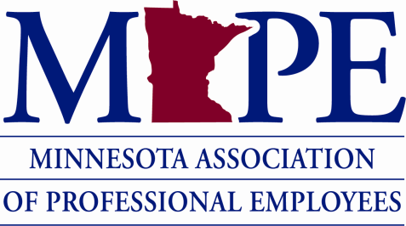

July 2022 Meeting Minutes

July 20, 2022, 2:30-4:30 pm
*Detailed minutes were not taken during this meeting. Partial minutes are included below.

Meeting overview (10 minutes-Megan)
- Review agenda and time allotments (Megan)
- Review action item spreadsheet and status of tasks (attached) (Megan)
- Update spreadsheet and de-highlight items

Asst. Area Fisheries Reclassification Appeal (5 minutes-Megan)
- Asking for a status update
- Appeal forwarded to Denise Legato on 4/8/2022. Prior to this communication, Fisheries staff have said they’ve received no response to having received the appeal required documents that were first sent by them in December 2021
- June 13, 2022 met with Brad Parsons, Fisheries Section Manager

MMB Policy Changes (e.g., Code of Ethical Conduct, Appropriate use of electronic communication and information technology, Mobile Device Use-45 minutes)
- Why were these policy changes made? Did anything precipitate the need for these modifications
- Did DNR have a role in these policies? Was DNR asked for input?
- Management referred staff to DNR’s Ethics Officer, Colleen Schmitz
- Fielding many concerns from staff:
  - Overreach into personal lives
  - Conflict of interest affecting existing DNR partnerships with natural resources organizations
  - Extension of family definition where staff has no control or authority over what those family members do e.g., ex-spouses, grandparents, etc.
  - Unclear what “dealings” means when referenced in the training.
    - Dealings relates to actual job duties and influencing decisions related to other organizations; Frequent conflict of interest more relate to the role within DNR and potential for influence within the partner organization and what the relationship is btw. DNR and that partner relationship.
  - “Using any state conferencing video technology (including Teams, etc.) for non-work-related purposes unless all parties attending are state agency employees.” This language seems to prohibit union conversations, which we consider an unfair labor practice.
  - Personal cellphone concerns and incidental uses of technology
  - Monitoring conversations or virtual calls
  - Unclear who to contact to disclose a conflict of interest or explore further

Wildfire – Ongoing Discussions (45 minutes)—Megan E., Dan E.
- Summary of current status and overall concerns.
- Asks that can be addressed within DNR
  - Reimbursement for fire boots—update; Adam will send out a comprehensive update to staff and on the intranet detailing what changes are and who is eligible to help people navigate the reimbursement (DUE: 5/13/22)
    - MAPE asked what management’s position is on this? Denise is expecting to get answers from division before end of July and then will convey a message that summarizes a response to fire boots and on-call by the end of the month.

  - On-call—request to pay for 16 hours as is indicated in the contract
  - Staffing/Scheduling re: current plans regarding
    - Hiring
    - Coordination with other Divisions
- MAPE’s next steps to address items that need to be addressed across the enterprise:
  - Paid R and R Days (MOU Review in progress)
    - Denise sent message to fire management this am about foundational questions re: what is the footwear requirement for fire so we have clarity around the issue and clarity on the situation; Megan sent fire manual language; Denise said it’s not just what we’re providing, but who is eligible for the reimbursement; there will be a special code for payroll for that R and R day if it falls on a week day. It will be charged to the fire.
  - Staffing/Scheduling—have heard Management is working on this, but what are the timelines for receiving updates
  - On-call—expanding MAPE contract cap from 16 to 24 hours (Megan E.)

Upcoming Agenda Items:
- Naturalist concerns (Megan)
- Nursing Mothers in the workplace (Monica)
- Culture of respect position (Kristi)

