MAPE, Local 1801 Meeting Agenda for February 9, 2021
Time: 12:00-1:00 p.m.
Please join my meeting from your computer, tablet or smartphone.
https://global.gotomeeting.com/join/229326949

You can also dial in using your phone. Access Code: 229-326-949
United States (Toll Free): 1 877 309 2073 United States: +1 (571) 317-3129

New to GoToMeeting? Get the app now and be ready when your first meeting starts:
https://global.gotomeeting.com/install/229326949

Agenda
1. Roll Call—Taken from Adobe Connect Screen
7 | Megan Benage | 13 | Kirsten Peterson
4 | Georgette Skindelien | 6 | Rebecca Kaas
10 | Teren Novotny | 20 | Taralee Latozke
14 | Bev Donley | 21 | Diane Stieper
17 | Russ Derickson | 9 | Gretchen Scharmer
1 | Dave Rischer | 15 | Naoko Meyer
12 | Theresa Ireland | 3 | Lorie Skaro-Johnson
5 | McKenzie Kack | 18 | Sandra Schlagel
16 | Lorna King | 8 | Pauline Arnst
2 | Krista Kube | 19 | Jake (from State Farm?)
11 | Molly Tranel Nelson | 22 | Tim Beske

2. Report from Officers
a. Treasurer’s report- only activity was the Jan drawing.
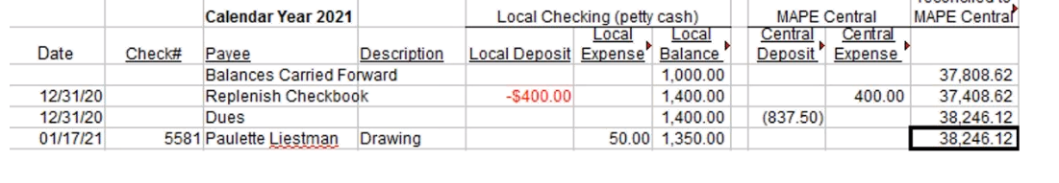
We went through 2021 budget for the year. Tara moved to approve, Naoko second. Approved.
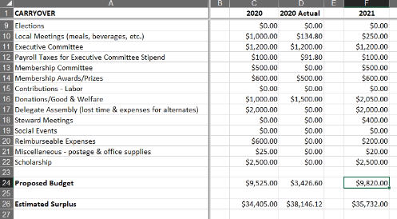

b. Membership Secretary Report- Nate was not here, but in general the membership is shrinking. (Report was added after meeting.)

Local 1801 Percentages
Person Type | Record Count | Percentage
Billable Member | 9 | 2.44 %
Billable Non-Member | 2 | 0.54 %
Member | 216 | 58.54 %
Non-Member | 142 | 38.48 %

60.98% Member / 39.02% Non-Member

New Hires (currently showing as non-members): Josh Brown (Corrections – Litchfield)

No new member sign-ups or dropped memberships.

c. Approval of Minutes- Russ moved to approve, Rebecca seconded.
d. Regional Director Update- Tim Beske
DOC- telework policy review. Elections review, legislative information. Priorities of no layoffs, raising revenue, student debt relief, and broadband, Day on the Hill (members can submit stories for these priorities), other issues. Broadband is the great equalizer, more than pay…. Tim eats broadband. Donated $1000 to Minneapolis Rent Coalition. Industrial Areas Foundation presentation, Dave Kamper presented survey results… huge participation rate. Circle Project- opportunities for members to make meaningful connections, open on the portal. Strategic Planning- who are the stakeholders, how are they reached?
e. BA Update
f. Negotiations update-
g. Meet and confer updates as available
h. Other Reports?

3. Elections (Nominations)- We described positions.
We don’t have an Elections Committee. Tara Latozkee accepted nomination for Treasurer.
Molly is willing to run again, but may have to switch unions depending on result of position audit/reallocation.
Megan is not running again- we need someone to run for President. If you are interested contact Megan. Currently no one is nominated for President.
Mackenzie Kack was nominated for president, but she is going to be gone for half the year. Mackenzie decided not to accept nomination.
Naoko Meyer was nominated for membership secretary. She accepted. Nate Mullendore was nominated for membership secretary, he wasn’t present to accept.

7. Drawing – Lorna King is the winner!

Local 1801 Officers: Megan Benage (President), McKenzie Kack (Vice President),Teren Novotny (Treasurer), Molly Tranel (Secretary), Nathan Mullendore (Membership Secretary)

