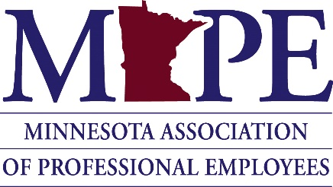

POLITICAL COUNCIL MEETING/RETREAT
December 17, 2020

Minutes

Chair Cotter called the meeting to order at 8:34 A.M

Roll Call: A quorum was established
Present: Chair Cathleen Cotter, Vice-Chair John Ferrara, Secretary Amanda Hemmingsen-Jaeger, Nicole Juan, Monica Weber, Jason Broberg, Chet Bodin, MAPE President Megan Dayton, MAPE Staff Leah Solo, MAPE Staff Devin Bruce

Business:
- Welcome

- Motion (Juan): Approve all previous meeting minutes that have not been approved yet.
  - Second (Weber)
  - Passed

- Motion (Ferrara): Reaffirm decision to purchase additional Slack licenses
  - Second (Weber)
  - Passed

- Updates

- Reflections on 2020

- Announcements
  - Congratulations on election to board, Jason! Last meeting with Political Council will be in January.

- “Our View of Politics” (Laura Johnson-Faith in Minnesota)
  - Electoral politics and the legislative session
  - Messaging

- Planning Session 1 – Long Term Planning

- Professional Development Activity (“The Drawbridge Exercise”)

- Planning Session 2 – 2021 Political Council Planning
  - Motion (Ferrara): Approve MAPE legislative priorities and platform (with understanding that the platform section may undergo formatting edits; no substantive changes)
    - Second (Weber)
    - Passed

- 2021 Political Council Communication and Engagement Strategies

Next meeting: January 8, 2021 at 8:30 AM

Adjourned at 4:02 PM

