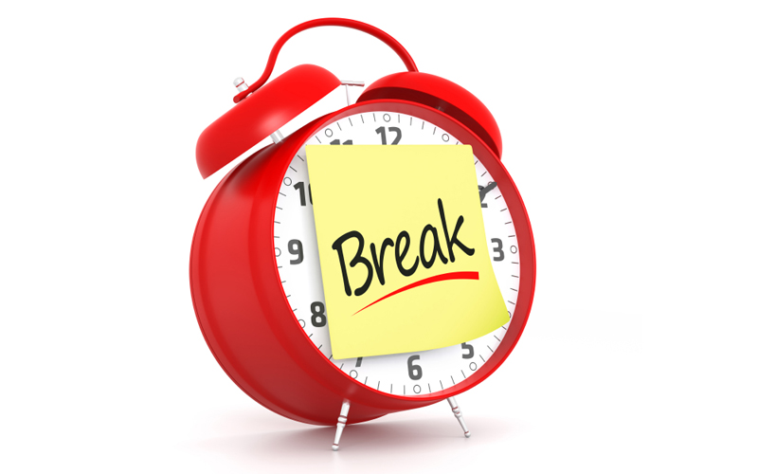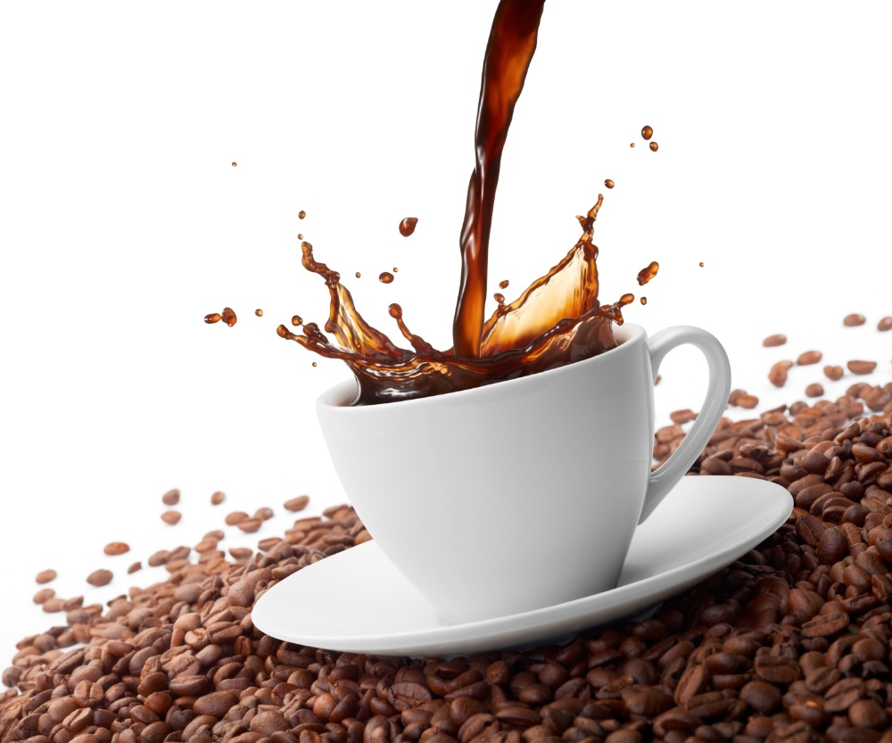

**Meet your local officers, stewards, and learn more about your local.**

**Room 2000**

**9am-10am**

**Tuesday, October 6th**

**Local 401 Coffee Break with MAPE**

**IT’S TIME FOR**

**BREAK**

**E**

**COFF**