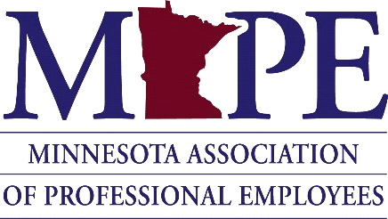
POLITICAL COUNCIL MEETING

April 30, 2021

Joint Political Council, Political Action Committee, and Political Fund Meeting

Minutes

Called meeting to order at 10:05 A.M.

Members Present:
Political Council (PC) Present: Chair Cathleen Cotter, Vice-Chair John Ferrara, Secretary Amanda Hemmingsen-Jaeger, Nicole Juan, Chet Bodin, Monica Weber, Rebeca Sedarski

Political Action Committee (PAC) Present: Chair Monica Weber, Nicole Juan, Treasurer Ben Nicla, Lynn Butcher, Deputy Finance Vernitta Moore

Political Fund (PF) Present: Cathleen Cotter, Randy Shimpach, MAPE President Megan Dayton

MAPE Staff Present: Leah Solo, Devin Bruce

Business:
- Welcome/Introductions

- Discussion about how to make political program stronger

- Presentation by Sarah Duniway
  - Q and A session
  - Slides will be sent out

- Debrief and next steps
- Future topics for PAC and PC

Adjourned at 12:40 PM

