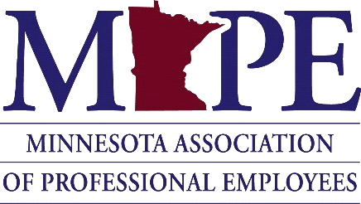
POLITICAL COUNCIL MEETING

April 8, 2022
Minutes

Chair Cotter called the meeting to order at 9:08 A.M.

Roll Call: A quorum was established
Present (PC): Chair Cathleen Cotter, Vice-Chair John Ferrara, Secretary Amanda Hemmingsen-Jaeger, Nicole Juan, Chet Bodin

Absent: Devin Bruce, Leah Solo, Kristin Kirchoff-Franklin (excused)

Business:
- Welcome/Approve March 11th minutes
  - Passed by consensus

- Development Zone follow-up
  - 1:1s follow-up
  - How can we support people?
    - Member-to-member calls
    - Partnering with other unions

- Legislature
  - Contracts
    - Passed the House on March 28th
    - Hearing in the Senate TBA
  - Writing to Senators in progress
  - Rally discussion

- Updating Legislative priorities
  - Period poverty platform proposal (Monica Weber)
  - Upcoming solicitation for reviewing legislative priorities
  - Listening sessions in May/June (after session ends)?

- Table at Women Winning event

- Candidates for Political Council
  - Two appointments
  - Two vacancies, but only one nomination so will need a special election
- In-person vs. Virtual meeting
  - Next six-month schedule of development zone locations
  - Summer schedule
    - May 13th (in-person at MAPE HQ)
    - June 9th (virtual)
    - OC Membership drive June 10th (in-person)
    - July 7-8 for onboarding new members

- Executive Team Update (Cotter)
  - Labor Notes Conference in Chicago, June 17th-19th (https://www.labornotes.org/2022)
  - New Board of Directors and Executive Team App – Govenda
  - OC Membership Drive on June 10th

- Political Action Committee (PAC) Report (Juan)
  - Recap of screening meeting with Governor Walz
    - Endorsed by MAPE
  - Endorsements update
  - Plans post-session
  - Local meetings

Next meeting: Friday, May 13th at 9:00 AM (MAPE HQ)

Adjourned at 11:17 AM

