**Meet and Confer June 17th, 2024**

**Attendance:**

Katrina Kessler

Kellie McNamara

Peter Tester

Wayne Cords

Kaity Taylor

Brett Nagle

Kristin Mroz-Risse

Shanna Schmitt

Mel Markert

Cindy Osborne

1. **Student Loan Reimbursement Program and Policy**
   1. Survey results and summary
      1. Meet and Confer team shared a PowerPoint with results from a recent student loan reimbursement program survey.
         1. The survey was sent by Meet and Confer to all MPCA staff with a MAPE represented position.
         2. 263 responses to survey as of June 17th
         3. 173 additional comments. MAPE has not had a chance to go through all of these comments and summarize them.
      2. Student loans have been very impactful on employee’s lives.
      3. Loan payments and loan totals have caused staff to delay or decide against many life choices – saving for retirement was the largest response.
      4. 112 respondents still owe towards a current student loan debt. The majority of those owe more than $25,000
      5. Education or training beyond high school was required for the majority of respondent’s current MAPE position
      6. The majority of survey respondents responded “Yes” when asked “Would the student loan reimbursement at PCA (up to 5,000 per year for 5 years) make you more likely to recommend working at the PCA to friends or relatives?”
   2. Listening sessions and feedback summary:
      1. Summary
         1. 5 listening sessions held over two weeks
         2. Over 135 attendees
         3. Sessions were led by Meet and Confer members and two MAPE members that were very interested in the program and wanted to help out
         4. This program would be a good retention and recruitment tool.
      2. Remaining questions from session attendees:
         1. How does this program work with PSLF? Are recipients of a reimbursement payment still eligible for PSLF (assuming all other eligibility requirements for PSLF are met?)

Answer: Information on PSLF eligibility can be found at the [Public Service Loan Forgiveness FAQs | Federal Student Aid](https://studentaid.gov/manage-loans/forgiveness-cancellation/public-service/questions) website. Screen shot below:

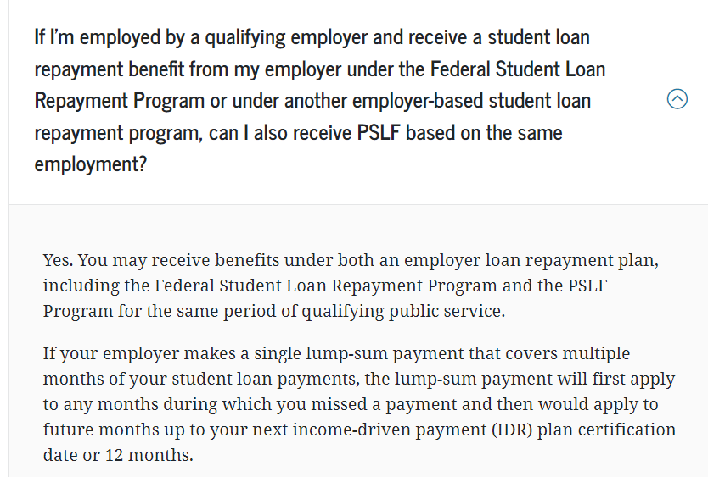

* + - 1. What type of loans are eligible? Private? Public? What if an employee took out a credit card loan or a loan from a parent?

Answer: the policy will include language that requires proof that the loan is from a student loan service provider. Other forms of loans will not be eligible.

* + - 1. Further explanation of taxes on the reimbursement. Both federal and state taxes apply?

Answer: Under section 127 of the Internal Revenue Code (IRC), Student Loan Payment Reimbursements are excluded from federal income, state income, Social Security, and Medicare taxes up to the maximum of $5,250 through December 31, 2025. MPCA’s policy caps SLR at $5,000/year and excludes those who receive tuition reimbursement payments from MPCA from also seeking tuition loan reimbursement. MPCA should be able to exclude taxes from the reimbursement amount. The SLR payments will still be reported on the employee’s W2.

* + 1. Suggestions and feedback from attendees:
       1. Want for additional information and transparency - process of applying and determining amount of reimbursement. Especially since there is no appeal process.
       2. Lots of interest in allowing this benefit for spouses or children
       3. Overall a lot of interest and want for this to be a sustained program for the PCA!
    2. Discussion:
       1. Meet and Confer Team asked that a PSLF expert or contact person be provided for staff. HR responded that there is no expert and that they are not able to determine eligibility for programs that they do not run. They recommend reviewing the FAQs here: [Public Service Loan Forgiveness FAQs | Federal Student Aid](https://studentaid.gov/manage-loans/forgiveness-cancellation/public-service/questions)
       2. Katrina voiced that this is a good program overall and there have been a lot of good results from listening sessions and general feedback. There are opportunities to be responsive to questions and keep improving as we move forward. Kellie said work is being completed on the interface. It’s nobody’s intention to not be transparent, but this is still a work in progress and more updates will follow.
       3. Wayne asked if there were any demographics collected? Specifically, how much a person is paying each month/year? Meet and Confer did not ask for this information because that monthly amount can change depending on a suite of things, including whether or not the individual decides to participate in the PCA student loan reimbursement program. Meet and Confer felt that total loan amount remaining was a more representative number to report out.
  1. Requests
     1. Update on program and policy
        1. Meet and Confer requested to be informed right away if there are changes to the policy or program. HR agreed.
        2. The procedure section of the policy will be updated to include information about the online form.
        3. The online form is moving along and expected to be ready for October as previously announced. People should be able to apply there and upload their proof of payment.
     2. HR or other main contact
        1. Suzette Henry (suzette.henry@state.mn.us) has been managing this and will continue to.
     3. Agency start to communicate to staff about the program
        1. Meet and Confer requested that the agency start communicating to staff about the program.
        2. Staff are really excited about this and want to dive in. Having information coming from HR as well as MAPE would be great.

1. **Communication: What’s working and what can be improved.**
   1. Upper management to staff level communication.
      1. Staff are seeing more information move from upper management to the staff level. Communication through this route seems to be improving and staff appreciate it.
   2. Hot topics/newsworthy items related to PCA.
      1. Staff would like some guidance on how to speak about PCA “Hot Topics.” Staff are asked by the public and their personal circles about events involving the PCA and would appreciate the agency helping with talking points.
      2. Katrina noted that sometimes even she isn’t sure what’s going to be hitting the news that involves the PCA. She also said this would be a great idea and at the very least have some kind of “who to contact” if staff need more information about a topic. There needs to be a balance between sharing information and overwhelming staff. Touch base with Andrea?
   3. Communication about division/unit roles and functions and communication when these change.
      1. With so many new faces at the agency it’s not always clear who everyone is or what their roles are. This isn’t an issue unique to the PCA, but could be find an effective way to share information about who has joined the agency, what their roles are, and what changes might have occurred with SOPs related to those roles?
      2. Katrina noted a lot of the “who, where” is covered in new employee orientation. Aside from that and expanding the Lorax how else can this be covered? Are there specific areas to start with?
      3. It would be nice for PCA to offer refreshers of new employee orientation to existing staff.
      4. Katrina and Peter both asked for specific topics this can be done with. Exampled like grant services or Equis user workshops. Overall, it seems ideal to have Experienced people share about their work/SOP/experiences.
      5. Wayne asked if the fiscal tidbits in PCA2day were helpful? Overall yes, they went over well.
      6. Another idea was to have “nice to know” information in the PCA2Day.
      7. Revisit this topic with more discussion and ideas for what topics the members would find helpful.
      8. Katrina is working on some brown bag sessions to recap the legislative session. Information on the legislative session will also be shared on the website.
2. **Let’s Connect and Career Development**
   1. Meet and Confer team requested an update on what’s next for the Let’s Connect Series and the Career Development Conference
      1. Let’s Connect series will continue. Next series is planned to be around job shadowing.
      2. There will be another Career Development Conference in February 2025. PCA might have MMB staff assist. Also open to thoughts or suggestions.
   2. Suggestion for future topic
      1. Meet and Confer team suggested that the Let’s Connect series could be a way to help improve communication and who to contact for resources. For example, providing an overview of the Lorax and other “who to contact” resources. This could help improve communication and reinforce agency connections
3. **Vacancy and Job Filling Update**
   1. Request for agency-wide and MAPE numbers on vacancies and job filling status.
      1. There are 172.5 MAPE vacancies left to fill, 42 of those positions are temporary
      2. There are 92 vacancy requests in HR right now, not sure how many are MAPE. These are active in the hiring process at some stage.
      3. Kellie will follow-up with the additional information – temporary and permanent vacancies in MAPE.
   2. Legislative updates on new positions and funding
      1. More info to follow at the brown bag sessions.
      2. Katrina plans to speak on vacancies/new positions. She said 15 new positions were funded through the legislature for Air.
      3. There is a new law related to consumer packaging that will likely result in new positions.
4. **Other Updates or Asks of Meet and Confer**
   1. Wayne is looking for a MAPE member for the safety committee. Meet and Confer team will continue to ask in quarterly update email and at the local 301 meeting
   2. Kellie asked that Meet and Confer team encourage members to submit nominations for Voyager awards. They are due by August 9th. Meet and Confer team will include this in the quarterly update email and at the local 301 meeting