March 5, 2025 - Teams Link
Start time 12:05 PM End time 1:00 PM
Meeting Summary - scribed by Derek Duran
Date, Time & Location: Wednesday, March 5, 2025 – Microsoft Teams Link
Next Meeting Date, Time & Location: Noon-1:00 p.m., Wednesday, April 2, 2025, online via Microsoft Teams.

Topic | Key Points Raised | Decision/Action
Welcome – Lisa Becker, President | Welcome! | No Action
Membership Secretary Report – Christian Noyce | The next new MAPE employee orientation is May 14th. Two fun events on the horizon! Movie night on March 29th at 9:45am at Grandview Theater (1830 Grand Ave, St. Paul) and Skate Extravaganza on April 27th from 2:30-4:30pm at Twin Cities Skaters Studio (3045 Hennepin Ave in Minneapolis).  Contact Sophie Nikitas (sophie.nikitas@state.mn.us) or Christian Noyce (Christian.noyce@state.mn.us) with questions. | No Action
Treasury Report - Michael Zajicek | We received $1,760 in income in January 2025 and had $656 in expense (lost time for Women in Leadership conference attendees).  Motion to allow members to apply for Lost Time for Lobby Day and those attending the rally. Seconded by Mary Heim. Motion Language:  - Whereas MAPE traditions indicate that larger locals help support lost time for their members.  - Whereas the leaders of Local 601 fully support the ability to pay for lost time for Local 601 members to attend Lobby Day on March 6th.  - Whereas the MAPE Financial Workgroup uses the wage of $39.50 per hour to calculate projected lost time for members.  - This motion is to authorize Local 601 to formally use its reserves to cover the cost of Lost Time for Local 601 members who will be able to attend Lobby Day in its entirety, up to $25,000.  Notes from motion author:  (This number is based on data indicating that as of 2/10/25 that 60 members of Local 601 would be attending Lobby Day, multiplied by 9 hours for a standard workday (9 to account for people who get paid 1 additional hour because they took unpaid leave from their job and will lose vacation accrual for that single day instead of a vacation day from their job) , multiplied by an average wage of $40 per hour, which totals to $21, 600.  Furthermore, there are 14 members of Local 601 who are attending the rally only as of 2/24/25. Local 601 leaders believe that compensation of 2 hours of lost time is reasonable for people who attend the rally for Lobby Day, so 14 multiplied by the average wage of $40 per hour multiplied by 2 is $1,120.  The grand total thus stands at $22,720 when accounting for the averages, but Local 601 leaders believe that wiggle room is warranted if wages are above average for our local, therefore the motion is rounded up to $25,000 to allow for wiggle room in the budget.)  The motion passed.  Other notes about Lobby Day – It is expected to be the largest on record with more than double the past record! Local 601 leadership will try to provide a summary at next month’s meeting.  Contact Michael Zajicek (Michael.Zajicek@state.mn.us) with questions. | Motion Passed
Steward Report – Mary Heim | Basic Steward Training is April 25th from 830am to 5:00pm at MAPE Central. This is in person. If you need accommodations such as remote option, indicate this on your registration and the trainer will contact you. This is good foundation level training for all MAPE involvement, whether as a steward and/or in local or state officers, regional director, organizer, membership committee. There are opportunities for additional training, such as organizing for stewards, and advanced steward training that is only available for stewards.  Contact Mary Heim (mary.heim@state.mn.us) or Catherine Okoneski (catherine.okoneski@state.mn.us) with questions. | No Action
Regional Director Report – Nate Hierlmaier | Nate conveys that these are trying times but events like Lobby Day and Fund our Future are ways to show solidarity with one another. This is a time to band together and take action. There is still time to partake in the rally portion of Lobby Day.  Nate also convey that delegate elections are coming up this April for Delegate Assembly and that it’s great way to get more involved in MAPE.  Additionally, the following timeline was provided for some internal MAPE processes:  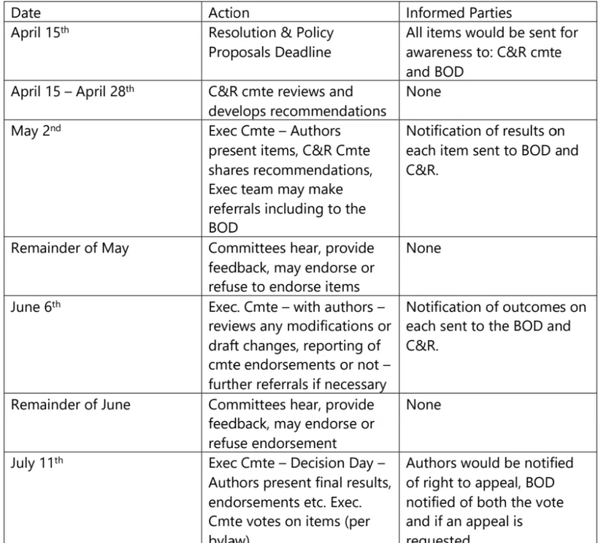  Contact Nate Hierlmaier (nhierlmaier@mape.org) with questions. | No Action
Contract Action Teams Update – Rachel Wittkopp | Ongoing effort: Enlisting CATs  CATs can lead meetings, conduct townhalls, direct action plannings, conduct listening sessions, and recruit members.  Sign up to be a CAT today!  QR Code for Joining  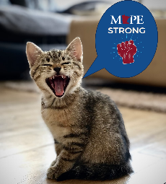    Contact Rachel Wittkopp (Rachel.wittkopp@state.mn.us) with questions. | No Action
Business Agent Report – Frank Cave-LaCoste | Frank asks that members fill out this survey that hopes to convey how important public and state employees are to running the state and country. Public workers are under attack, and we need to set the narrative accurately and loudly.  Survey Link  Contact Frank Cave-LaCoste (fcavelacoste@mape.org) with questions. | No Action
Adjourn | Next Meeting: Noon-1:00 p.m., Wednesday, April 2, 2025, online via Microsoft Teams | No Action

Local 601 Leadership Team
Position | Name | Email Contact
President | Lisa Becker | lisa.becker@ssa.gov
Vice President | Roberta Suski | roberta.suski@state.mn.us
Secretary | Derek Duran | derek.duran@state.mn.us
Treasurer | Michael Zajicek | michael.zajicek@state.mn.us
Membership Secretary | Sophie Nikitas  Christian Noyce | sophie.nikitas@state.mn.us  Christian.noyce@state.mn.us
Regional Director | Nathan Hierlmaier | nathan.hierlmaier@mape.org
Regional Steward Directors | Mary Heim & Catherine Okoneski | mary.heim@state.mn.us & catherine.okoneski@state.mn.us
Community Engagement Officer | Andrew Ulasich | andrew.ulasich@state.mn.us
Regional Negotiator | Jasen Bonnet | jason.bonnett@state.mn.us
MAPE Assigned Negotiator | Kirsten Peterson | Kirsten.peterson@state.mn.us
Local Contract Action Team Lead | Rachel Wittkopp | rachel.wittkopp@state.mn.us
MAPE Business Agent | Frank Cave-LaCoste | fcavelacoste@mape.org

