Agenda for February 11, 2025

MAPE Local 1801 Monthly Meeting

1. Roll Call- Taken from Zoom screen
   * Ben Nwachukwu
   * Taralee Latozke
   * David Hearth
   * Anne Hall
   * Danni Bristol
   * Ellen Preisinger
   * Emily Wolf
   * Jim Levitt
   * Lorena Lindemann
   * Lorna King
   * McKenzie Kack
   * Nate Johnson
   * Nathan Mullendore
   * Russ Derickson
   * Tim Beske
2. Lobby Day – James Dirth, Political Council (approximately 12:05 to 12:25)
   * Attendee signup: Surpass the attendance almost tripled the number from prior years lobby day
   * It is important that we hear from members in our local so he encourages members to sign up and show up for the event
   * Stressful period due to Federal funds and state budget shortfall. It is important that we rally around for this to make our voices heard
   * We need to be there to show that MAPE members are the critical employees who are the ones that administrate those program.
   * Travel time, mileage and lost times will be covered and reimbursed
   * If you are not able to attend you can schedule time with your local to meet with your legislator or write an email or letter to them.
   * Lobby day agenda: Mornings will be training on how to talk to your legislator, 12pm: lunch is provided and then a rally afterward, to listen to speeches. 1pm to 5pm meeting with legislators depending on their schedule during their sessions.
   * Parking will be available at the event center
3. Report from Officers
4. BA Updates
   * So far we have 709 members registered for Lobby day you can still register if you are still thinking attending.
   * Article 17 Layoff and Recall Contract Discussion
     + With current funding and forecast of deficits in the coming years
     + If any, when layoff occur that will happen and what people will face
     + Layoff is initiated by the employer for the classified service
     + We are reaching out the statewide Meet and Confer agencies about any specific budgetary planning
     + Encourage everyone to go look at the seniority roster to make sure that it is correct
     + Layoff happen in a seniority unit (Appendix D)
     + If you are receiving layoff letters it has be issues a 21days
     + Group #1 35 miles
       1. Employee’s current class/class option
       2. Bump least senior in affected employee’s current class/option condition
       3. Accept vacancy in previously held classification

* Group #2 still within 35 miles
  + 1. Bump least senior in equal or lower class
    2. Accept vacancy in lower class/option the affected employee has served
    3. Bump employee in temp. Apt with 30 days or more in same class/option. Temp. Employee will be separated
    4. FT employee bumps or accept vacancy of different employment condition with same class/option OR
    5. Vice versa to #4 (PT->FT)
* Group #3 Outside 35 miles

1. Accept vacancy in same, equal or lower class/ option previously served or deemed qualifies
2. Bump least senior employee in option listed above

* If no options: Layoff

b. Regional Director Update: No update was given due to time limit

c. Treasurer’s report

* MAPE Central account balance: $34,215.00

d. Membership Secretary’s report

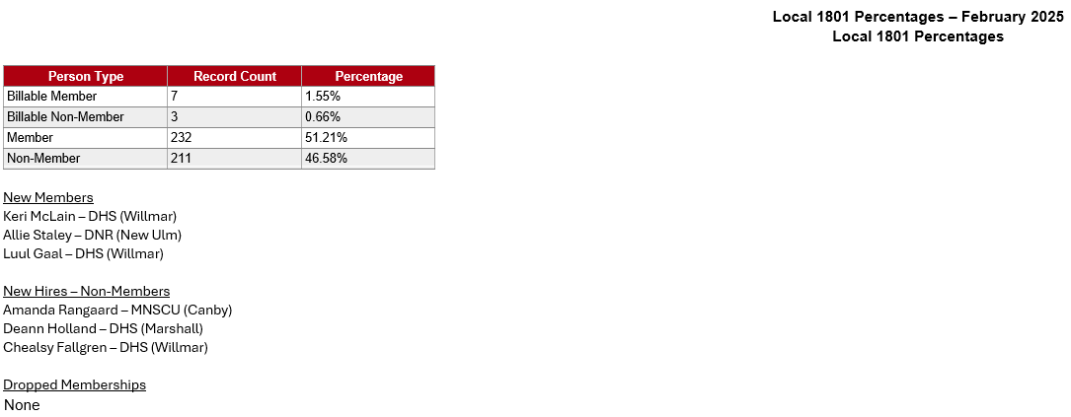e. Other reports

Local Presidents Committee report

1. Annual donation to non-profits or community discussion
2. Contract Negotiations Updates
3. CAT lead request for agencies and locations in region
4. Listening sessions—upcoming scheduled meetings
5. Contacts for people who have suggestions for negotiations
6. Drawing
   * Lorna King
   * Lorena Lindemann
7. Adjourn

