MAPE Local 1302 Meeting Agenda | 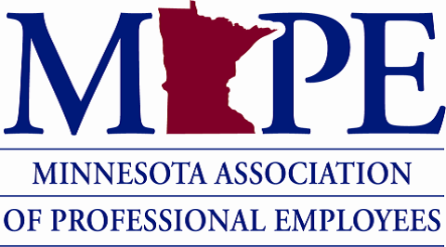 | Date: Wed. Dec. 11th, 2024  Time: 12:00-12:50 pm

Topics | Notes | Additional notes and Action Items
Local 1302 Officers & MAPE Business Agent | - President – Paige Wheeler, paige.wheeler@normandale.edu  - Vice President: Vacant.  - Rae Simonson – Treasurer, rae.simonson@normandale.edu  - Ted Scamp – Secretary, ted.scamp@normandale.edu  - Membership Secretary: Vacant.  - Amanda Prince. MAPE Business Agent, aprince@mape.org 612-963-1307- cell | Final meeting for current local officers, besides Rae who is continuing as Treasurer for 2025-2027.
Purpose of the Local Meetings | - Connect with employees in MAPE Local 1302 union.  - Update members on important MAPE business.  - Listen and discuss what is important to members.  - Members vote on things like how we use our budget.
Members vote on Local Budget for 2025 | - Local 1302 Approved 2025 budget  - Only members (pay dues) can vote  - Will vote by poll. Budget was approved.  - Not set in stone: we can change how we spend the money if needs or priorities change if members approve at a local meeting | Suggestion to double ($2,000 to $4,000) for the Donations/Good and Welfare category, which funds the Local 1302 Member Assistance Fund. Group agreed to this change.
MAPE Updates | - MAPE Statewide elections open until Dec. 12th. Must be a member to vote. Your ballot link was emailed to you. Candidate personal statements and open forums.  - Gearing up for contract negotiations. Join Contract Action Teams. Submit a proposal to the contract negotiators by Jan. 4, 2025. Listening sessions.  - MAPE Lobby Day at the Capitol Thurs. March 6th, 2025. Registration will open soon.  - 32 Hour Work Week Info Session at Minnesota State, Fri. 12/13 12-12:30 pm via Zoom. Register online.  - Local 1302 members asked about MAPE’s possible role if Trump Administration ends or changes some Federally-supported programs | Make yourself heard sooner rather than later!  Possibly affected programs include TRIO, basic needs, and DEI.
How to be a Member | https://mape.org/join-mape
Local Officers and Local Activity for 2025-2027 | - Paige (Local President) and Ted (Secretary) done in Local Officer positions end of Dec. 2025  - Rae Simonson (Treasurer) will serve for 2025-2027.  - We need more Local Officers. Position descriptions. Our Local positions are: President, Vice President, Treasurer (filled), Secretary, and Membership Secretary. There isn’t a description in the link for Membership Secretary; this position educates MAPE employees about the benefits of Membership. If you are interested in serving reach out to Paige.Wheeler@normandale.edu by end of Dec. 2024. | Rae has the power to appoint officers after Jan 1st.  You do not need previous union role experience to be an officer.
Reminder: Local 1302 Member Assistance Fund | - MAPE Local 1302 Member Assistance Fund Policy  - Intended to financially support Local 1302 members with sudden hardships.  - Members may request up to $400 per calendar year. (have so far done 3 of 5 requests for this year)  - To apply a member would submit a request form including a written explanation by e-mail to the local 1302 executive committee (paige.wheeler@normandale.edu; rae.simonson@normandale.edu; ted.scamp@normandale.edu) indicating the following: The desired amount and the reason for applying.  - You must be a dues-paying member to qualify; if you are not a member but want to become one you can do so online. | For 2025 budgeted $4,000 up from the 2024 budget of $2,000.
Anything else?

Next Local Meeting | To be determined. Rae Simonson (Treasurer) will organize if no other officers.
Questions?

