December 4, 2024 - Teams Link
Start time 12:05 PM End time 1:00 PM
Meeting Summary - scribed by Derek Duran
Date, Time & Location: Wednesday, December 4, 2024 – Microsoft Teams Link
Next Meeting Date, Time & Location: Noon-1:00 p.m., Wednesday, February 5, 2025, online via Microsoft Teams.

Topic | Key Points Raised | Decision/Action
Welcome – Lisa Becker, President | Welcome! Lisa gave a shout out to the Delegate Assembly and encouraged people to sign up to be alternate delegates. | No Action
Leadership Changes – Lisa Becker, President | Mary Ly and Peter Gens are stepping down from their roles (Membership Secretary and Steward Director respectively).  Sophie Nikitas and Christian Noyce will be joint Membership Secretaries and Catherine Okoneski will join Mary Heim as a joint Steward Director. Welcome! | No Action
Women in Public Service Conference Report – Roberta Suski and Mary Ly | Roberta Suski and Mary Ly attended a “Women in Public Service” conference and reported their learnings to the group. Both stated the conference to be inspiring and listed a neurodivergent class, a grief seminar, and a “Your Voice Matter” talk as some of the highlights. | No Action
Statewide Elections – Lisa Becker and Candidates | Candidates for Statewide President, Secretary, and Political Council attended the meeting and were all given time to give their pitch to the Local on why members should vote for them and also fielded several questions.  For Statewide President: Megan Dayton and Ted Snaza  For Statewide Secretary: Amy Mueller, Sophie Polonsky, and Michael Yost  For Statewide Political Council: Nicole Juan, William Treumann, and Jon VanOeveran | No Action
Motion for $500 to be allocated for Steward Jackets – Mary Heim | Mary Heim motioned to have $500 of the Local’s budget be allocated for jackets. Christian Noyce seconded and the motion passed.  Contact Mary Heim (mary.heim@state.mn.us) with questions. | Motion Passed
Regional Director Report – Nate Hierlmaier | N/A
Contract Action Teams Update – Rachel Wittkopp | N/A  Ongoing effort: Enlisting CATs  CATs can lead meetings, conduct townhalls, direct action plannings, conduct listening sessions, and recruit members.  Sign up to be a CAT today!  QR Code for Joining  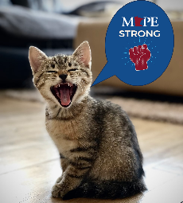  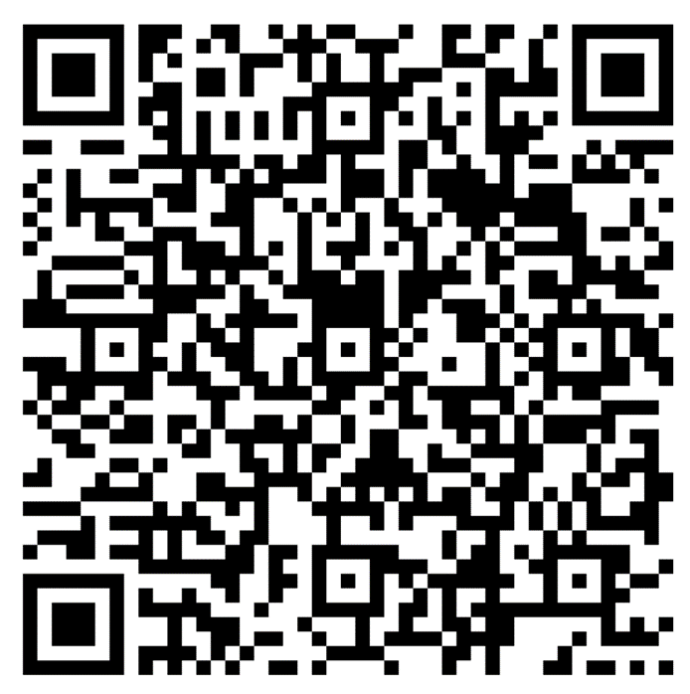  Contact Rachel Wittkopp (rachel.wittkopp@state.mn.us) with questions. | No Action
Business Agent Report – Beth Swanberg | N/A  Contact Beth Swanberg (bswanberg@mape.org) with questions. | No Action
Adjourn | Next Meeting: Noon-1:00 p.m., Wednesday, February 5, 2025, online via Microsoft Teams | No Action

Local 601 Leadership Team
Position | Name | Email Contact
President | Lisa Becker | lisa.becker@ssa.gov
Vice President | Roberta Suski | roberta.suski@state.mn.us
Secretary | Derek Duran | derek.duran@state.mn.us
Treasurer | Michael Zajicek | michael.zajicek@state.mn.us
Membership Secretary | Sophie Nikitas  Christian Noyce | sophie.nikitas@state.mn.us  Christian.noyce@state.mn.us
Regional Director | Nathan Hierlmaier | nathan.hierlmaier@state.mn.us
Regional Steward Directors | Mary Heim & Peter Gens | mary.heim@state.mn.us & catherine.okoneski@state.mn.us
Community Engagement Officer | Andrew Ulasich | andrew.ulasich@state.mn.us
Regional Negotiator | Jasen Bonnet | jason.bonnett@state.mn.us
MAPE Assigned Negotiator | Kirsten Peterson | Kirsten.peterson@state.mn.us
Local Contract Action Team Lead | Rachel Wittkopp | rachel.wittkopp@state.mn.us
MAPE Business Agent | Beth Swanberg | bswanberg@mape.org

