|  |  |  |
| --- | --- | --- |
| **Order of Agenda** | **What to do or discuss** | **Time** |
| **Call to order:** | President  *15 online* | 1 min |
| **Approve previous minutes** | If posted to site by 11/26/24.  [https://mape.org/locals/1601](https://gcc02.safelinks.protection.outlook.com/?url=https%3A%2F%2Fmape.org%2Flocals%2F1601&data=05%7C02%7Cmel.markert%40state.mn.us%7C356f6e943d2a4708ed8508dd0afe7d42%7Ceb14b04624c445198f26b89c2159828c%7C0%7C0%7C638678810375896368%7CUnknown%7CTWFpbGZsb3d8eyJFbXB0eU1hcGkiOnRydWUsIlYiOiIwLjAuMDAwMCIsIlAiOiJXaW4zMiIsIkFOIjoiTWFpbCIsIldUIjoyfQ%3D%3D%7C0%7C%7C%7C&sdata=7dJtK5Y6RJAeRs2X6iSJWbTsqlowqDttWMjrSBFWiL8%3D&reserved=0)  September is posted please review.  *Susie Sunde motions*  *Aarica Burke seconds* | 2 min |
| **Presidents Report:**  **Laura Czech** | Introductions and time allotted for any motions from the floor. | 5 min |
| **Treasures Report:**  **Aarica Burke** | Local Financial Standing.  *We will have some information coming up in the next couple meetings to review concerning the budget. Right now, nothing new and in good standing.* | 3 min |
| **Steward Director Report:**  **Jesse O’Connor** | Updates on any issues in the region.  *Nothing at this time from Jesse.*  *Amanda updates: DHS some issues with the mandatory shifts.*  *Annual reminder that each union has different overtime, so there will be conversations about that with DHS.*  *One person was placed on administrative leave. Working on that case and trying to get them back to work.* | 7 min |
| **Membership Secretary:**  **Susan Sunde** | Membership totals.  69.39% Members  30.61% Non-members | 2 min |
| **Regional Negotiations Rep Report:**  **Susan Sunde** | Update on any contract information. Negotiation plans and CAT.  *Been meeting the last two days.*  *Elected Healthcare coalition representatives.*  *Gabe Perkins and Kirstin Petersen*  *Talked about cost analysis and about the listening sessions that have been hosted so far.*  *In January they will start compiling the list of contract proposals.*  *Another meeting coming up with Aarica for the CAT (contract action team).*  *Talk to Susie or Aarica if you are interested in joining.*  *More information in the coming months. Watch for emails and other events.*  *Lobby Day is coming up. An email was sent out. We are working on transportation if you want to attend. If you got the email, you can forward it to others who might be interested or who might have misplaced the email. Members can get lost time paid for this event.* | 7 min |
| **Regional Directors Report:**  **Darren Hage** | Update on any regional business.  *Minor things on the restoration project to finish at the building.*  *Election info coming. Voting opens on Dec 2nd.* [*https://mape.org/resources/mape-documents/mape-internal-election-information*](https://mape.org/resources/mape-documents/mape-internal-election-information)  *DA recap online:* [*https://mape.org/news/delegate-assembly-2024-wrap*](https://mape.org/news/delegate-assembly-2024-wrap)  *Updated technology at central.*  *MAPE staff working to hire another BA. We are growing as a union and would like another BA to help cover the growing organization.*  *Advanced steward training 12/13. Sign up on MAPE portal or talk to Darren. You can also get a hotel or meal paid if needed and you can get lost time paid.* | 7 min |
| **Business Agent:**  **Amanda Prince** | Updates on any organizational business.  *Onboarding 3 new BAs. Amanda will remain in region 16 and splitting with Kelly Ahren. Took on a new position as a coordinator with organizing. Will remain as our BA.*  *Negotiations is the next big thing. Watch your emails.*  *If you get an anti-union mailing, we are looking at doing something creative with them on how to respond, especially if they come with a prepaid envelope. Working on a campaign response for members.* | 7 min |
| **New Business** | Delegate Assembly, 32-hour work week presentation.  *See below.*  *If you have questions or want more information, please reach out to the team using the following email:* 32mape@gmail.com | 5 min |
| **Old Business** | Delegate Assembly | 1 min |
| **Good and Welfare** | Bridget Stoner and Wendy Lane  *Propose to send them a check like previous times.*  *Susie Sunde motion.*  *Sherie Reuss seconds*  *Passes for both Wendy and Bridget.* | 1 min |
| **Gift Card Drawing** | Susie will draw: *Theresa F congratulations!* | 1 min |
| **Next meeting** | 01/28/25  *No meeting in December due to holidays. Happy Holidays!!* | 1 min |
| **Adjourn** |  |  |

After adjourn talking about the 32 hour work week with Kaity Taylor.

## ****I’m worried that pushing for this will mean we don’t get wage increases.****

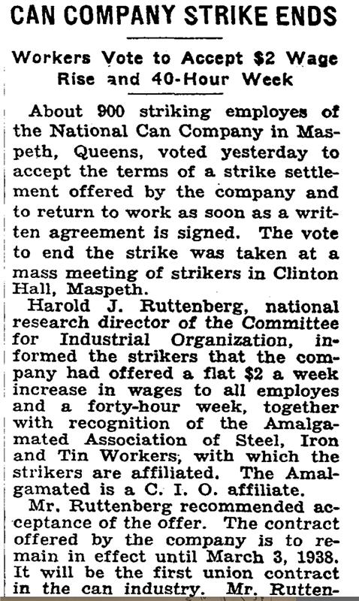

Let’s take a lesson from the Can Company workers in 1937 who won wages and time! Having multiple bold demands can strengthen us in contract negotiations. Last year United Auto Workers included a 32-hour workweek in their demands, and while they didn’t win it, they did win [historic pay raises](https://www.npr.org/2023/11/16/1212381342/gm-autoworkers-vote-yes-approve-uaw-contract-ford-stellantis#:~:text=But%20workers%20will%20get%20pay%20increases%20of%20at,money%20will%20see%20their%20pay%20more%20than%20double.). AFSCME in San Juan County won both a 32-hour workweek and wage increases in 2023.

Big 3 autoworkers vote 'yes' to historic UAW contracts

With voting nearly complete, long-time workers should soon see pay rise by about 33%, while some newer workers and temps will see their pay more than double. Final tallies are expected this weekend.

NPR

Letter of support: <https://docs.google.com/forms/d/e/1FAIpQLSdSO3hfpis1Ed5TYIZgJYg8GaNFkJn_xzQCI9243oPY_lGntQ/viewform>

Info session slides: <https://docs.google.com/presentation/d/1yvSBYUl8mWhnKczqc0Twmt_t5qV7c9wCmXzCMjsg8zc/edit?usp=sharing>

FAQ: <https://docs.google.com/document/d/11ydJmVyRBJlPZQCHX1y1e9NlcgRTusZ23tAtn-prYjg/edit>

32 Hour Work Week Example: <https://engage.sanjuancountywa.gov/20872/widgets/81869/documents/54512>

32-Hour Work Week email: 32mape@gmail.com