November 6, 2024 - Teams Link
Start time 12:05 PM End time 1:00 PM
Meeting Summary - scribed by Derek Duran
Date, Time & Location: Wednesday, November 64, 2024 – Microsoft Teams Link
Next Meeting Date, Time & Location: Noon-1:00 p.m., Wednesday, December 4, 2024, online via Microsoft Teams.

Topic | Key Points Raised | Decision/Action
Welcome – Lisa Becker, President | Welcome! Lisa gave a shout out to the Delegate Assembly and encouraged people to sign up to be alternate delegates. | No Action
Budget Vote  – Michael Zajicek | Michael provided a summary of the previous year’s budget and the new proposed budget for our Local. The greatest difference was that the local has more income now due to more members paying dues. Beka Ehlerbrackt made a motion to pass the proposed budget and it was seconded. The local was polled through the Teams Chat and passed. | Proposed Budget – Vote Passed
Delegate Assembly Recap – Christian Noyce | Christian Noyce provided a recap of the Delegate Assembly. He reiterated that the DA is a great way for new and old members to get more involved. The revenue requirement item, the Israel-Palestine ceasefire, and nominations passed. The item on attorney fees failed. Items regarding increased funding per local, money not spent by the local being sent elsewhere, and the 32-hour work week were all tabled and sent to committee. | No Action
AI Education – Lisa Becker and Lex Brand | Leadership received comments and concerns about the use of AI, including privacy concerns as well its ability to accommodate ASL and summarization. Leadership is seeking feedback from members. | No Action
Steward Report – Mary Heim/Pete Gens | Mary Heim provided the following and discussed it in the meeting:  Stewards are hearing concerns from members and represented employees about workload concerns. Our contract allows you the right to have a “meet and confer” with your managers to discuss concerns about being unable to perform job duties because of increased workload. A steward can help support you with the process. You will be asked to take an active role in the process as well. Please reach out to the steward team. Mary Heim and Peter Gens, Regional Steward Directors can help connect you with a steward to discuss your options.  Contact Mary Heim (mary.heim@state.mn.us) or Peter Gens (peter.gens@state.mn.us) with questions. | No Action
Regional Director Report – Nate Hierlmaier | Nate reiterated that political environment post-election is tough but that rather than mourn we should organize. He pitched that we need to make sure we show up on Lobby Day. Nate reported that work in the Healthcare Committee has been discussion making healthcare a right and to reach out with any question.
Contract Action Teams Update – Rachel Wittkopp | The Negotiations Team have hosted a few listening sessions so far and reiterate that their importance. Jason states that you can reach out to him if you want to schedule more listening sessions.  Rachel Wittkopp also reiterated the importance of joining the Contract Action Teams (CATs).  CATs can lead meetings, conduct townhalls, direct action plannings, conduct listening sessions, and recruit members.  Sign up to be a CAT today!  QR Code for Joining  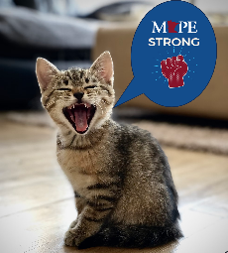  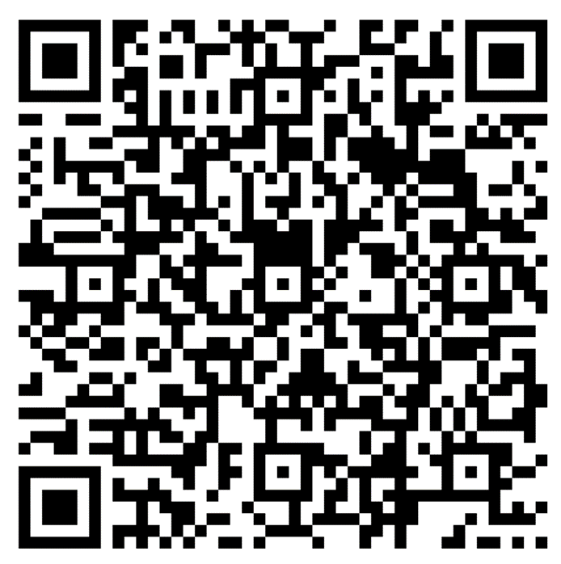  Contact Rachel Wittkopp (rachel.wittkopp@state.mn.us) with questions. | No Action
Business Agent Report – Beth Swanberg | Beth encouraged more members to get involved and to take the basic and advanced steward trainings. She also states that the goal is to have 1 CAT for every 10 people in the local.  Contact Beth Swanberg (bswanberg@mape.org) with questions. | No Action
Adjourn | Next Meeting: Noon-1:00 p.m., Wednesday, December 6, 2024, online via Microsoft Teams | No Action

Local 601 Leadership Team
Position | Name | Email Contact
President | Lisa Becker | lisa.becker@ssa.gov
Vice President | Roberta Suski | roberta.suski@state.mn.us
Secretary | Derek Duran | derek.duran@state.mn.us
Treasurer | Michael Zajicek | michael.zajicek@state.mn.us
Membership Secretary | Sophie Nikitas  Christian Noyce | sophie.nikitas@state.mn.us  Christian.noyce@state.mn.us
Regional Director | Nathan Hierlmaier | nathan.hierlmaier@state.mn.us
Regional Steward Directors | Mary Heim & Peter Gens | mary.heim@state.mn.us & peter.gens@state.mn.us
Community Engagement Officer | Andrew Ulasich | andrew.ulasich@state.mn.us
Regional Negotiator | Jasen Bonnet | jason.bonnett@state.mn.us
MAPE Assigned Negotiator | Kirsten Peterson | Kirsten.peterson@state.mn.us
Local Contract Action Team Lead | Rachel Wittkopp | rachel.wittkopp@state.mn.us
MAPE Business Agent | Beth Swanberg | bswanberg@mape.org

