September 4, 2024 - Teams Link
Start time 12:05 PM End time 1:00 PM
Meeting Summary - scribed by Derek Duran
Date, Time & Location: Wednesday, September 4, 2024 – Microsoft Teams Link
Next Meeting Date, Time & Location: Noon-1:00 p.m., Wednesday, October 2, 2024, online via Microsoft Teams.

Topic | Key Points Raised | Decision/Action
Welcome – Lisa Becker, President | Welcome! Lisa gave a shout out to the Delegate Assembly and encouraged people to sign up to be alternate delegates. | No Action
MAPE Restructure Update  – Lisa Becker | The update on the restructure plan is that the group has not come to a consensus on what the plan will be and that there will be no restructure this year. Additionally, there is a not a timeline as of yet. However, they have decided that they want the Delegate Assembly to vote to allow all MAPE members to vote on the proposal when there is one. | No Action
Budget Update – Michael Zajicek | Michael provided a budget report for each month since September of 2023. A summary of the report is that food and “membership related expenses” or events account for our Locals’ biggest expenses typically. Our local’s revenue comes from our dues – about $1.25 of every paycheck goes to our Local. Currently, we have around $143,800 in reserve that not allocated to any particular project or expense.  Contact Michael Zajicek (michael.zajicek@state.mn.us) for the full report or any questions. | No Action
Regional Director Report – Nathan Hierlmaier | Nate gave an update on how MAPE is structured and how the Delegate Assembly (DA) fits into the overall workings of MAPE as a whole. The DA is on October 25 and 26th and our Local gets 9 delegates with as many alternate delegates. Delegates must attend one budget and one resolution forum before the DA. There are several forums scheduled between now and October 25th and can be found on the MAPE website under events. They are open to all members, not just delegates and alternate delegates – we encourage all who are interested to attend!  Of note, the budget forum has $1 Million budget item focused membership outreach and retention that members may be interested in learning more about.  Nate listed the six proposed resolutions that the DA will vote on:  - Allow local and region to pay for attorney fees  - Dissolution of the nominations committee  - Increase funding for locals  - Unspent local funds recaptured  - Add 32-hour workweek to legislative agenda (already happened)  - Support ceasefire and divestment in Israel/Palestine  Nate emphasized the importance of the DA and encouraged members to take on the alternate delegate role as way to get more involved.  Jason and Lisa clarified – delegates and alternate delegates are eligible for loss time, i.e. compensation for time spent doing DA work.  Contact Nathan Hierlmaier (nathan.hierlmaier@state.mn.us) with any questions. | No Action
Steward Report – Mary Heim/Pete Gens | Mary Heim provided the following in an email that Roberta Suski read aloud in the meeting:  A recent incident became public where a DNR employee had their social media comments condoning political violence reported to MN DNR. Stewards are here to help when you’re under investigation but also to help you prevent getting into this type of situation.  We do not want to discourage our members from exercising their rights. However, we do want you to think about how what you post on social media could impact your employment, reputation, and legal status. There are factors which may create a nexus, or a connection, to your employment and put you at risk of disciplinary investigation for your employment, put your reputation at risk or legal concerns. Some things to consider:  Do you list your employer in your social media profile?  Do comments or posts reference your status as a state employee?  Who can view your social media profile, posts, and comments? What are your settings for each?  Who are your friends/followers on social media? Colleagues? Supervisors? Managers?  Could my comments be reasonably interpreted as disparaging or discriminating against people, based on their membership in a protected class (e.g. race, sexual orientation, gender, religion, aged 40+, national origin, use of public assistance, or disability)? Remember, one does not need to be a minority to be part of a protected class. Every person is a member of a protected class under MN and federal law, because every person, for example, has a race.  Could my comment be reasonably interpreted as promoting violence, illegal drug use or other illegal activities?  Could my comments be reasonably interpreted as threatening harm or violence to a person or group of people?  Your steward team does not want to limit or restrict your freedom of expression. We certainly don’t want to tell you what to think or say on any hot button issues. We aren’t your social media managers. We do want you to take a moment and think about your social media usage and how it can impact your employment and reputation. What you post on social media is forever, even if you think you’re just sharing with friends or delete your post or comment. It’s especially easy to get caught up on in the moment as we are in election season. Slow down. Take a breath. Think and re-think before you post. Also please think about how your social media viewing and usage can impact your mental health. Most of us could benefit to cut down.  Seek out assistance from our Employee Assistance Plan if needed. You can call Life Matters EAP at 1-800-657-3719.  Steward Support  Stewards are here to make sure your rights are respected, and you feel safe and heard as a state employee. We are also here to support you in ensuring your rights are respected and you feel safe and heard as a union member or represented employee. Our team of stewards deeply values each member. We all contribute to the diversity of our membership. It’s not always easy to be a union member. There may be topics that are sensitive or difficult that get brought up or brought up in a manner that can be emotionally triggering. We aren’t here as stewards to tell you what to think or feel, but we do want to help make sure all members feel safe and heard, especially about issues that may impact them the most. We have a great bunch of stewards in Region 6. Please reach out to us if you need support, both as a state employee and as a union member or represented employee. You can contact Peter Gens and Mary Heim. We will help you directly or get you in contact with a steward who can assist. You can also find stewards in the Find Your Steward | Minnesota Association of Professional Employees (mape.org) section of the MAPE website.  It’s worth repeating: Seek out assistance from our Employee Assistance Plan if needed. You can call Life Matters EAP at  1-800-657-3719  Contact Mary Heim (mary.heim@state.mn.us) or Peter Gens (peter.gens@state.mn.us) with questions. | No Action
Contract Action Teams Update – Rachel Wittkopp | Rachel Wittkopp presented on Contract Action Teams (CATs).  Rachel explained that in the negotiation process the MAPE negotiators will negotiate with the state and in that process, they will want quick feedback from MAPE members. This is where the CATs come in. The negotiators will give information to Rachel who then give that information to our army of CATs. These CATs will have a group of ideally 10 or so members who will provide feedback to those CATs who then relay that information to Rachel and then to the Negotiators. The CATs are necessary for the Negotiators to get a pulse on how the MAPE members as a whole are feeling on certain issues or certain topics – they will be the all-star communicators this negotiation cycle!  CATs can lead meetings, conduct townhalls, direct action plannings, conduct listening sessions, and recruit members.  Sign up to be a CAT today!  QR Code for Joining  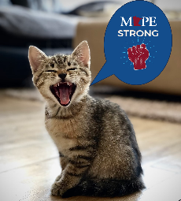  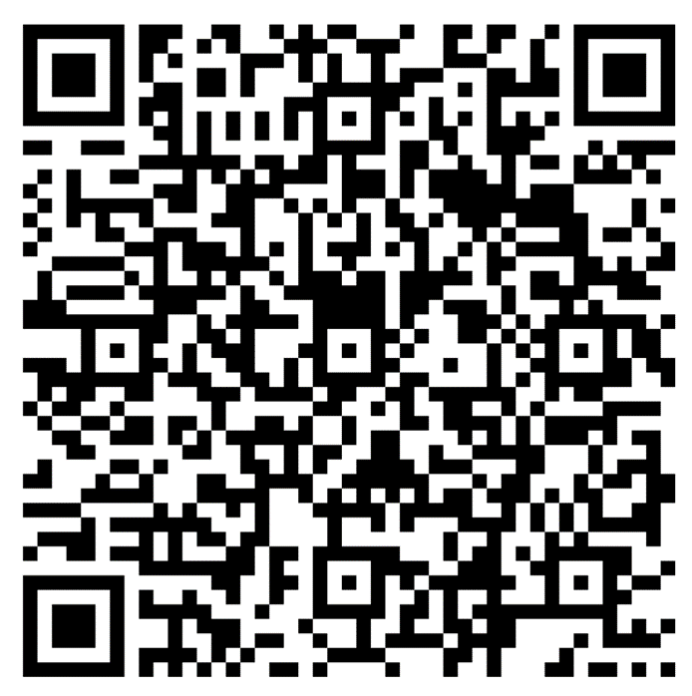  Contact Rachel Wittkopp (rachel.wittkopp@state.mn.us) with questions. | No Action
Business Agent Report – Beth Swanberg | Beth encouraged members to step up and jump into the new leadership roles discussed in the meeting today. The alternate delegate roles as well as the Contract Action Team leads will be very important and will provide great experience.  The Office of Cannabis Management members have done 2 listening sessions to hear member concerns regarding the opening of their new agency. Member leaders have stepped up to and are in the process of scheduling a meet and confer with management.  After various listening sessions and planning the Commerce Meet and Confer committee will have an introductory meeting with management on 9/9.  Contact Beth Swanberg (bswanberg@mape.org) with questions. | No Action
Adjourn | Next Meeting: Noon-1:00 p.m., Wednesday, October 2, 2024, online via Microsoft Teams | No Action

Local 601 Leadership Team
Position | Name | Email Contact
President | Lisa Becker | lisa.becker@ssa.gov
Vice President | Roberta Suski | roberta.suski@state.mn.us
Secretary | Derek Duran | derek.duran@state.mn.us
Treasurer | Michael Zajicek | michael.zajicek@state.mn.us
Membership Secretary | Mary Ly | mary.ly@state.mn.us
Regional Director | Nathan Hierlmaier | nathan.hierlmaier@state.mn.us
Regional Steward Directors | Mary Heim & Peter Gens | mary.heim@state.mn.us & peter.gens@state.mn.us
Community Engagement Officer | Andrew Ulasich | andrew.ulasich@state.mn.us
Regional Negotiator | Jasen Bonnet | jason.bonnett@state.mn.us
MAPE Assigned Negotiator | Kirsten Peterson | Kirsten.peterson@state.mn.us
Local Contract Action Team Lead | Rachel Wittkopp | rachel.wittkopp@state.mn.us
MAPE Business Agent | Beth Swanberg | bswanberg@mape.org

