**MAPE LOCAL 1002 General Membership Meeting Agenda**

**21 May 2024 (Third Tuesday of Month)**

**President: Saadia Mohamed**

Welcome

**Treasurer’s Report: Kristine Anderson**

* Nothing to report.

**Meet and Confer: Michael Diedrich**

* No updates. Most recent meeting needed to be rescheduled.

**Coalition Building Workgroup, John Gimpl**

* We support other union and labor movement fights based on shared values of a strong labor movement.
* We are still building what this looks like, so we welcome thoughts, feedback, and communication.
* Overview:
  + Showing up for actions, pickets, and strikes
  + Providing strike support (mostly physical support but some financial)
  + Finding ways to cohost events and conversations
  + Sharing trainings and resources around solidarity, cross-labor issues, and union education
  + Exploring how shared negotiations among unions can benefit all
  + Additional Questions, ask/email John Gimpl
  + There is a ‘MAPE LOCAL 1002 Membership’ MS Teams distribution/chat
  + This information will also be in the MAPE 1002 Newsletter

**Accessibility Update, Emily Jahr**

* Meet and Confer has formed a sub committee to address building accessibility and improvements.
* Feel free to forward any building concerns to the subcommittee to address with administration
* Emily.jahr@state.mn.us

**Membership: Holly Andersen and the Membership Committee (3)**

* Head’s up on most recent membership /involvement opportunities
  + Thanks for all that showed up for May Day celebration
  + Forward any ideas to Holly as the lead of membership/ feel free to join the membership team
  + Update to raffle/giveaway: returning to the MAPE-wear SWAG instead of gift certificates
  + Also, if you don't win the raffle today and still want to show your MAPE pride, you can order MAPE swag from the MAPE store. https://mapestore.itemorder.com/shop/home/

**Discussion Sara Weiss**

Four Key Issues for discussion from Feb to March workload, student loans, building accessibility and telework

[**MAPE Discussion Board**](https://docs.google.com/document/d/1y0lBv_Xk5dPZCaPQ0lIMKr67v7IfGkm6YzCKk8PvezU/edit%23heading=h.p331vsopbizb)

No significant updates on

* Accessibility, send additional concerns to Emily Jahr
* Student Loans, acknowledgement of status

**Discussion**

* **Workload**: moment in time snapshot of workload perpetual or related to leg session 2023
* **Telework:** moment in time snapshot of requirements for in person presence and scheduling
* Where are the intersections between the two, how they work together or conflict?
* Examples?

**Business Agent: Dan Engelhart Jackie Blagsvedt (5) Region 10 Director)**

* Board of Director’s update
  + 17200 MAPE supported staff. Membership has seena significant increase from last year.
  + Finances are on target.
  + Dues is where we want it to be, but we need to increase percent of members to keep
  + Over the past two months, April 12 members commented.
    - UE cease-fire petition
    - Divest from war related industries
    - Some members want a ceasefire statement, some want us to be silent/neutral
    - PETITION TEXT: https://secure.everyaction.com/w1qW7B3pek2rTtv9ny5bqw2

**Org Council: Sarah Weiss**

* Nothing to report

**Raffle: Holly Andersen**

**Closing** 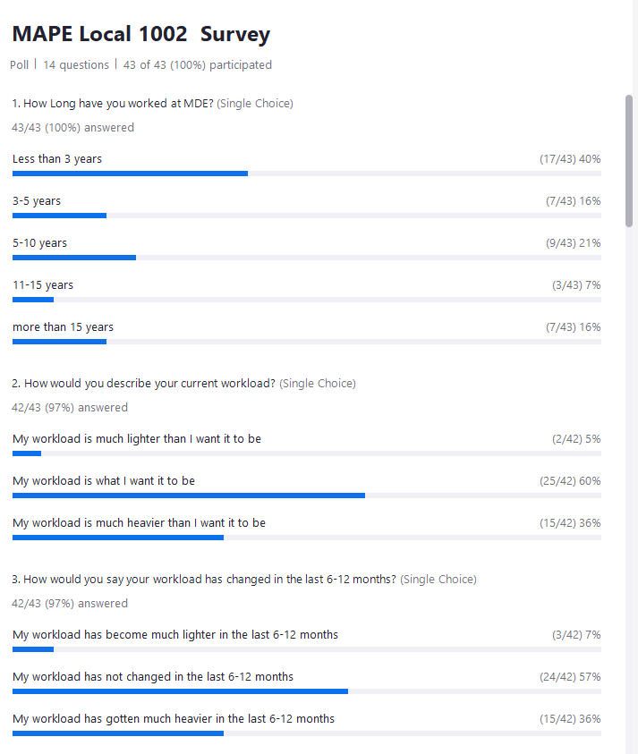

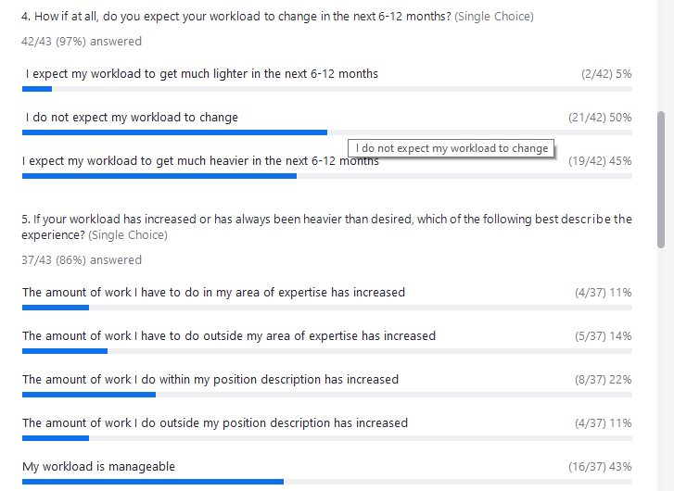

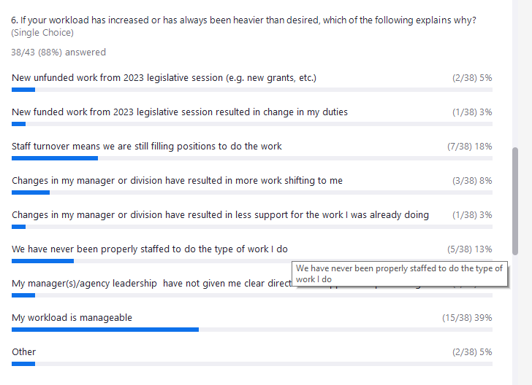

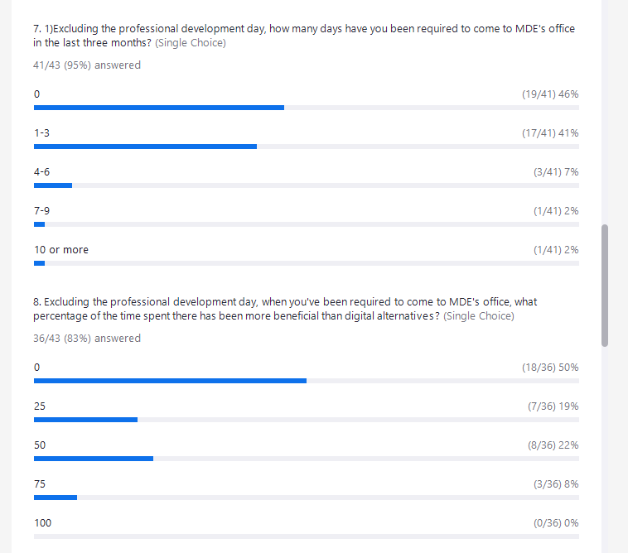

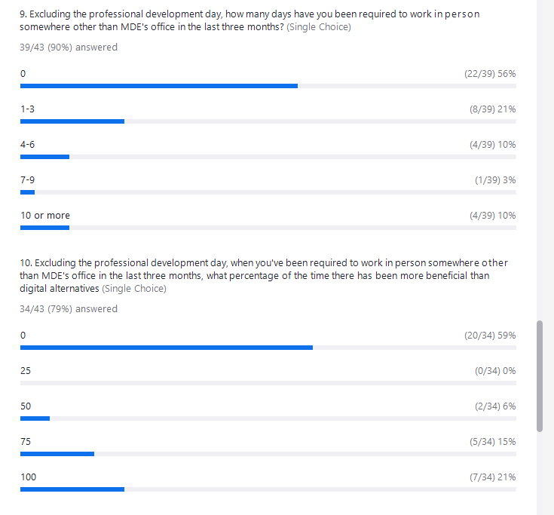

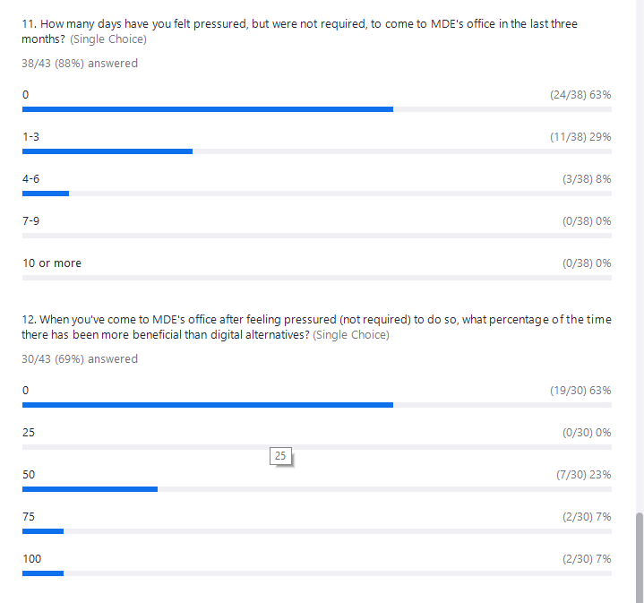

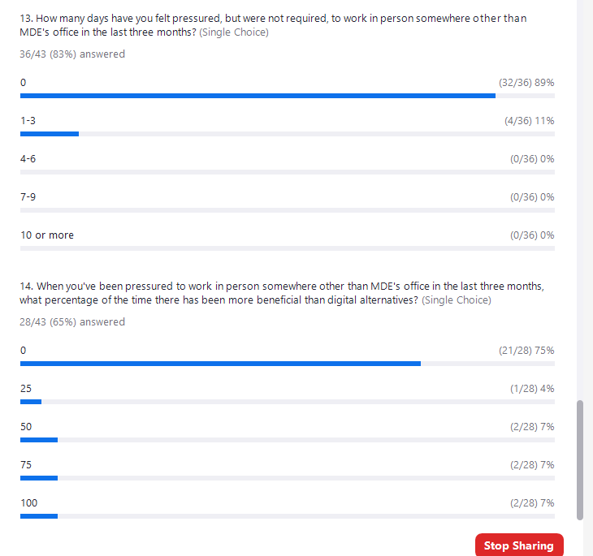

**Jackie Blagsvedt (she/her) MDE** 11:35 AM  
Also, Local 1002's MAPE Business Agent (staff) Dan Engelhart is on Vacation today.  
  
**Holly Andersen MDE (she/her)** 11:35 AM  
And Michael Diedrich is at a conference, but he has added meet and confer updates to the newsletter (to be in your inbox tomorrow)  
  
**Sarah Weiss, she/her MDE** 11:39 AM  
So cool John!!  
  
**Emily Jahr** 11:44 AM  
Emily.jahr@state.mn.us  
  
**RReyes** 11:44 AM  
Hi Emily Jahr thank you for being here.  
  
**RReyes** 11:45 AM  
Is there language in the MDE building lease that talks about building accessibility?  
  
**RReyes** 11:46 AM  
Did the contractor who installed the cubes and floor design have an Accessibility plan for the MDE layout?  
  
**Jackie Blagsvedt (she/her) MDE** 11:47 AM  
Also, if you don't win the raffle today and still want to show your MAPE pride, you can order MAPE swag from the MAPE store. https://mapestore.itemorder.com/shop/home/  
  
**Sarah Weiss, she/her MDE** 11:50 AM  
https://jamboard.google.com/d/17Trhcrikdswr-faUnSJzGgLHq_Aj-vj1Djh8tvo3djQ/viewer  
https://docs.google.com/document/d/1y0lBv_Xk5dPZCaPQ0lIMKr67v7IfGkm6YzCKk8PvezU/edit#heading=h.p331vsopbizb  
  
**Megan Carter (she/her), MDE** 11:58 AM  
When the new MDE building first opened, we had a limit on the number of days/month that supervisors could require us to come in if we were approved for full time teleworking. Does something like that still exist?  
  
**Jackie Blagsvedt (she/her) MDE** 12:01 PM  
I'm searching MMB's site to see if I can find the latest MMB telework agreement template.  
  
**Jackie Blagsvedt (she/her) MDE** 12:01 PM  
chrome-extension://efaidnbmnnnibpcajpcglclefindmkaj/https://mn.gov/mmb-stat/policies/1422-telework.pdf  
  
**Alina Campana, she/her, Arts Specialist** 12:01 PM  
Here is the current (I believe) state telework policy: https://mn.gov/mmb-stat/policies/1422-telework.pdf  
  
**Ashley Bieber (she/her)** 12:02 PM  
Also are we still required to be in 3 days a week to have an assigned cube?  
  
**Joe Maffit** 12:03 PM  
Not seeing it...just notes.  
  
**Betsy Blackhawk** 12:05 PM  
I want to be one of the people:  'my workload is manageable'.  🤣  
  
**Sarah Weiss, she/her MDE** 12:06 PM  
  
**Betsy Blackhawk** 12:06 PM  
I find that staff turnover is the main reason why workload is increased or heavier.  
  
**Betsy Blackhawk** 12:07 PM  
Question #6  
  
**Sarah Weiss, she/her MDE** 12:06 PM  
  
**Emily Jahr** 12:07 PM  
Staff turnover and not staffed properly was something that has been on my mind  
  
**RReyes** 12:08 PM  
Also Management at the Director and Supervisor level are not asking these questions of staff quarterly.  
  
**Ashley Bieber (she/her)** 12:09 PM  
High turnover in HR are making the hiring process soooo long  
  
**Ashley Bieber (she/her)** 12:10 PM  
And then no good onboarding process  
  
**Gail Mulcahey** 12:10 PM  
The process of getting hired is ridiculous  
  
**Sarah Robinson (MDE)** 12:10 PM  
I applied for my current position last April and got called about an interview in September  
  
**Gail Mulcahey** 12:10 PM  
The job board is also pretty bad. It doesn't work in Firefox.  
  
**RReyes** 12:13 PM  
Lack of professional opportunity to cross train staff within divisions and across state agency programs.  
  
**RReyes** 12:14 PM  
MDE knowledge base is not keeping up with the workload...  
  
**Gail Mulcahey** 12:15 PM  
Remember many of us are new. It's all relative... we're comparing to corporate  
  
**Betsy Blackhawk** 12:15 PM  
Good question Jackie!  
  
**Michelle Niska** 12:16 PM  
Hmmm🤔  
  
**Sarah Robinson (MDE)** 12:16 PM  
My workload is manageable because I am still new. I still don't have a full scope of what my workload will ultimately look like. It's slowly increasing. But I do have an amazing supervisor who encourages time off and self care.  
  
**Holly Andersen MDE (she/her)** 12:18 PM  
Ohhhh comparing to the classroom experience is a good point  
  
**Sarah Robinson (MDE)** 12:18 PM  
I just came out of the classroom after 20 years. This job is a dream and much more manageable than what the previous 20 years was like!  
  
**Kari Johnson MDE (she/her)** 12:19 PM  
I think my work/life balance is great BECAUSE of teleworking.  
  
**Sarah Robinson (MDE)** 12:21 PM  
There was a car this morning that had its window broken out! I come to office nearly every day. I so don't want my windows to get broken.  
  
**Betsy Blackhawk** 12:21 PM  
Also for those that get a car for travel, and leaving your car there overnights.  
  
**Natasha Lemke** 12:21 PM  
I am deterred from using a state car for this reason  
  
**Jon VanOeveren - MN** 12:22 PM  
We used to have security at the old building, I haven't seen any at the new.  
  
**Jackie Blagsvedt (she/her) MDE** 12:22 PM  
Deb Rose and Kristine Anderson are two MAPE members on the safety committee  
  
**Betsy Blackhawk** 12:23 PM  
I was told that the only cameras that are out there, are pointed at the fleet cars. Do we know if there are other cameras out there?  
  
**Wendy Behrens, Minnesota Department of Education** 12:24 PM  
It is a reasonable expectation that employees have a safe place to park.  
  
**Jackie Blagsvedt (she/her) MDE** 12:24 PM  
I have some BOD updates  
  
**Michelle Niska** 12:22 PM  
Urgh, not looking forward to that deductible if my car gets broken into - I don't suppose that is covered by the state if the car is in the lot?  
  
**YCain** 12:24 PM  
Great question and statement. Who's is accountable if this occurs on state property.  
  
**Emily Jahr** 12:25 PM  
There has been several asks/statements made by our leadership to encourage coming to the building, and turning cameras on for all meetings to show that our division is visible.  
  
**Holly Andersen MDE (she/her)** 12:25 PM  
Thank you all for sharing in this convo, I have so enjoyed learning more about others experiences  
  
**Sarah Robinson (MDE)** 12:25 PM  
I'm here almost every day. The building is very quiet. It's always fun when there's more peeps here!  
  
**Wendy Behrens, Minnesota Department of Education** 12:25 PM  
why would anyone want to put themselves or their personal property at risk when it is not required?  
  
**Michelle Niska** 12:26 PM  
👏 More members!!  
  
**Michelle Niska** 12:24 PM  
It may not only be the Minneapolis community and safety concern - maybe it is the more isolated parking lot? Our lot in Roseville was wide open and things would happen but this is a bit more hidden, imho.  
  
**Holly Andersen MDE (she/her)** 12:27 PM  
Oh good point. I wonder about parking across the street versus next to the building... that lot is much more like the old mde building lot  
  
**Sarah Robinson (MDE)** 12:27 PM  
@Holly Andersen MDE (she/her) Good point! I hadn't thought of that!  
  
**Holly Andersen MDE (she/her)** 12:24 PM  
Nawid Raai and Michelle Niska are winning our MAPE merch! I will send emails  
  
**Kristine Anderson** 12:27 PM  
Sorry, Nawid. You already won the raffle once this year. We will need to pick someone else.  
  
**Holly Andersen MDE (she/her)** 12:28 PM  
Team effort!  
  
**Kari Johnson MDE (she/her)** 12:28 PM  
I love the newsletter Holly!  
  
**Jon VanOeveren - MN** 12:29 PM  
It was a large group from multiple locals.  
  
**Deb Rose** 12:27 PM  
The parking lot incidents will be addressed at the next all staff meeting. In the safety committee meeting we were told that the break ins have been targeted to specific makes of cars, mostly Kia, it is not targeted towards stealing items from vehicles. I do believe the agency leadership will down play it all. Safety Committee membership tried to encourage them to address it in a better way and make us feel safe. We will see if they listened!  
  
**Michelle Niska** 12:28 PM  
Thanks...I have a Hyundai which is also commonly stolen...lol. Wish I knew that before I bought the silly thing.  
  
**Betsy Blackhawk** 12:30 PM  
Great! I have a Kia. 🙁  
  
**Jackie Blagsvedt (she/her) MDE** 12:30 PM  
[The US Labor Movement Calls for Ceasefire in Israel and Palestine (everyaction.com)](https://secure.everyaction.com/w1qW7B3pek2rTtv9ny5bqw2)  
  
**Wendy Behrens, Minnesota Department of Education** 12:30 PM  
I agree with those who have asked the MAPE to remain neutral.  
  
**Jon VanOeveren - MN** 12:31 PM  
I was one of the members who spoke in favor and would be happy to have conversations with members regarding my position.  
  
**Holly Andersen MDE (she/her)** 12:29 PM  
Joe is the new MAPE merch winner! Is it Joe M?  
  
**Kristine Anderson** 12:30 PM  
I'll need Joe's last name!  
  
**Joe Maffit** 12:30 PM  
Maffit  
  
**Holly Andersen MDE (she/her)** 12:31 PM  
Hooray!  
  
**Joe Maffit** 12:31 PM  
Thank you, Holly!  
  
**Sarah Weiss, she/her MDE** 12:33 PM  
Have a great day everyone!  
  
**Michelle Niska** 12:34 PM  
Thaks!  
  
**Jon VanOeveren - MN** 12:34 PM  
Thank you all for coming today