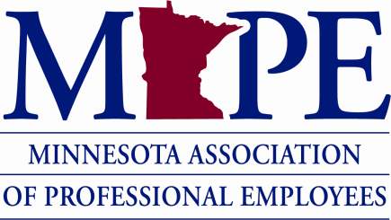

**MAPE Local 1301 Monthly Meeting Minutes**

**Tuesday February 20, 2024**

**12:00-1:00pm**

* Welcome
* DHS Student Loan Reimbursement
  + - This is an opportunity to hear the status of the student loan reimbursement program and members to share stories about how this program would impact you and your family.
* Listening session scheduled for Feb 22.
  + - * [Listening Session Sign Up](https://portal.mape.org/EventCalendar.aspx?DateToUse=01-Feb-2024&EventID=3219)
* Student loan reimbursement is different from public service loan forgiveness.
  + - * PSLF is something all government employees qualify for and has requirements around type of loan, when it was taken out, etc. More information about PSLF can be found here: [Public Service Loan Forgiveness (PSLF) Help Tool | Federal Student Aid](https://studentaid.gov/pslf/)
* Local 1301 professional development reimbursements
* Local 1301 has a budget allocated for licensing/certificate/professional development fees not covered by the employer for dues paying members.
* You can submit a reimbursement request for up to $150.
* You can submit request within 6 months of expense with receipt to local treasurer Jadwiga - [jadwiga.piskorski@state.mn.us](mailto:jadwiga.piskorski@state.mn.us)
* DEED range reassignments
  + - DEED recently implemented a salary range reassignment for several classifications.
    - This went into effect January 31, 2024
* Next Lobby Day is March 19, 2024 at the state capitol
  + Register on the MAPE website - <https://mape.org/events/lobby-day-2024>
* The more turnout we have for events like this, the higher the chance we will have a stronger position at the negotiation table.
  + - * Having conversations with elected leaders early and often is the key to getting our legislative priorities enacted.
  + Training available for first-time attendees
    - * March 13th noon–1 pm
      * March 14th 5-6pm
      * Sign up for training sessions: https://mape.org/news/lobby-day-training
* Membership drawing winner - Pamela Muehlbauer (DEED)

Upcoming Events:

Home Buyer’s Seminar - 2/25/24 5:30 pm - 7 pm at MAPE headquarters, 3rd floor

Lobby Day – Tuesday March 19, 2024

Advanced Steward Training – Friday, March 22nd from 8:30am-5:00pm at MAPE headquarters

***\*Next 1301 local meeting will be on Tuesday March 19, 2024, at noon via* Teams*\****