MAPE meeting minutes 2-20-24

- 2024 Budget Approval
Karen Roatch (treasurer) presented budget as of Dec 2023
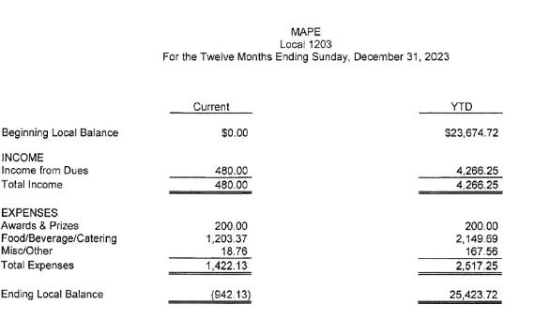
- $167.56 is for printing and supply purchases.
- Proposed Local 1203 Budget:
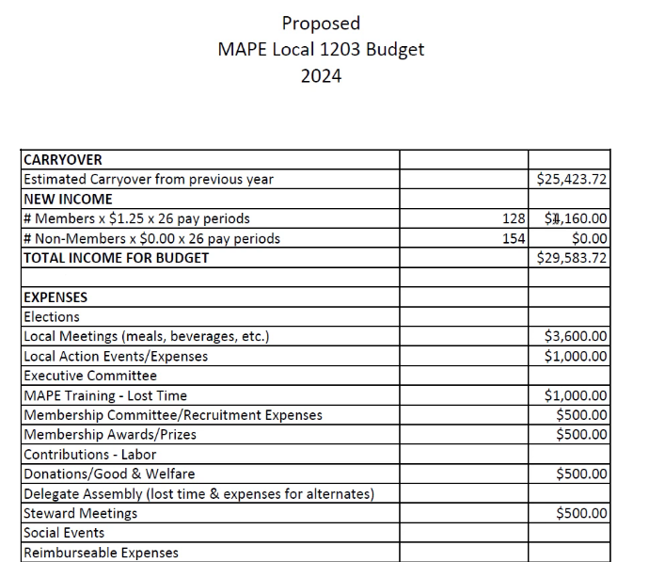
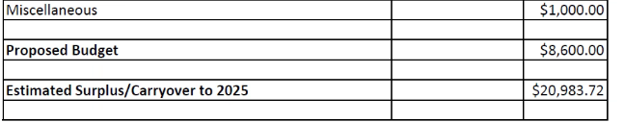
- Proposed budget is higher than our income, but we have a lot of carryover.
- Budget was accepted and seconded.
- Become a steward! Local officers are considered organization part of the union. Stewards role is in contract enforcement. You are the go-to person for contract questions. They are also a resource for when you are part of an investigation. Suzanne and Marlijn are the only two BCA stewards at this time. If you are interested, the next steward training is in the cities on April 26 and one in Bemidji April 17. You do not have to become a steward if you attend the training.
Steward Trainings:
https://mape.org/events/basic-steward-training-apr-2024
https://mape.org/events/bemidji-basic-steward-training
- Officer Training recap
Local officers attended officer training in January.
- Plans mentioned for a restructure, but it was in the very early stages. New structure will benefit members. Trying to be as transparent as possible with website updates/opportunities to comment.
- Breakout sessions for each officer type. Discussed communication options
- MAPE updates
- Goals for our local: Set consistent meetings (every other month), host more membership engagement events (outing, lunch, community engagement), and focus on membership recruitment
- Membership at 45%. Goal to get to statewide average of 65%. Bring ideas to local officers
- Tuesday, March 19: Lobby Day. Scheduled time for you to sit individually with a legislator and discuss policy legislation important to MAPE. 15 minute appointments. Deadline to register is March 8 at noon. Trainings available on March 13 (lunch) and March 14 (evening). So far, 80 people registered. Hoping to get 250.
Lobby Day Training
https://mape.org/news/lobby-day-training
Lobby Day 2024
https://mape.org/events/lobby-day-2024
- Political Council Caucus Training is tomorrow (February 21) at noon.
https://mape.org/events/political-council-caucus-training
- Future discussions will happen about health care. Think about what you are happy about and not happy about with your healthcare to prepare for future healthcare negotiations.
- Student Loan Reimbursement: following up with members, but have not been in contact with DPS yet. Have discussed with DHS how they are tackling student loan reimbursement. DPS claims they are not moving forward because some agencies can afford it and some cannot. Vanessa is still working on it.

