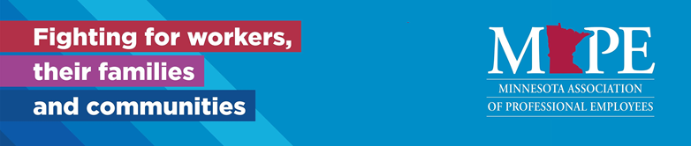[www.MAPE.org](http://www.MAPE.org)

**Local 1101 Monthly Meeting Notes**

**Date/Time:** Thursday, May 13th, 2021 at 11:30 a.m.

**Location:** Virtual Meeting until further notice—new link: <https://zoom.us/j/3658171800?pwd=SXRrdFg5R2poNzhHVVhGbE5SSkFEUT09> A recording will be sent out after meeting and a link will also be included in the minutes

(formerly at U Garden Chinese Restaurant 2725 University Ave SE, Minneapolis, MN 55414)

**May meeting recording link:**

<https://zoom.us/rec/share/IRSU8jLxd9v95VoLDV9kKjMxRVY_QFL9_6dMIqFq7IvJqDuZOb7ch320003C1k-h.k190VjaTKLZAed1J> Passcode: j8+1kbY1

**Agenda**

* Call to order
* Approval of April meeting minutes – motion to approve by Jared Golde, 2nd by Dawn Muller
* Region 11 Director’s Report (Jessica) –no report
* Treasurer’s Report (Rosie) Add .04 to account, no money spent.
* Membership Committee Report--welcome new members! No report.
* Lead Steward Report (Jared)
  + Very little activity, quiet in Region 11
  + Biggest news MMB has stated that Stewards, AFSCME and MAPE have been doing union work on state time. Instead, stewards need to go into no pay status for steward issues although it’s been done the same way for 20 years. This is possibly strategic. We have a robust case and it’s been the accepted interpretation of the case for the last 20 years. It is fully conditional bargaining. Grievants are the ones who really suffer from this.
  + Adam Novotny thought the memo was specific in the course of an investigation, but Jared didn’t think so, he thought it was any time that an employee is working on behalf of the union. However, it IS possible to flex schedules. They will continue to address this.
* Social Welfare Committee Report (Jennifer/Adam/Courtney)—any announcements from members? No, although Adam thanks everyone for the card re: the recent loss of his brother. ☹
* Negotiations report (Adam)
  + Adam Mon and Tues, Zach Gamm participated and helped a lot, arduous 2 days of bargaining. All proposals were resolutely denied. MMB brought forward 143 proposals and we brought 23 to them. They feel like they want to maintain management exactly as it is now. They want to maintain the right to rescind telework as a disciplinary measure whenever possible. Equity, diversity and Inclusion, preamble and asked what their hesitancy to agree with it was. It’s structural racism, and if it isn’t, then why they can’t they just change a few words? Shawn Swinson-Stafford hit them with hard questions at the end that they didn’t really address. They want to change the names of holidays to the dates in a bid for equity. But, it’s odd because it’s just candy-coating the holidays. In response we asked for Juneteenth, which they said would cost $20 million, which also isn’t true.
  + Jack Rusinoff noted that there is no reduction in workload for any paid holiday right now.
  + They received our health care updates, and they want us to take on more costs. $3.6 % in 2022 and 2023, total of 7.2% in increases, in the middle of the pandemic WHILE we’re sitting on a surplus. Also want to increase co-pays. Propose single increase from 5 to 7%, family to increase from 15% to 17%. SEGIP can only cover 92% of costs, we have to cover 8%.
  + They’re trying to propose language to automatically raise costs without going through union.
  + Disappointing because it was supposed to be collaborative instead of adversarial. Blatant union-busting, stripping away representational rights, stripping away seniority, stripping away union rights and giving them to managers.
  + Perhaps Layoff and seniority process are not the problem, perhaps it’s a lack of hiring and protecting of people in protective classes.
  + We’re going into remediation, we don’t have a choice. Johnny Villareal is the remediator. Land the plan, get a deal, avoid a strike.
  + What is the remedy when the other party does not seem to be negotiating in good faith? No remedy as it’s extremely hard to prove someone wasn’t negotiating in good faith.

Business Agent Report (Debbie—unavailable for meetings through June)

* Please sign the negotiations petition by 5/18! MMB is really playing hardball, so it’s vitally important that we get a strong showing from members that we are united for a fair contract. <http://bit.ly/MAPEpetition>

**Old Business**

* April meeting recording link: <https://zoom.us/rec/share/J6_z5AjzP25raxBLJDYryyN6ogJ8GcJdGAV2qnlvkbhVaHiorwPPuz87ddNWbJOT.KbaEpWtZPurRX0g6> Passcode: M@p7eB**
* Conversations About Race sessions (biweekly, 1st and 3rd Wednesdays, statewide open and honest conversations about race, ethnicity, culture, and more. 11-12:30: [Join Microsoft Teams Meeting](https://gcc01.safelinks.protection.outlook.com/ap/t-59584e83/?url=https%3A%2F%2Fteams.microsoft.com%2Fl%2Fmeetup-join%2F19%253ameeting_YzAxMGQ0NjYtZmQ1ZC00ZjYyLWFlZGQtMWRhNGFmZTRmMjll%2540thread.v2%2F0%3Fcontext%3D%257b%2522Tid%2522%253a%2522eb14b046-24c4-4519-8f26-b89c2159828c%2522%252c%2522Oid%2522%253a%2522d620986a-b11c-46a1-93ac-200eb9ea2d1e%2522%257d&data=04%7C01%7Chalie.rostberg%40state.mn.us%7Cf39a65bf48244d65cf1e08d8b0edf27a%7Ceb14b04624c445198f26b89c2159828c%7C0%7C0%7C637453883314535842%7CUnknown%7CTWFpbGZsb3d8eyJWIjoiMC4wLjAwMDAiLCJQIjoiV2luMzIiLCJBTiI6Ik1haWwiLCJXVCI6Mn0%3D%7C1000&sdata=X7%2BRhfl9KBrHu92%2B9G0cz%2FSkOAxAKNjyf%2FYe8ZV578g%3D&reserved=0))

**New Business**

* Local 1101 DA candidate forum: Kevin Nelson, Michele Wilson, Jared Golde, Ilyas Ali, and Shawn Swinson-Stafford. The delegates are voted for in a ranked fashion on the ballot. The top two voted delegates on the ballot will be seated and all the rest will be seated as alternates.
  + Kevin Nelson (read by Kevin)
    - My name is Kevin Nelson. I work for the Department of Corrections in St. Paul. I have been a state employee for just over twenty-one years, and a member of MAPE for that duration. I stood on the picket lines during the strike of 2001 but did not become more heavily involved in the union until I was laid off approximately 18 months ago. MAPE was so supportive and helpful throughout the bumping process that I decided to give back by becoming a union steward, Vice President of Local 1101, and an alternate member of the DOC Meet & Confer committee. MAPE gave me a voice when I felt powerless. I want to be able to help other MAPE members have a voice as well. That is why I am running for the office of Local 1101 Delegate.
* Michele Wilson (read by Halie)
  + - My name is Michele Wilson and I have been a Minnesota Department of Corrections employee for nearly fifteen years and a MAPE member from the start. I currently work in St. Paul and am a member and secretary of our Local 1101. Last year, I became a steward as well. While I have always attended MAPE meetings off and on, changes in our workplace made it more important than ever that we have a voice in respect to equity, teleworking, wellbeing, and overall practices of our state departments. I look forward to playing an important part in making sure all voices are heard!
* Jared Golde (read by Rosie)
  + - My name is Jared Golde, and I currently serve as Co-Chief Steward for MAPE Region 11. I work as a special investigator with the Department of Corrections in Saint Paul. I want to take this opportunity to provide you a bit of information about my education and work experience relevant to my nomination as both MAPE Statewide trustee and Local 1101 Delegate.
    - Currently, I hold two undergraduate degrees and one graduate (master's) degree from the University of Minnesota-Carlson School of Management. A significant part of my graduate studies focused on financial and managerial accounting, learning the fundamentals of generally accepted accounting principles (GAAP). Familiarity with GAAP has allowed me to analyze enterprise finances at both micro and macro levels.
    - Before becoming an employee of the State, I worked as a hospitality executive for seven years, overseeing the enterprise's operations, human resources, and finance divisions. During this time, I conducted audits and reviews to confirm compliance with internal and external record-keeping and reporting policies. Moreover, I systematically analyzed the effectiveness of the companies existing financial controls and made recommendations on areas of concern. Of equal importance, I analyzed enterprise-level income statements, cash-flow reports, and balance sheets to assess the organization's financial health and reported my analysis to the board of directors.
    - Over time I have developed a robust set of knowledge, skills, and abilities as an investigator, allowing me to fairly and objectively examine peculiar journal entries, notes, paper trails, and occurrences to determine the credibility of any entry withdrawal or transfer.
    - I can think of no better way to serve fellow MAPE members than to ensure that our Union's funds and assets are appropriately used and accounted for and to represent MAPE members as both a Trustee and local 1101 delegate.
* Ilyas Ali (read by Halie)
  + - DEED Diversity and Inclusion Committee member, Meet and Confer Member, Region 11 Negotiations Representative
    - I have observed that when my friends are asked to describe me as an individual, they would often describe me as somebody who is very diverse, pleasant, and active. Of course, those are things secondary to being described as being intelligent. I believe that such experience has opened my eyes to the reality of field work.
    - A very interesting combination of experience has also helped me to become the man that I am today. As public servants, we have the rare opportunity of using our union not only to uplift one another as workers, we can uplift the communities, people, businesses, and lands that we serve. I humbly ask for your vote to represent you, and all, as a delegate at MAPE’s 2021 Delegate Assembly.
* Shawn Swinson-Stafford (read by Rosie—Shawn noted he would prefer to be alternate)
  + - Greetings, Local 1101 members. My name is Shawn Swinson-Stafford. I am an investigator with the Minnesota Department of Human Rights (MDHR). I have served two stints with the State and have had continuous MAPE membership since 2005 or thereabouts. My MAPE experience includes serving as a member of the MDHR MAPE Meet and Confer Committee, as the Chair of the MDHR Meet and Confer Committee, and as an at-large member of the Negotiations Committee.
    - I am running for the office of Local 1101 Delegate because I have three important qualities to offer.
    - The first quality is a desire to stand up for Local 1101. We have several amazing leaders, and many amazing members, in Local 1101. I am eager to serve the members of Local 1101 by making sure our voice is heard loud and clear within MAPE.
    - The second quality, informed by my background in the field of human rights, is that I value the diverse backgrounds and perspectives of our members. I firmly believe that having different backgrounds and perspectives imbues our collective efforts with strength and wisdom.
    - The third quality is valuing loyalty. By this, I mean that it is vital that we have solidarity with each other, but that we also think critically about the integrity and motives of those who purport to be allies of MAPE.
    - Thank you very much for considering me as a candidate!
* Region 11 Director candidate forum: Jessica Raptis and Ilyas Ali.
  + Jessica Raptis (read by Kevin)
    - My name is Jessica Raptis, and I would like to continue as your Regional Director for MAPE. I have served on the Board of Directors representing your best interests since August of 2018. I have been active as the co-chair of the DA planning committee, chair of the scholarship committee, and was a member of the board development subgroup.
    - I have attended organizing training through MAPE with IAF. In addition, I am an active steward and serve as the vice chair of the DOC Statewide Meet and Confer team. These positions provide me with the knowledge of issues occurring within our agencies, and with that knowledge I can better represent membership. This past year I was awarded the Betty Rodgers award for union achievement. Before serving as your director, I served as the secretary for Local 1101. Before MAPE, I was a member of AFSCME at the Oak Park Heights prison and spent a great deal of time down at the Capitol meeting with legislators and attending hearings.
    - I have been committed to holding ourselves accountable as leaders and ensuring we are fiscally responsible with membership dues. I believe all members should have a voice, and it is imperative that our Board of Directors acts under the direction of membership and is transparent. Just as I believe we need to hold the State of Minnesota as an employer accountable, I am also committed to ensuring we are a fair and supportive employer to our MAPE staff. It is critically important to ensure that not only the state, but also our union demands equality, inclusion and accessibility for all of our members and staff.
    - Thank you for allowing me to be your director. I hope to have the opportunity to continue to serve as your representative on the board of directors!
* Ilyas Ali (read by Kevin)
  + - When we center members, we democratize the union and grow our power. MAPE’s Board of Directors is the main governance body which ensures our union has financial resources, oversight, and strategic direction to strengthen our union and keep our members at the center of everything we do.
    - Diversity in our board of directors is key to that centering of our members. The experiences and barriers I have faced throughout my life, combined with my business degree and professional experience, have formed strong values of advocacy, hard work, and tireless optimism while facing conflict. It has also provided me with a wider perspective and better understanding of life, as well as illuminated the path forward on members’ goals. I believe in offering and keeping a non-negotiable standard of quality and service and commit to upholding these values and standards as your representative.
    - Together, we as MAPE members have a real opportunity to rise to the moment and use our collective strength to advocate for a better Minnesota that lifts up all working people. In region 11, we are fortunate to have some of the most intelligent and resourceful members working towards these noble goals, and I ask for your vote to give me the privilege of representing your voices on MAPE’s Board of Directors.
* Personal statements available here: <https://mape.org/resources/mape-documents/mape-internal-election-information>
* Elections online balloting between 5/13/21 and 5/27/21! Please vote! If you have questions about which statewide candidates we are endorsing, please ask Halie Rostberg or Jessica Raptis.
* Recorded forums for statewide trustee, vice president, and political council available here: <https://mape.org/news/mape-elections-candidate-forums>
* The Boards building is moving, so we are losing those members.
* Thank you note from Ain Dah Yung Center (Dawn).
* Thank you to our members who volunteered at recent multi-union Farmers to Families free food giveaway Saturday events: Jessica Raptis, Mary Sturm, Halie Rostberg, Dawn Muller, and Anna Werner.
* Charitable organization winner for April/May/June (quarterly $1,000 donation): Eastside Neighborhood Services.
* Monthly attendance drawing for one $25 U Garden gift card (offering takeout as well as food orders through third party delivery service apps). Jack Rusinoff won.
* Rosie Widell and Jack Rusinoff approved the meeting ending.

**Next Meeting Date:** Thursday,June 10th, 2021 at 11:30 a.m.

**Local 1101 Leadership Team**

Region 11 Director: Jessica Raptis, DOC 651-361-7325, [Jessica.Raptis@state.mn.us](mailto:Jessica.Raptis@state.mn.us)

President: Halie Rostberg, DOC, 651-361-7358, [Halie.Rostberg@state.mn.us](mailto:Halie.Rostberg@state.mn.us)

Vice President: Kevin Nelson, DOC, 651-402-0404, [Kevin.Nelson@state.mn.us](mailto:Kevin.Nelson@state.mn.us)

Secretary: Michele Wilson, DOC, 651-285-8697, [Michele.Wilson@state.mn.us](mailto:Michele.Wilson@state.mn.us)

Membership Secretary: Rob Hobson, SSB, 651-539-2350, [Robert.Hobson@state.mn.us](mailto:Robert.Hobson@state.mn.us)

Treasurer: Rosie Widell, DOC, 651-361-7261, Rose.Widell@state.mn.us

Contract MAPE Agent: Kathy Fodness, MAPE/Central, 651-287-8755, [kfodness@mape.org](mailto:kfodness@mape.org)

Organizing MAPE Agent: Debbie Prokopf, MAPE/Central, 651-287-8762, [dprokopf@mape.org](mailto:dprokopf@mape.org)

Negotiations: Adam Novotny, DOC, 651-361-8762, [Adam.Novotny@state.mn.us](mailto:Adam.Novotny@state.mn.us)

Social Welfare Committee: Adam Novotny, Jennifer Paulus, Courtney Wanek

Region 11 Co-Lead Stewards: Jared Golde, DOC (1101), 651-361-7207, [Jared.R.Golde@state.mn.us](mailto:Jared.R.Golde@state.mn.us)

Laura Heezen, MDVA (1102), 612-548-5774, [Laura.Heezen@state.mn.us](mailto:Laura.Heezen@state.mn.us)

**Local 1101 MAPE Stewards**

Brittany Anderson, DOC, 651-361-7113

Marlana Balk, DOC, 651-308-4442

Jared Golde, DOC, 651-361-7207

Rob Hobson, SSB, 651-539-1108

Lana Hogan, DEED, 651-642-0705

Brianne Lucio, DHR, 651-539-1108

Kevin Nelson, DOC, 651-402-0404

Adam Novotny, DOC, 651-508-2245

Jennifer Paulus, DOC, 651-361-7614

Jessica Raptis, DOC, 651-361-7325

Mary Reis, DEED, 651-539-4156

Halie Rostberg, DOC, 651-361-7358

Alana Strickler, SSB, 651-539-2291

Elaine Valadez, DHR, 651-539-1101

Rosie Widell, DOC, 651-361-7261

Michele Wilson, DOC, 651-285-8697

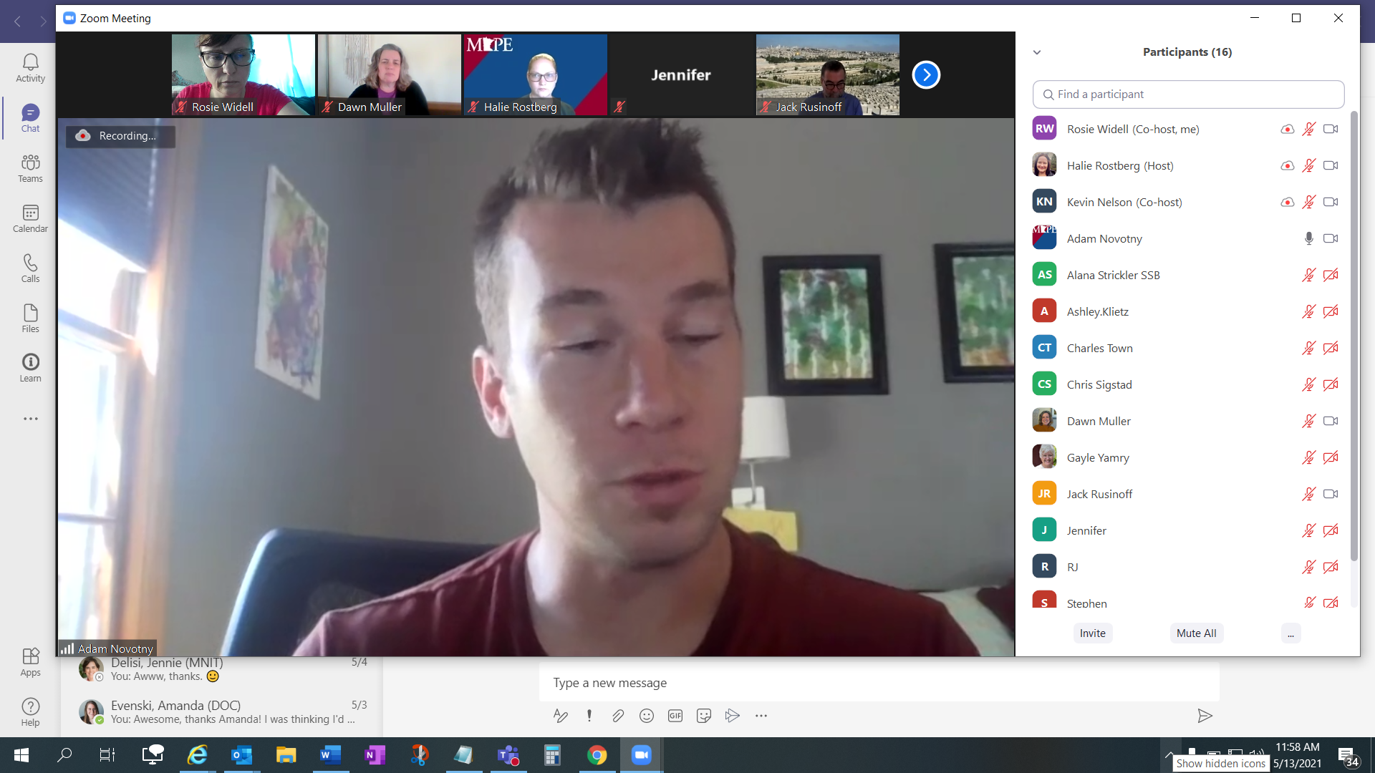

Susan Fox

Zachary Gamm